

JCMS Web User’s Guide

##### Computational Sciences

##### The Jackson Laboratory

|  |  |  |  |
| --- | --- | --- | --- |
| **Revision** | **Date** | **Author** | **Comments** |
| **1** | 06/20/12- 06/22/12 | Kavitha Rama | First Draft |
| **2** | 01/11/13 | Craig Hanna | JCMS Web Version 4.6.0 Release |
| **3** | 01/14/13 | Craig Hanna | JCMS Web Version 4.6.0 Update |
| **4**  **5** | 04/08/13  05/08/13 | Mike Amato  Mike Amato | JCMS Web Version 4.7.0 Update  JCMS Web Mouse Scheduling |
| **6**  **7** | 05/14/13  06/6/13 | Craig Hanna  Mike Amato | JCMS Web Administration  JCMS Web Mouse Scheduling Calendar |
| **8**  **9**  **10**  **11**  **12**  **13**  **14** | 06/17/13  07/16/13  09/16/13  09/16/13  09/16/13  09/16/13  10/04/13 | Craig Hanna  Mike Amato  Mike Amato  Mike Amato  Mike Amato  Mike Amato  Mike Amato | JCMS Web Administration Update Manage Cages  JCMS Web Mouse Scheduling Calendar – Add use  JCMS Web Samples Module  JCMS Web Roles  JCMS Web Bulk Updates  Add User Screen  Storage Manager |
| **15**  **16**  **17**  **18** | 10/23/13  12/9/2013  1/20/2014  1/20/2014 | Beth Sundberg  Mike Amato  Mike Amato  Mike Amato | Vivaria Layout  Vivaria Layout Add Mating and Cage Card Ownership  Vivaria Layout Add Litter with Pups  Calendar View – Projected Wean Dates |
| **19**  **20**  **21**  **22** | 2/3/2014  2/26/2014  4/24/2014  5/16/2014 | Beth Sundberg  Michael Amato  Michael Amato  Michael Amato | Wean Report  JCMS Dashboard  Use Schedules  3.7.0 Updates |
| **23** | 6/9/2014 | Beth Sundberg | Phenotypes |
| **24** | 6/13/2014 | Michael Amato | Dashboard updates |
| **25** | 7/25/14 | Beth Sundberg | User Preferences |
| **26** | 8/12/14 | Beth Sundberg | Added Mating User Preferences |
| **27** | 8/22/14 | Beth Sundberg | Added Litter User Preferences |
| **28** | 3/6/15 | Beth Sundberg | Added Experimental Data |

##### **Table of Contents**

Description 7

Overview 7

Getting Started 8

Home 8

Navigation 8

Administration 9

Centers 9

Accounts 9

Add User 10

Controlled Vocabulary 10

Genotyping 12

Matings 14

Miscellaneous 14

Mice 15

Phenotypes 16

Use Schedules 17

Cages, Rooms, and Cage Cards 17

Vivaria Layout Manager 20

Samples 21

Manage Colony 24

Add Mouse 24

Auto incrementing IDs 26

Business Rules or Validation 27

Edit Mouse - Search 27

Search results 28

Edit Mouse Form 29

Litter Search and Select Litter# 29

Save button 31

Return to Search 31

Preview Cage Card 32

New Cage 32

Business Rules or Validation 33

Add Mating 34

Business Rules or Validation 35

Dam/Sire ID Search and Selection 36

Edit Mating 37

Add Litter with Pups 40

Business Rules or Validation 42

Edit Litter 44

Litter Search Results 45

Add Genotype 47

Edit Genotype 48

Mouse Scheduling 49

Add Mouse Use 49

Edit Mouse Use 50

Delete Use 50

Mouse Scheduling Calendar 50

Add Use 51

Projected Wean Dates 52

Plug Dates 53

Add Plug Date 53

Edit Plug Date 54

Bulk Updates 55

Vivaria Layout 56

Moving Cages 56

Vivaria Layout Color Coding and Icons 57

Adding Cages 58

Change Mouse and Cage Status 58

Move Mice 58

Create Mating 59

Add Litter with Pups 62

Use Schedules 62

Use Schedule Manager 63

Kaplan Meier Plots 63

Queries 64

Reports 65

Colony Summary Report 65

Cage Summary Report 65

Wean Report 66

Mouse Scheduling Calendar 67

Cage Cards 67

Make a Custom Cage Card 68

Load Card 70

Business Rules 71

Pedigree Tracker 71

Strain Viability Report 73

Colony Status Histograms 76

Kaplan Meier Charts 76

Samples 77

Add Sample 77

Edit Sample 79

Experiment Data 79

Add Test Type 80

Add Experiment Data 82

Edit Experiment Data 83

Query Experiment Data 83

My Preferences 84

Global Changes 85

Strain Name First 85

Add and Edit Mouse Screen 85

Add and Edit Mating Screen 87

Add and Edit Litter Screen 87

Known Issues 88

HTTP Status 403 – Access to the requested resource has been denied 88

Browser is unable to display the web page 88

##### **Table of Figures**

Figure 1: Navigation Example 9

Figure 2: Add New User 10

Figure 3: Add User 11

Figure 4: Example of Standard Functionality and Add Allele 12

Figure 5: Pager Control 12

Figure 6: How to Edit Seconds in a Date 13

Figure 7: Second Method for Editing a Date 13

Figure 8: Phenotype Selection 17

Figure 9: A Use Schedule Example 18

Figure 10: Manage Cages - Cage List 19

Figure 11: Manage Cages - Edit Cage Status and Location 20

Figure 12: Add Vivaria Layout 21

Figure 13: Edit Vivaria Layout 22

Figure 14: Storage Manager 24

Figure 15: Storage Manager - Sample List 24

Figure 16: Manage Mice - Add Mouse 26

Figure 17: Manage Mice - Edit Mouse Search 29

Figure 18: Edit Mouse - Search Results 30

Figure 19: Edit Mouse 31

Figure 20: Edit Mouse – Select Litter 32

Figure 21: Edit Mouse - New Cage 33

Figure 22: Add Mating 35

Figure 23: Add Mating – Select Dam/Sire 37

Figure 24: Select Mating for Editing 38

Figure 25: Edit Icon 39

Figure 26: Edit Mating 40

Figure 27: Select Cage 40

Figure 28: Add Litter with Pups 41

Figure 29: Add Litter with Pups (lower portion) 42

Figure 30: Add Litter - Mouse Search 44

Figure 31: Edit Litter - Litter Search 45

Figure 32: Litter List/Edit Litter - Search Results 46

Figure 33: Edit Litter 47

Figure 34: Add Genotype - Search 48

Figure 35: Genotype Search Results 49

Figure 36: Add Genotype – Show Link 49

Figure 37: Edit Genotype 50

Figure 38: Mouse Scheduling 51

Figure 39: Mouse Use Calendar 52

Figure 40: Edit Mouse Use on Calendar 53

Figure 41: Projected Wean Date Pop Up 54

Figure 42: Add Plug Date 55

Figure 43: Edit Plug Date 55

Figure 44: Bulk Update 56

Figure 45: Vivaria Layout View 57

Figure 46: Layout Color Coding and Icons 58

Figure 48: Change Life Status and Cage Status 59

Figure 47: Cage Details Panel 59

Figure 49: Move Mice to a New Cage 60

Figure 50: Add mating with Vivaria Layout 61

Figure 51: Mating Details 62

Figure 52: Mating Cage 62

Figure 53: Litter Details Panel 63

Figure 55: Kaplan Meier Plots 64

Figure 54: Use Schedule Manager link 64

Figure 56: Mouse Query Search Results 65

Figure 57: Load Queries 66

Figure 58: Download Cage Summary Report 67

Figure 59: Wean Report Options 67

Figure 60: Print Blank Cards 68

Figure 61: Cage Cards 69

Figure 62: Custom Cage Card Builder 71

Figure 63: Load Cage Cards 72

Figure 64: Mouse Pedigree 73

Figure 65: Genotype based Pedigree Tree Visualization 74

Figure 66: Strain Viability Filter Panel 75

Figure 67: Kaplan Meier Chart Tool 78

Figure 68: Add Sample – Choosing a Source 78

Figure 69: Add Sample 79

Figure 70: Edit Sample 80

Figure 71: Experiments 81

Figure 72: The test type detail list shows all the data result fields, format, and any min/max values 81

Figure 73: Add a test type 82

Figure 74: Adding data for an experiment 83

Figure 75: Edit experiment data 84

Figure 76: Experiment query 85

Figure 77: My Preferences on the Menu Bar 85

Figure 78: Hide Icon 86

Figure 79: My Preferences Choices 86

Figure 80: Preference Choices for the Add and Edit Mouse Screen 87

Figure 81: Preference Choices for the Add and Edit Mating Screen 88

Figure 82: Preference Choices for the Add and Edit Litter Screen 88

# Description

JAX Colony Management System Web (JCMS Web) is a web interface for the JCMS application, providing mouse colony management.

# Overview

JCMS Web is organized into these functional areas.

* Home
* Administration
* Manage Colony
* Samples
* Experiment Data
* Queries
* Reports
* Cage Cards
* Pedigree Tracker
* About JCMS Web

Home provides a general page to navigate to all areas of JCMS.

Administration provides center, workgroup, user management, and system access.

Manage Colony provides mouse, litter, and mating management; genotyping; mouse scheduling; phenotypes; and vivaria layout.

Samples provide tracking of physical materials.

Experiment Data provides a method of describing the data to collect and data management by mouse.

Queries provide custom mouse, mating, and experiment data reporting.

Reports provide standard colony and cage summary reporting and a mouse scheduling calendar.

Cage Cards provide custom cage card management.

Pedigree Tracker provides mouse pedigree reporting.

My Preferences provides a place for specifying user-specific customizations.

About JCMS Web summarizes the most recent system information for JCMS Web and JCMS.

# Getting Started

JCMS Web default URL is http://{servername}:8080/jcms. Consult with your local Information Technology department for specific instructions. For problems with starting JCMS Web, see the Known Issues section.

The first step is to create JCMS Web users and grant system access. Refer to the next section on Administration for guidance.

# Home

This is the central navigation area to all JCMS Web modules: manage mice, create custom queries, run standard colony and cage reports, manage and customize card design, and research mouse pedigree hierarchies.

## Navigation

JCMS Web employs a menu across the top and a sidebar down the left side. To get to an interface, select the topic, such as ‘Manage Colony’. Second select the subtopic from the left side, such as ‘Manage Mice’. It will open up to show more choices. Third select the desired interface, such as ‘Add Mouse’ and the interface will open.

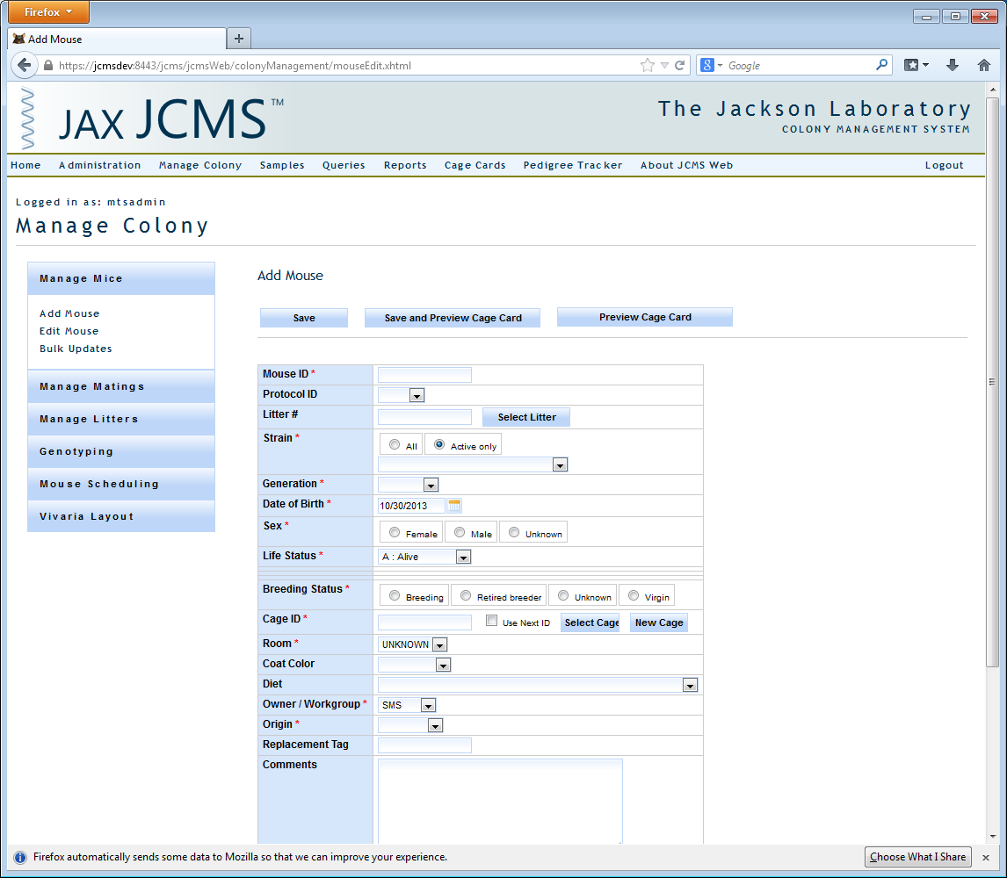

Figure : Navigation Example

# Administration

## Centers

### Accounts

An administrator accesses JCMS Web administration by logging in as a user that has administration privileges granted to them (such as mtsadmin). Once in JCMS Web, navigate to Administration to create centers, workgroups, and user accounts as well as edit user accounts and who has access to different workgroups.

A center is an organizational grouping of users. Further subdivisions are workgroups where a user can belong to one or more workgroups. To add a center click the add center button and to add one or more workgroups to a center select the desired center and then click add workgroup. Note that only mtsadmin can create new centers.

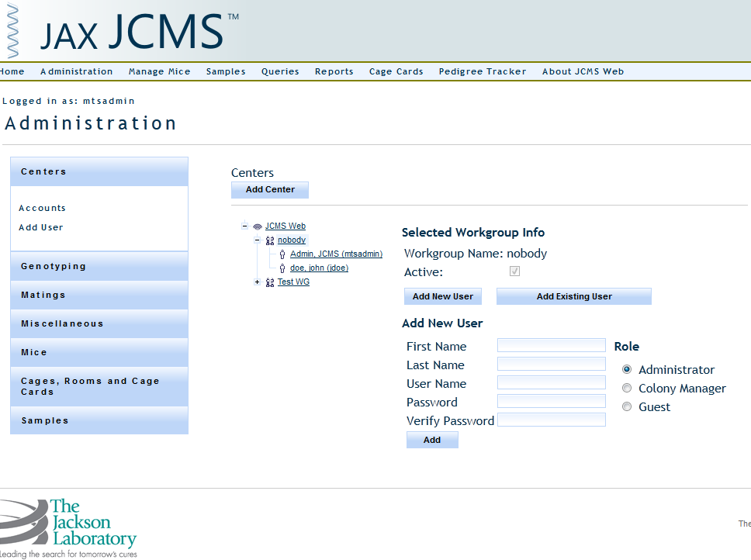

Figure 2: Add New User

There are two different means of adding users through this screen. In the case where you are adding a new user to a workgroup you must select the ‘Add New User’ button. To add a user to a workgroup that already exists, click the ‘Add Existing User’ button. The add new user view is pictured above (Figure 2). Keep in mind that should you wish to add a new user to multiple workgroups it is likely faster to use the ‘Add User’ screen explained in the following subsection.

By clicking on a user in the accounts tree you can edit that user’s information such as their username and password, but you can also edit the role of that user in that specific workgroup (administrator, colony manager, or guest).

The roles in JCMS Web are defined as follows: An administrator can do all JCMS Functions (including Controlled Vocabulary management and Add/Edit/Remove user functionality), a colony manager can access all screen except the administration screen, and a Guest can only access data read features such as Queries, Reports (not including the mouse scheduling calendar), Cage Cards, and the Pedigree Tracker.

### Add User

The Add User panel gives users a faster means of adding a user to multiple workgroups. To get there one simply needs to click on the ‘Add User’ link in the Administration sidebar under the label ‘Accounts’.

The screen will appear as shown below. You will need to provide a username and password and select a role and workgroups to add this user to in that role. An administrator can do all JCMS Functions (including Controlled Vocabulary management and Add/Edit/Remove user functionality), a colony manager can access all screen except the administration screen, and a Guest can only access data read features such as Queries, Reports (not including the mouse scheduling calendar), Cage Cards, and the Pedigree Tracker.

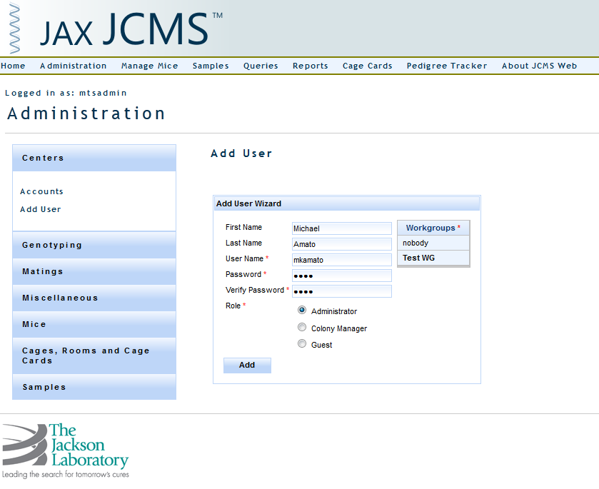

Figure 3: Add User

## Controlled Vocabulary

Controlled vocabularies standardize JCMS colony management terms and concepts. The first step in setting up JCMS Web is to visit each one of these vocabularies and enter at least one value. Each set of vocabulary are grouped together into logical categories.

* Genotyping
* Matings
* Miscellaneous
* Mice
* Cages, Rooms, and Cage Cards

#### Standard Functionality

Most, if not all, vocabulary is displayed in a tabular list. Just below each column label may be an empty field. After you have some results a filter can be applied to filter out some extraneous rows. Each filter performs a “contains” search except in some situations where there is a checkbox where it retrieves all active or inactive data. For example, it can select all alleles containing a plus sign, “+”. Simply enter + in the blank field and tab out. Tabbing out of the filter field initiates the action to filter the search results.

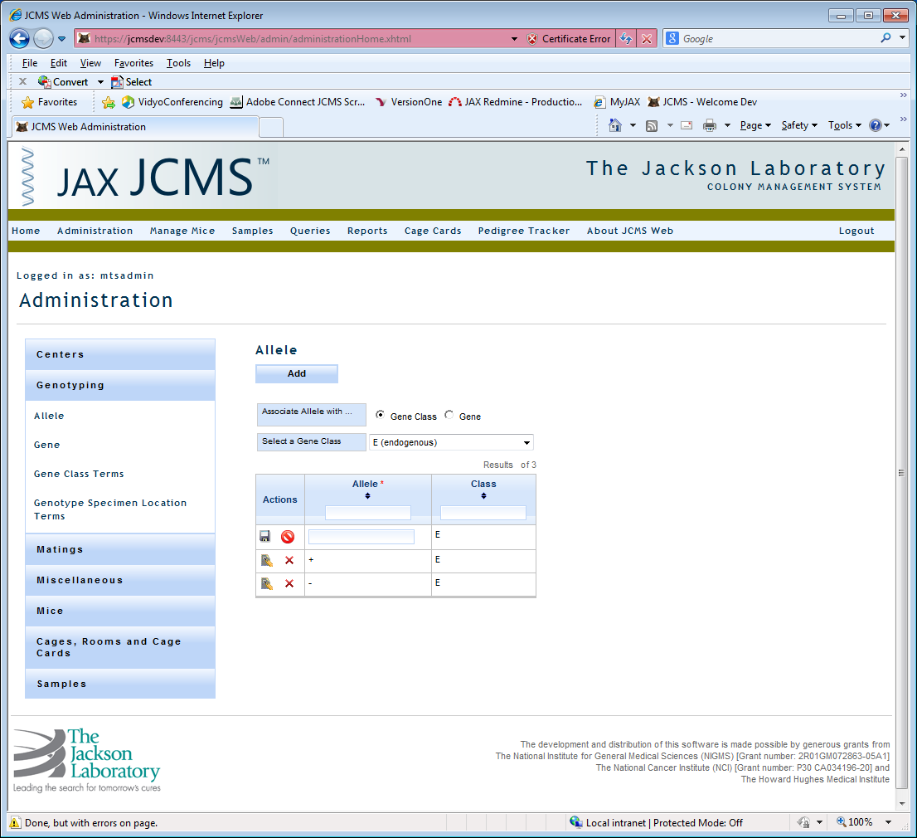

Figure 4: Example of Standard Functionality and Add Allele

On selecting the add button an entry row is inserted as the first row of the list view. Enter the required data and select save to store your new values. Pay close attention to any error messages above the section header. In the case of alleles, messages display just above the add button and Allele title. Delete removes a vocabulary from storage. Strain delete is an exception to the rule because strains are either active or inactive.

On save, validation messages will display if you haven’t entered all required data and in the proper data type, such as text or number. Read the error message, fix content, and select save once more.

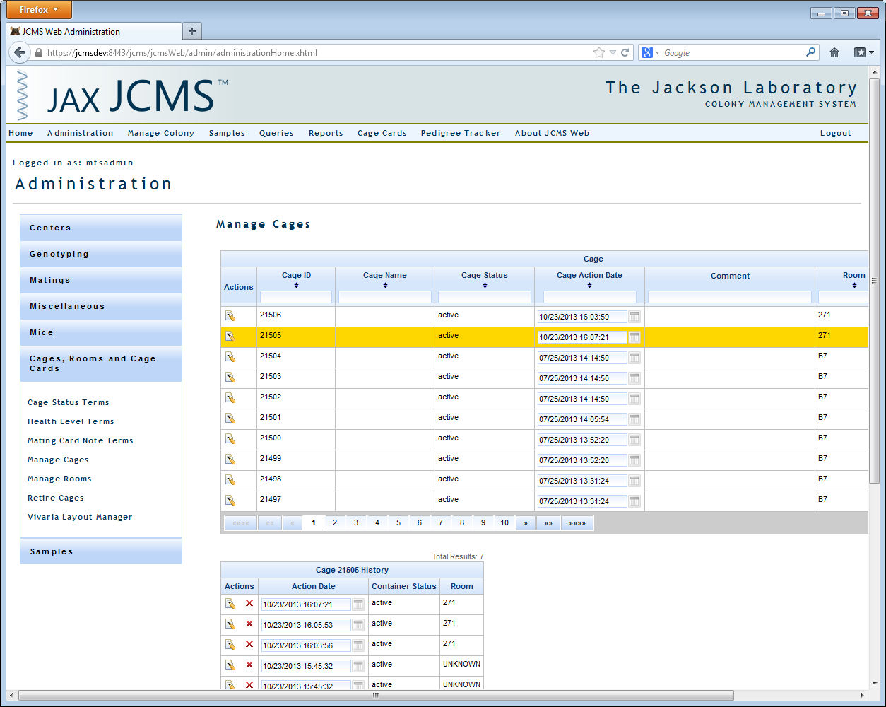

Figure 5: Pager Control

All list views will display a pager control at the bottom of the tabular display when a specific number of rows are reached. When it displays there are more rows to access by selecting the next available page or using the speedy buttons to go to next, previous, first, or last set of results.

##### Date and Time Editing

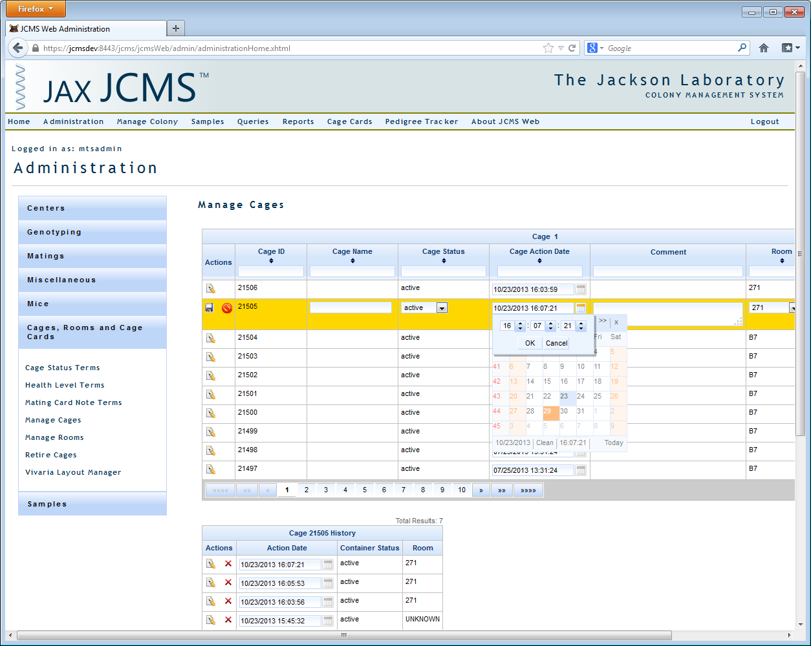

Figure 6: How to Edit Seconds in a Date

To edit a date field, click the small calendar icon and select the date. To change the time, click on the time where it is shown below the calendar and a new box pops up as shown in Figure 6. Click ‘Clean’ to remove the date leaving the field blank. Note that you may not be able to change a date by typing in the field.

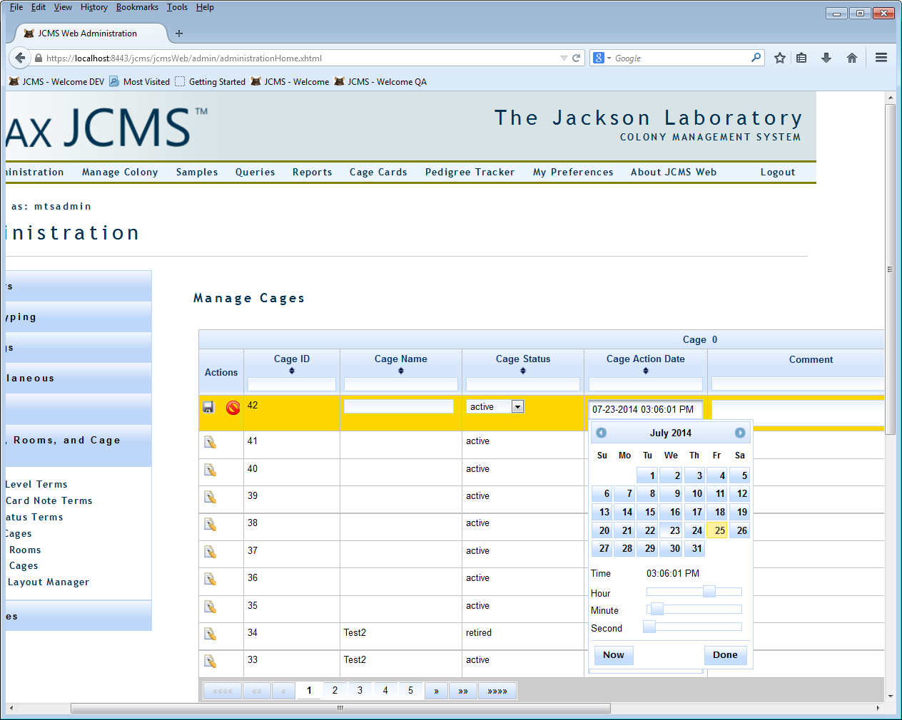

Figure : Second Method for Editing a Date

If there is no calendar icon, click in the date. Use the sliding bars to enter the time and click ‘Done’.

### Genotyping

To add an allele you need to add some genes and gene classes first.

#### Gene Class Terms

This interface displays a list of gene classes. All standard functionality is provided.

General guidelines:

* Gene class names are not case sensitive
* Duplicate gene class names are not allowed
* Required fields are marked with a red asterisk

#### Gene

This interface displays a list of genes. Genes are not a simple vocabulary as each gene is made up of six potential data elements, only one of which is required, lab symbol.

If trying to navigate more than 20 genes make special use of the tabular pager and filters to find your data faster.

General guidelines:

* Gene names are not case sensitive
* Duplicate gene names are not allowed
* Required fields are marked with a red asterisk

#### Allele

To add an allele you need to add some genes and gene classes first.

This interface displays a list of alleles by gene class or gene (Figure 4). Start by selecting a ‘Gene Class’ or ‘Gene’. This action automatically jumps you to the next step which is selecting a specific gene class or gene. After selecting, search results are displayed in a tabular view below the selections.

List view contains three columns of data. The first column provides the ability to edit an allele, delete an allele, save an allele, and cancel changes. Alleles are not editable but can be deleted and added back in at a later time.

General guidelines:

* Allele names are not case sensitive
* Duplicate allele names are not allowed
* Required fields are marked with a red asterisk

#### Genotype Specimen Location Terms

This interface displays a list of gene specimen locations. All standard functionality is provided.

General guidelines:

* Gene specimen locations are not case sensitive
* Duplicate gene specimen locations are not allowed
* Required fields are marked with a red asterisk

### Matings

#### Approved Mating Strains

This interface displays a list of approved mating strains. An approved mating strain is comprised of a dam strain, sire strain, and litter strain. Additionally, mating strains can be marked inactive. Select the active filter checkbox to display active or inactive mating strains. All standard functionality is provided.

General guidelines:

* Dam, sire, and litter strain names are not case sensitive
* Unique combinations of dam, sire, and litter strains are enforced
* Required fields are marked with a red asterisk

### Miscellaneous

This category lists a variety of administrable system variables and functionality.

#### JCMS Setup Variables

This interface is a tabular display of JCMS Web setup variables. These variables are grouped by container, litter, and mouse. Container variables display by default after selecting Miscellaneous -> JCMS Setup Variables links.

Container is divided into sub groups ‘Container Defaults’ and ‘Cage Cards’. Litter and mouse tabs require no additional groupings.

Here is a helpful chart listing each variable name, system property, and corresponding description. Tool tips are available for each variable field where you can hover over the field and view a short description of each. Users who are completely new to setting up JCMS may want to show all descriptions at once by enabling ‘Show Descriptions’ in the upper right hand corner of the display.

| Group | Setup Variable | Description |
| --- | --- | --- |
| Cage |  |  |
| Cage Defaults | Automatically Increment Cage ID | If enabled, the cage ID is automatically incremented when adding new cages. |
|  | Cage Status | Specify the default value for cage status; must match a value in the cage status table. |
|  | Maximum Mice Per Cage | Maximum number of live mice in any cage. |
|  | Mouse Room | Specify the default mouse room; must match a value in the Room table. |
|  | Use Cage Names | If enabled, cage names will be displayed on most forms. |
|  | Warn about Duplicate Cage Names | If enabled, warn if a duplicate cage name is used. |
|  |  |  |
| Cage Cards | Detail Card Note | A note that will be printed on all Detail cage cards. |
|  | Lab Name | Name of lab PI who owns colonies tracked by JCMS, printed on some cage cards. |
|  | Phone Number | Phone numbers, printed on mating card. |
|  | Print Exited Mice | If enabled, mice with an exit status such as dead, euthanized, missing, shipped, etc. will print on cage cards. |
|  | Relax Restrictions on Cage IDs | [NOT IMPLEMENTED]  If enabled, then it is required that a cage card is printed for all cages. |
| Litter |  |  |
|  | Automatically Generate Litter Numbers | If enabled, litter numbers are automatically generated for matings. |
|  | Loop Litter Numbers | If enabled, the litter numbers recycle after 10 litters, appending a character to the number. |
|  | Maximum Auto Litter Number | This variable sets the number of litter numbers that are assigned to a mating. It should be set to a value bigger than the max number of litters you ever expect. Suggested values are 10 or 100. |
| Mouse |  |  |
|  | Extended Wean Time | The number of days from the birth date to when a litter should be weaned - used for late weanings/"long" wean time. |
|  | Mouse ID Prefix | A short string of characters that are prefixed on mouse IDs generated by JCMS (not all mouse IDs are generated by JCMS). |
|  | Standard Wean Time | The number of days from the birth date to when a litter should normally be weaned. |
|  | Strain Name First | If enabled the strain name will appear first (to the left of the Stock number) in all drop down lists. |
| Security |  |  |
|  | Enforce Password Change | Tells application whether to remind user whether to change password after password change period has elapsed |
|  | Password Change Period | The number of days between a user changing and being reminded to change their password. |
| Preferences |  |  |
|  | Date Format Preference | Value describing date format in JCMS Web |

### Mice

This group contains many vocabularies for managing mouse interfaces. Instead of listing each separately, here is a list of all the simple vocabularies accessible using the same standard user interface. Other vocabularies containing functionality out of the norm are listed with a description of the additional features.

Standard mouse vocabularies are:

* Cause of Death
* Coat Color
* Diet
* Generation
* Life Status
* Mouse Origin
  + Not editable
* Mouse Protocol
* Mouse Use
* Phenotypes
* Strain Status
  + Strain status A, C, D, and F cannot be modified. The JCMS system requires these values to apply special business logic.
* Strain Type
  + Not editable

#### Strains

This interface displays a list of strains and a search panel to retrieve strains. Strain can be searched by strain name containing specific text and stock numbers greater than, less than, or in a range of numeric values.

Unique to this strain list view is the column header grouping yellow line viability columns and red line viability columns. Aside from that all standard functionality is provided.

### Phenotypes

A mouse may have several different phenotypes associated with it. They are assigned on the add mouse, edit mouse, or bulk update screens. The mouse query may be filtered by one or more phenotypes and phenotypes can be returned as an output column.

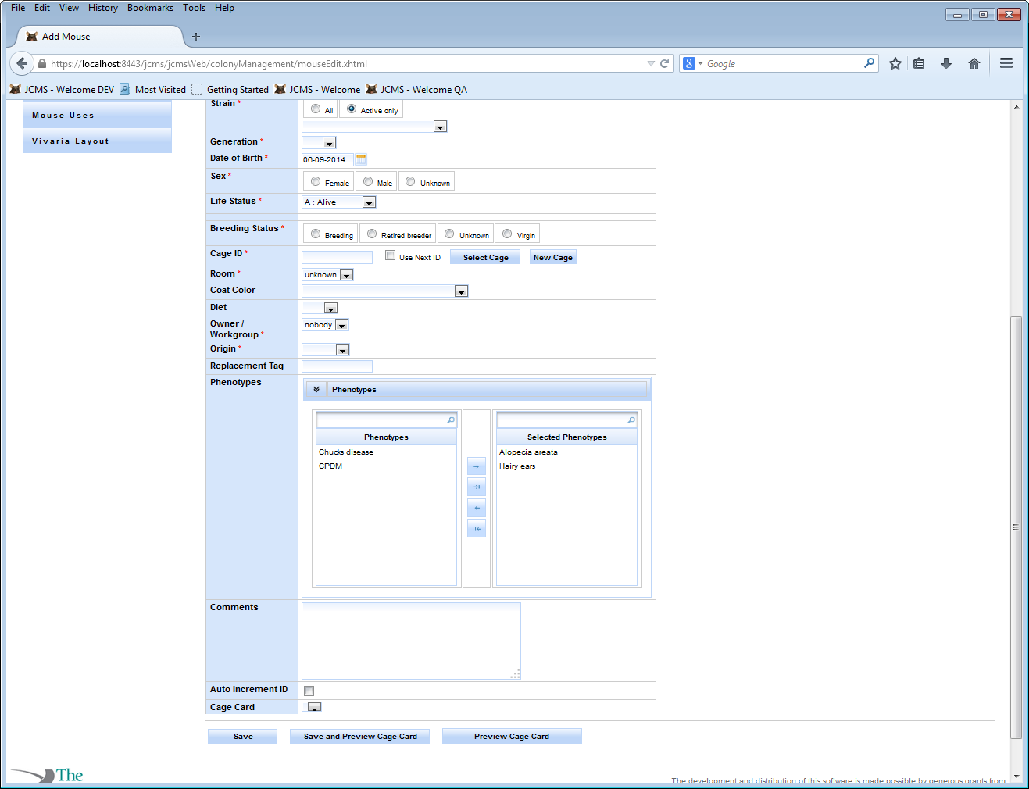

Figure 8: Phenotype Selection

### Use Schedules

Use schedules are a collection of mouse uses scheduled according to a date of interest (for example a plug date or a mouse birth date). To add a use schedule click ‘Setup Use Schedule’ in the Mice portion of the administration accordion and click the ‘Create Use Schedule’ button.

The ‘Use Schedule Name’ is what users will see in the view when they are viewing use schedule information. The Workgroup is the owner of the use schedule, and only users who are members of that workgroup will be able to add mice/view information on that use schedule. The color will be integrated more in the future, but for now is only used in the ‘Manage Use Schedules’ view. The start event is the event that will be the start date of the use schedule. For example if the start event is birth date, and you have a use scheduled to happen 5 days after event, then the use will be scheduled for the day that is five days after the birth date of the mouse.

Once the Use schedule has been created you can schedule uses for that use schedule. In the example below you can see that it is a birth date triggered use schedule and there are 6 uses associated with it, all MP Injections happening at 5 day intervals after birth.

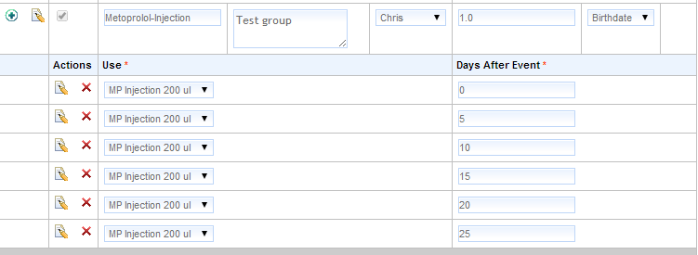

Figure 9: A Use Schedule Example

### Cages, Rooms, and Cage Cards

This group contains many vocabularies for managing cages, rooms, and cage card interfaces. Instead of listing each separately, here is a list of all the simple vocabularies accessible using the same standard user interface. Other vocabularies containing functionality out of the norm are listed with a description of the additional features.

Standard cage, room, and cage card vocabularies are:

* Health Level Terms
* Mating Card Note Terms
  + Not editable
* Cage Status Terms

#### Manage Cages

This interface provides you a simple view of all cages in JCMS. Using header sort and filter options you can pare down the number of cages to a select few. Each cage is editable by clicking on the edit action. Edit is an inline update where you make changes in the list view one cage at a time. Note that any change must have a unique cage action date, which can be done by changing the time by a few seconds. Duplicate cage names are allowed. A setup variable is provided for turning off the warning about a duplicate cage name. Once updates are complete select the save button to save or the cancel button to cancel all changes one cage at a time.

Cage history is displayed just underneath our cage listing for each cage you select. Operationally, this interface works the same as the manage rooms interface.

* Editing a cage requires a unique action date
* Each cage update to room or status creates a new cage history record
* All cage history records can be deleted except for one, the last one, which is read only
* Cage history detail is editable

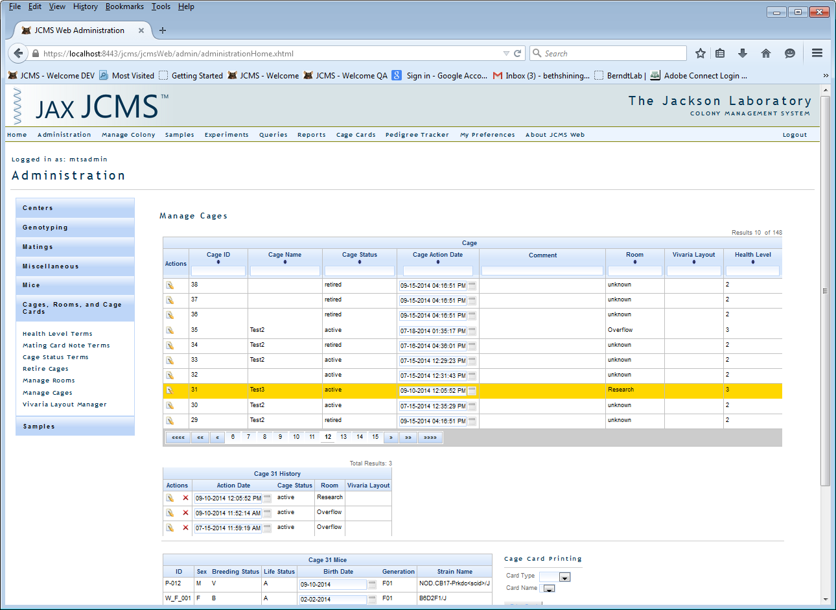

Figure 10: Manage Cages - Cage List

Mice residing in the selected cage are displayed below cage history. Mouse detail is not editable although you can print detail, mating, and wean cards using the features to the right of this mouse listing.

When using cage card printing, select a card type first, detail, mating, or wean card, then select from a filtered list of card names by card type. Last step is to print the card(s). Printing one or more cards displays a print preview, review the cards, and print out the cards of your choosing. When there are no mating or wean card templates the corresponding option will not display as a card type option.

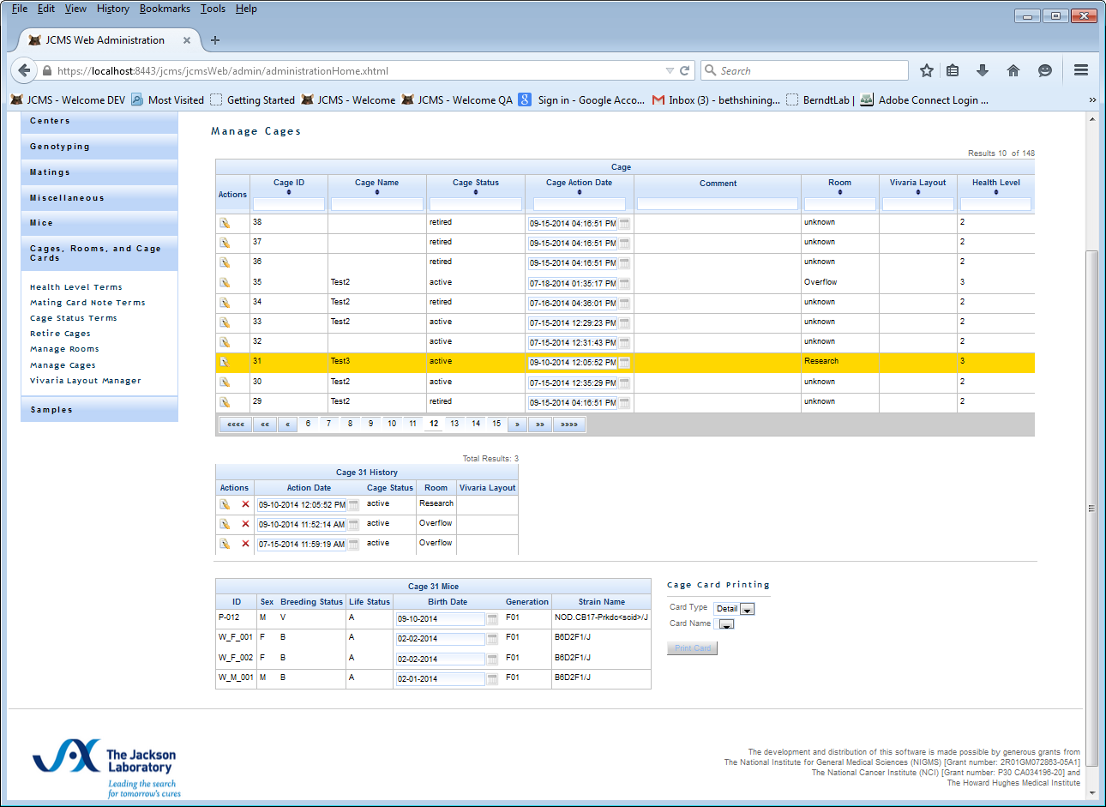

Figure 11: Manage Cages - Edit Cage Status and Location

#### Manage Room

This interface displays a list of mouse rooms and recorded health history per room. Main display is arranged and functions as other interfaces. Can add, save, cancel, and deactivate any room. Additionally, selecting a room displays a list of health level history on the top right hand side of the screen. Each time a new room is created or a change to either the health level or health level start date is made a history record is created. The only activity that does not produce a history log is renaming a room name.

Health level history tracking introduces a few user interface rules:

* Renaming a room does not generate a history log
* Only one health level entry is allowed for a specific date and time.
  + Additional entries are possible by changing the date and time.
* Room name size is limited to 8 characters
* When changing a health level
  + If start date is before the most recent health level than just add to history table
  + If start date is after most recent health level than add to history table and update room to point to this new entry
  + If the current health record is deleted, the room health level must be set to point to the new current health level record.
* Can delete any health level history except the last one.
  + The last history log is read only

#### Retire Cages

This interface is significantly different than the other standard vocabulary screens. Bulk retiring of cages is an Administrator function. The retire cages action searches the database for cages that are empty (have no mice in them or have only mice in them that have an exit life status). These cages have their cage status set to retired on today’s date.

NOTE: The retire cage function can take a long time to complete. It may take up to 3 minutes to finish. If you have more than 10,000 cages, you should consider running the retire cages function when you have several hours available in which the database will not be used. You should also back up your MySQL database before running this function just in case they take too long to complete. Whether or not this precaution is necessary will not be known until we have more experience with the retiring cages performance with very large data sets.

### Vivaria Layout Manager

The vivaria layout allows you to describe the room(s) where your cages reside in greater detail. The layout uses a hierarchy so a room can be subdivided into sections, racks can be in sections, etc.

Start at ‘Administration’ on the menu, click on ‘Cages, Rooms, and Cage Cards’, and then on ‘Vivaria Layout Manager’.

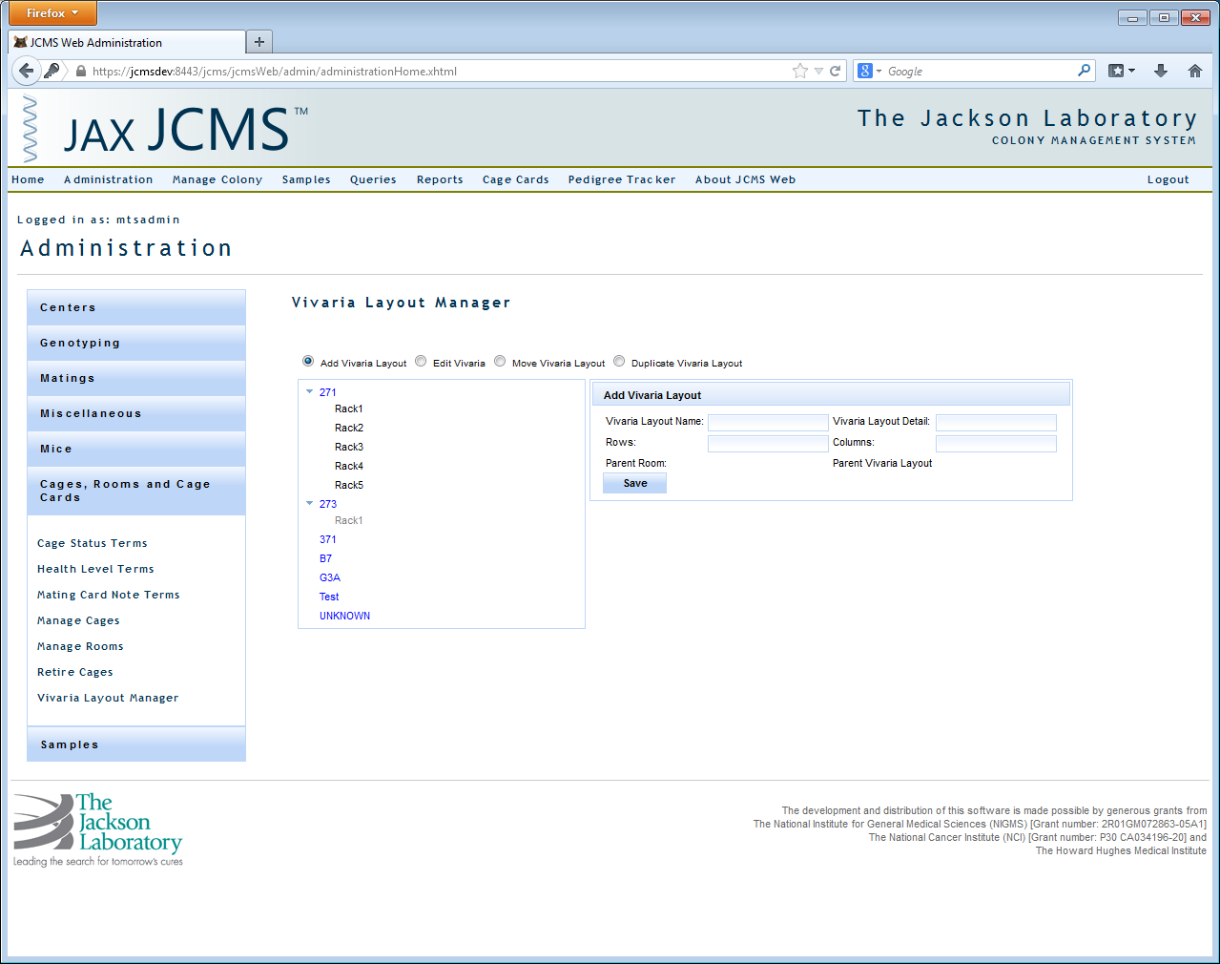

Figure 12: Add Vivaria Layout

#### Add Vivaria Layout

Select the ‘Add Vivaria Layout’ radio button to create a new level. Click on the room or sub-level where the new layout level should go. Give it a ‘Vivaria Layout Name’. The ‘Vivaria Layout Detail’ is for adding any comments about this layout. The bottom level will need to have rows and columns defining its shape. Intermediate levels may be setup with zero rows and zero columns if no cages will be placed there. For example, Room 371 has two sections, each section contains racks. Cages will only be placed in the racks. The sections are considered an intermediate level with 0 rows and 0 columns, while each rack has a two-dimensional layout. If a rack has a three dimensional layout, then it should be defined with shelves as the final level.

#### Edit Vivaria Layout

Select the ‘Edit Vivaria Layout’ radio button. Click on the level to be changed, it will be highlighted in yellow. Make the desired changes and click ‘Save’ or click ‘Delete’ to remove.

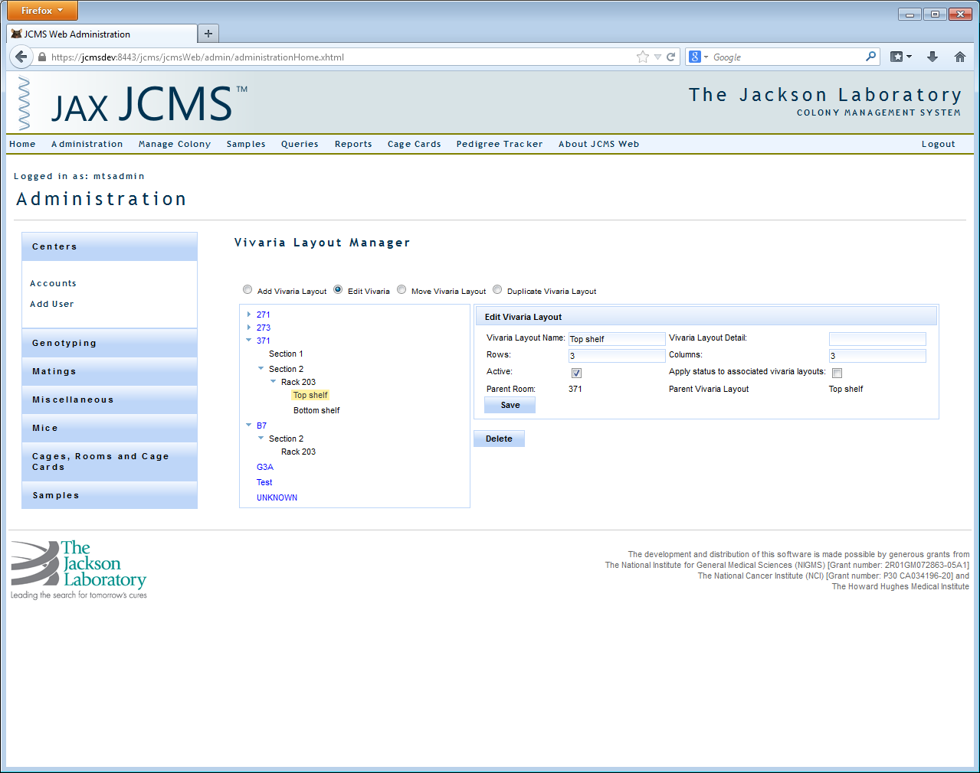

Figure 13: Edit Vivaria Layout

#### Move Vivaria Layout

Select the ‘Move Vivaria Layout’ radio button. Click on the layout and drag it to a new location. Hover over the room or layout name where it will be moved until it is highlighted in light blue. Drop the layout and it will be moved to become sub-layout of the selected room or layout.

#### Duplicate Vivaria Layout

Select the ‘Duplicate Vivaria Layout’ radio button. Once a room layout has been created, you may like to duplicate it in other rooms or sections of rooms. Click on the layout and drag it to a new location. Hover over the room or layout name where it will be duplicated until it is highlighted in light blue. Any sub-layouts will also be duplicated. The duplicated layout will not contain any cages.

### Samples

#### Sample Class

This interface displays all the sample classes. Sample Classes have Sample Types and Preservation Types associated with them. To add a sample class click ‘Add’ give the name of the sample class and click the save icon.

#### Sample Types

Sample types must be associated with sample classes. To add a new sample type click ‘Add’ and type in the name of the sample type, choose a sample class from the drop down, and click the save icon to the left.

#### Preservation

This interface is used for adding Preservation Types, Methods, and Details. Types are associated with sample classes, methods with preservation types, and details with preservation methods.

To add a preservation type, select a sample class from the drop down, type in the preservation type name, and click save. The ‘Add’ button will be disabled unless a sample class is selected from the drop down. To add a preservation method, select a preservation type from the preservation type list, provide a preservation method name in the input text box below the preservation method list box, and click ‘Add’. To add a preservation detail, select a preservation method, type in the name of the detail in the text box below the preservation detail list box, and click ‘Add’.

#### Sample Date Type

To add a sample date type, click ‘Add’, type in the sample date type, and click the save icon.

#### Harvest Method

To add a harvest method, click ‘Add’, type in the harvest method, and click the save icon.

#### Weight Unit

To add a weight unit, click ‘Add’, type in the weight unit, and click the save icon.

#### Time Unit

Time unit has a time unit name (minutes, seconds, hours etc.), an abbreviation (what will be displayed in the time unit drop down), and minutes per unit.

To add, click the add button, provide a value for each field, and click the save icon. To delete, click the delete icon, and to edit, click the edit button, and then you can change either the abbreviation or minutes per unit.

#### Epoch

To add an epoch, click ‘Add’, type in the epoch, and click the save icon.

#### Sample Status

Sample status has two fields, is in storage and sample status. You can edit whether or not the status is in storage. To add a sample status, click add, provide values for the two fields, and click the ‘Save’ icon.

#### Storage Manager

The storage manager is a tree-like structure where a storage facility is the ‘root’ and the locations are where you store the samples. For example, a building might be a storage facility and in that building is your lab, which is a location. In your lab you can have a freezer location with shelves in the freezer and so on. So a location can either be associated with a storage facility OR another location.

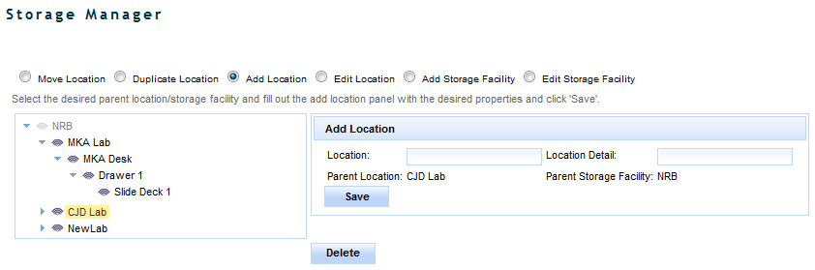

Figure 14: Storage Manager

If a Storage Facility or Location contains no samples it can be deleted. To delete a location/storage facility click on the node you would like to delete and click the ‘Delete’ button. If a storage facility/location contains samples, those samples will be displayed in a table to the right of the tree upon clicking on the node. You can edit these samples by clicking on the edit icon in the ‘Actions’ column of the table.

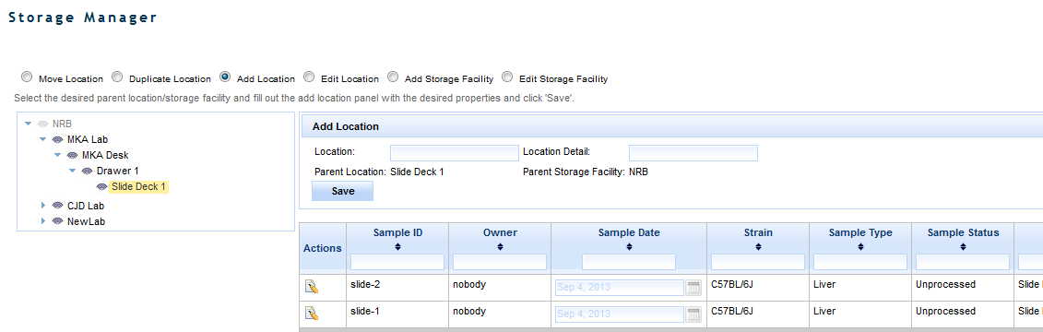

Figure 15: Storage Manager - Sample List

To add a storage facility, select the ‘Add Storage Facility’ radio button, type in the name of the storage facility, and click ‘Save’. To edit a storage facility, select the radio button, click on the storage facility you would like to edit, provide the new name, and click ‘Save’. To add a new location, click on either a storage facility or location node in the tree (this will be the parent node), provide the location type and detail, and click ‘Save’. You can also edit the location type name and detail by clicking the ‘Edit Location Type’ radio button, typing in the new location type and detail, and clicking save.

In order to edit or move a location or storage facility you must be in all the workgroups of the samples contained within that location/storage facility.

One can move locations by selecting the ‘Move Location’ radio button. To do this, click on the location you would like to move, drag it to its new location/storage facility, and drop it. This will move all the locations that reference the moved location and all samples to the new location you drop it on. Remember that to move a location you must be in the workgroups of the samples contained in the location you are moving.

One can also duplicate a location by selecting the ‘Duplicate Location’ radio button and dragging the location you would like to duplicate onto the node you would like to contain it. This will recreate the location structure in the dropped node, but will NOT duplicate any of the samples.

# Manage Colony

This module provides the ability to manage mice, matings, and litters; genotyping; mouse scheduling; and vivaria layout.

## Add Mouse

Adding mice in JCMS Web works similarly to how it works in the JCMS Access interface. After adding the first mouse and enabling auto increment ID, the mouse ID increments to the next system maintained ID (see Auto incrementing IDs below). The next mouse is ready to add. All fields are already initialized to the details entered on the first mouse. Review the content, make the appropriate updates, and save. This process can be as simple as ten mouse clicks to quickly add 10 mice to JCMS.

Notice each mouse is added to a specific owner designated by the Owner/Workgroup required field. This establishes workgroup ownership of all mice. Other users can update and report on these mice only if they have access to do so.

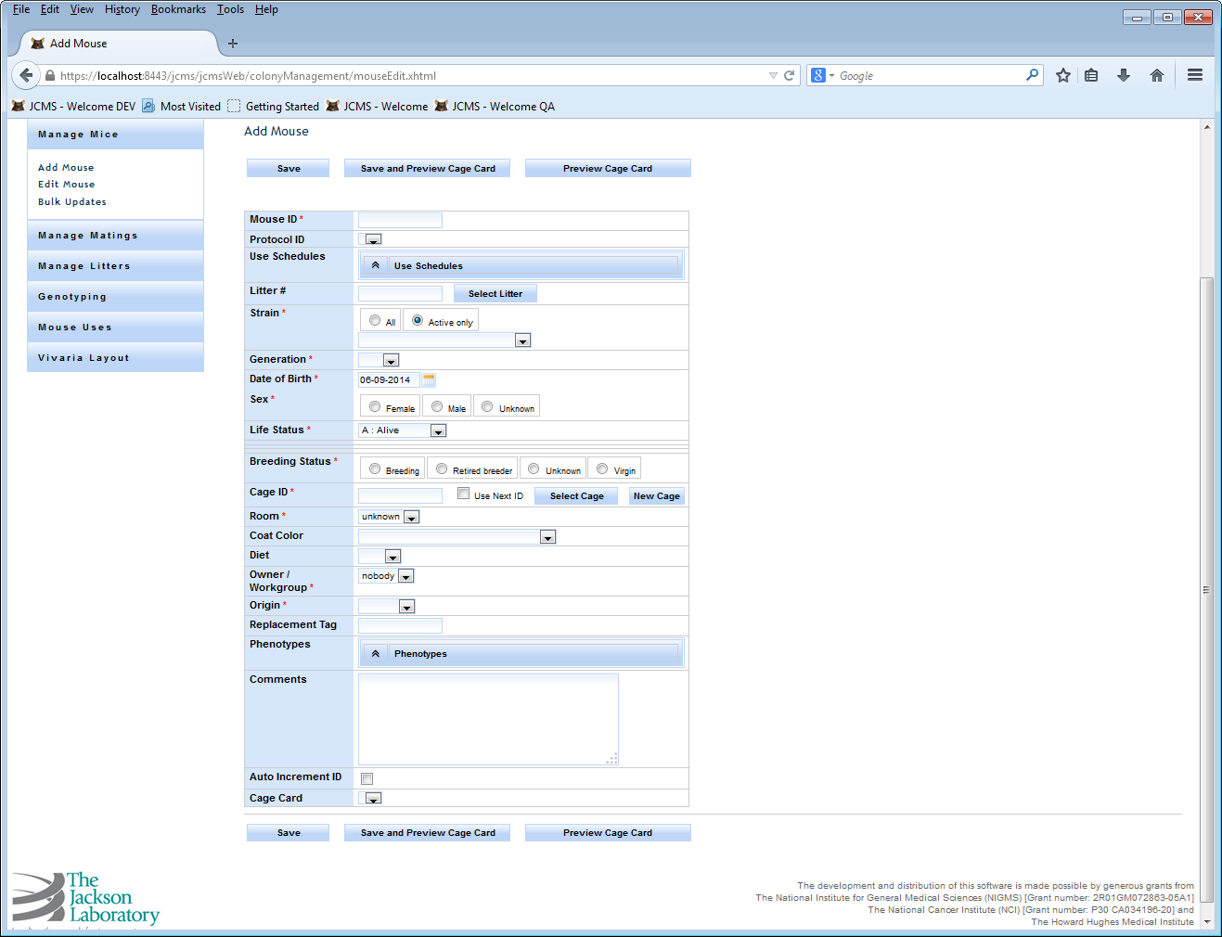

Figure 16: Manage Mice - Add Mouse

My Preferences may be used to hide and/or set a default value for some of the fields on this screen. A hidden field with a default will always have that default value added for the mouse.

Cage ID has a bundle of functionality tied to it. The recommended operation is to enable ‘Use Next ID’ to auto generate the next cage ID for the first mouse. After the first mouse is saved the second mouse pre-initialized content disables ‘Use Next ID’ so all you have to do is save again to save the second mouse in the same cage as the first. When you fill up the first cage enable ‘Use Next ID’ to get the next system cage ID and continue the process of adding mice to the second cage. With all values remaining consistent, many mice and cages can be created in a manner of minutes.

A user can enter a custom cage ID by disabling ‘Use Next ID’ and entering the value in the Cage ID field. Also available are ‘Select Cage’ and’ New Cage’ options. ‘Select Cage’ provides a way to search for and choose an existing cage. While ‘New Cage’ allows you to create a new cage capturing more detail than the automated way.

After creating a custom cage card you can select it from the ‘Cage Card’ drop down list. Select ‘Preview Cage Card’ to display this mouse detail in your custom cage card format and print it out if you like.

### Auto incrementing IDs

Enable ‘Auto Increment ID’ to auto generate the next available Mouse ID. The mouse ID must be appended with a numeric value in order to use this feature. For example, mouse ID “ABC-100” is a valid identifier.

|  |  |
| --- | --- |
| **Action** | **System** |
| User clicks the ‘Add Mouse’ link from the ‘Manage Mice’ sidebar  User clicks the ‘Edit Mouse’ link from the ‘Manage Mice’ sidebar  Mouse information is added/updated when ‘Save’ button is clicked | System displays Add Mouse Form  Data entry fields are displayed  New mouse is added to database  System displays Edit Mouse Form  Data entry fields are displayed  Mouse data is updated in the database |
| **Exceptions** | **Validation Message** |
| Mouse ID is blank | Message “Mouse ID is missing. Please enter a Mouse ID” is displayed |
| Strain is blank | Message “Strain is missing. Please enter a Strain” is displayed |
| Generation is blank | Message “Generation is missing. Please enter a Generation” is displayed |
| Date of Birth is blank | Message “Date of Birth is missing. Please enter Date of Birth” is displayed |
| Sex is blank | Message “Sex is missing. Please enter Sex” is displayed |
| Life Status is blank | Message “Life Status is missing. Please enter a Life Status” is displayed |
| Breeding Status is blank | Message “Breeding Status is missing. Please enter a Breeding Status” is displayed |
| Owner is blank | Message “Owner is missing. Please enter Owner” is displayed |
| Origin is blank | Message “Origin is missing. Please enter the Origin” is displayed |
| Cage ID is blank | Message “Cage ID is missing. Please enter a Cage ID” is displayed |

### Business Rules or Validation

1. Mouse ID must be unique otherwise the user will see an error message “Mouse ID already exists. Please choose a unique Mouse ID.”
2. Replacement Tag ID must be unique otherwise the user will see an error message “Replacement Tag already exists. Please choose a unique Replacement Tag.”
3. Date of birth is defaulted to today and cannot be in the future.
4. When litter is selected, strain and generation is auto populated.
5. Exit date cannot be before the Birth date. If Exit is in the future, then a warning is displayed.
6. Age is calculated for the Edit Mouse Form based on the following rules
   * Mouse age is calculated from exit date minus birth date. If the exit date is null, then from the difference between birth date and today’s date.
   * Days, weeks, and months are the options
   * The value is rounded to the nearest integer for days, rounded to one decimal value for weeks, and rounded to two decimal values for months.
   * Whenever birth date or exit date is revised, age is recalculated and redisplayed.
7. Auto increment Mouse ID is implemented in only the Add Mouse Form. If checked, Mouse ID needs to be able to be incremented sequentially for the next mouse to be added.
8. If Life Status is “Alive” and Exit status is false, then Exit Date, COD, and COD Notes columns disappear. If Life Status is not “Alive” and Exit status is true, then Exit Date, COD, COD Notes columns appear, and Exit Date, COD columns are required.

## Edit Mouse - Search

Edit Mouse opens with a convenient search screen for finding mice in your workgroup.

Specify an Owner/Workgroup filter to identify where you want to search for mice.

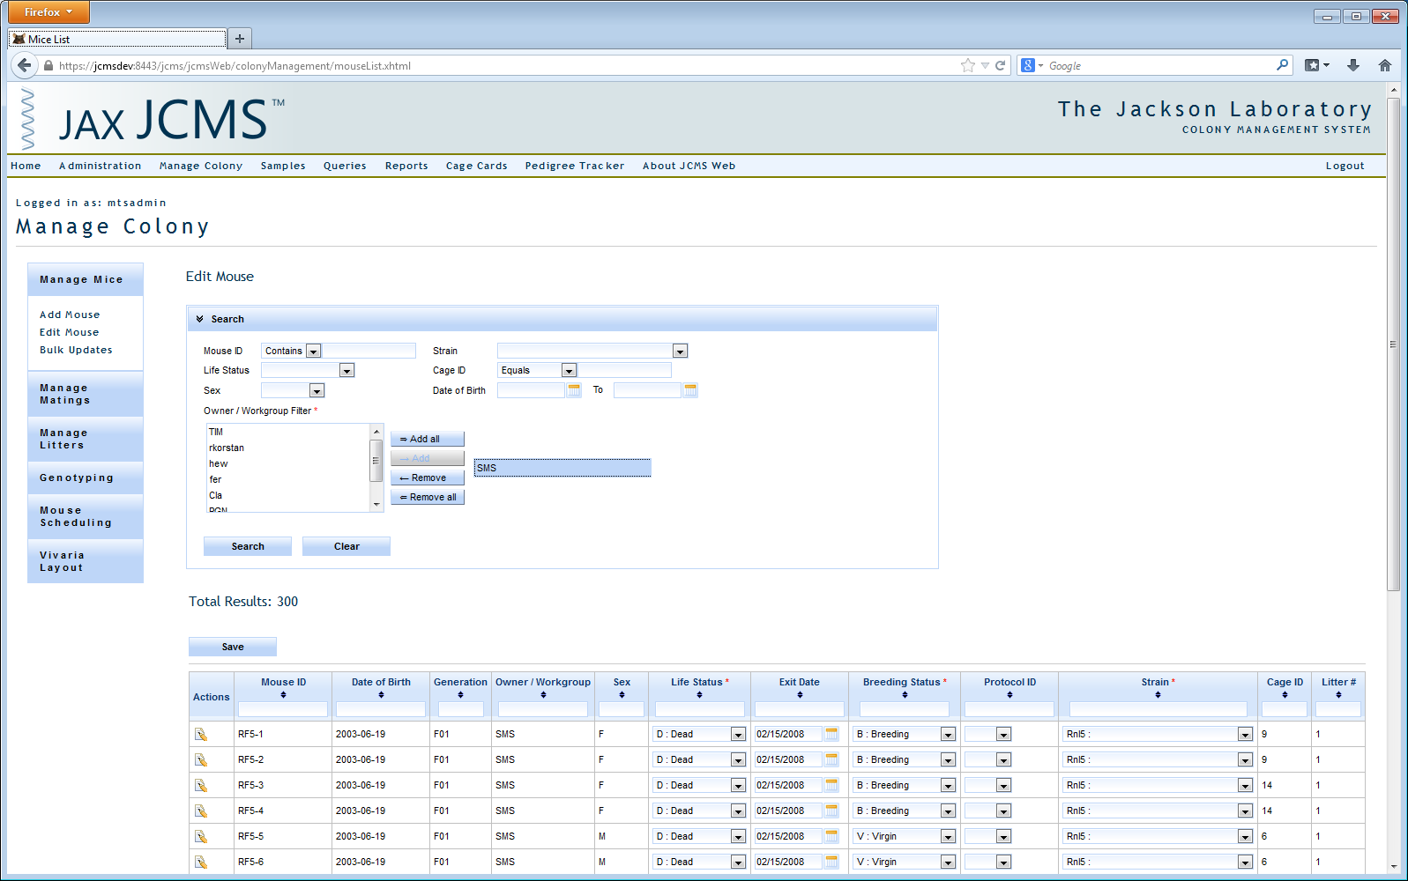

Figure 17: Manage Mice - Edit Mouse Search

Search results are displayed below the filter section in a tabular list.

Select some search criteria to avoid too many results showing up. Otherwise the user will see an error message such as “Select some search criteria”.

The following Search fields are provided: Mouse ID, Strain, Life Status, Sex, Cage ID, Date of Birth, and Owner. Clicking on the ‘Search’ button brings up the search results. Clicking on the ‘Clear’ button clears the Search criteria and search results.

To avoid performance problems, only up to 500 rows are fetched from the database at a time.

### Search results

Search results offer more functionality than just an edit and delete action.

* All the columns can be sorted in Ascending or Descending order by clicking on the column header.
* Search results can be filtered by columns by typing in the filter criteria in the columns header text box.
* Pagination of the results is provided. 15 rows are shown per page; click the page control to get to the next set of results.
* Mouse ID, Date of Birth, Generation, Owner/Workgroup, Sex, Cage ID, and Litter # are provided as read only columns in the results.
* Life Status, Exit Date, Breeding Status, Protocol ID, and Strain are provided as editable columns as selectable drop down lists in the search results.
* After making bulk edits to the editable columns in the search results, when ‘Save’ button on the right hand side is clicked, changes are submitted to the database.
* An edit icon is provided under Actions on the first column for each row. Clicking it takes you to the details of the specific mouse in the Edit Mouse form, which lets you edit all the mouse details and save the changes to the database.



Figure 18: Edit Mouse - Search Results

## Edit Mouse Form

Use this screen to make changes to any mouse record you have ownership of. Aside from the standard add functionality you’ll notice the cage ID option to use next ID is not visible. Auto generating the next cage ID is only available when you first add a mouse and for the first mouse in a series of adding mice. Cage ID is editable in case you ever need to change it or you can search for an existing cage assignment using select cage or create a new one by selecting new cage. Cage room can be updated from either add or edit mouse. Just keep in mind it does update the room for this cage system wide as you would expect. For example, there are 6 mice in cage “Blue” and you move it from building “One Room 3” to building “Two Room 5”. You can update the room by editing any one of the mice in this cage. The change affects all mice contained in the cage.

My Preferences may be used to hide some of the fields on this screen. No defaults are used when editing. When a mouse’s life status is changed to an exit status, the COD (cause of death) field will be displayed even if it is supposed to be hidden. The COD notes field is not shown, to see it, change your preference.

### Litter Search and Select Litter#

Litter search and select Litter# is the feature used by most of the manage mice forms. It works as follows.

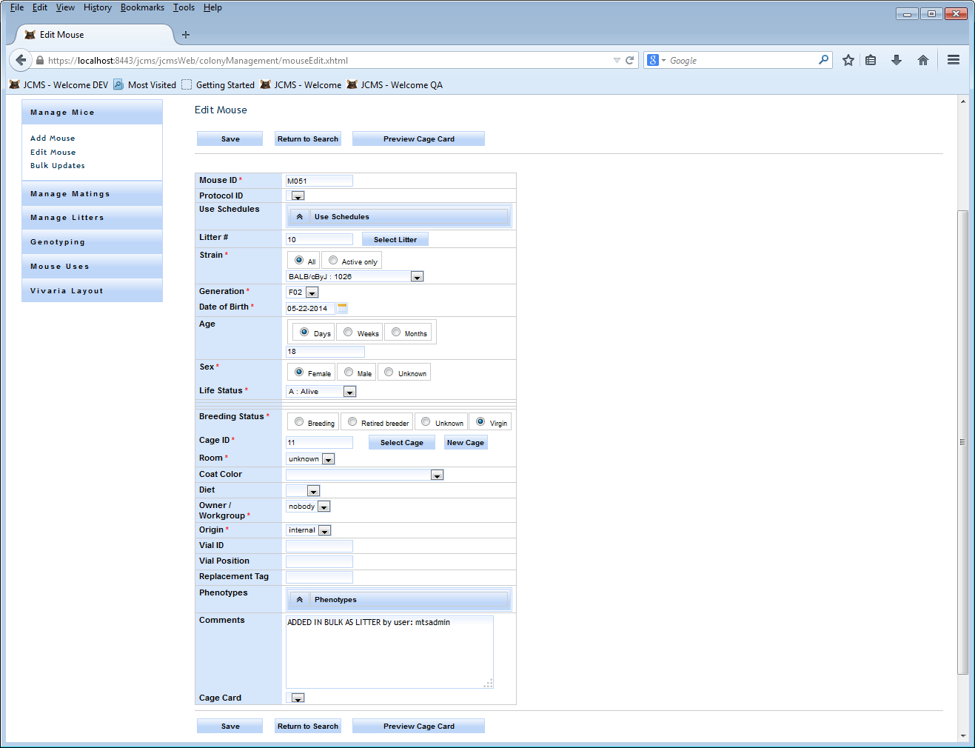

Figure 19: Edit Mouse

Litter # column has a text box where the user can directly enter or click the button ‘Select litter’. When the User clicks the ‘Select Litter’ button, the pop-up window below appears.

Select the search criteria and get the search results. Select the desired litter row, click the ‘Ok’ button, and litter ID will be populated in the form’s litter column.

Some search criteria need to be selected to avoid too many results showing up. Otherwise the user will see an error message such as “Select some search criteria”.

Litter Search has the following search columns: Litter #, Mating ID, Born After specific date, and Strain.

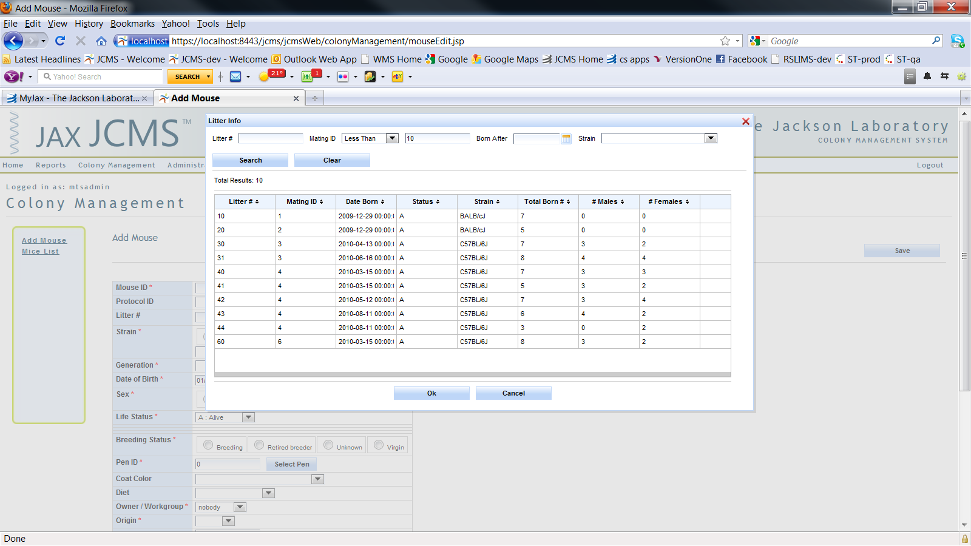

Figure 20: Edit Mouse – Select Litter

Litter Search Results has the following columns

* Litter #, Mating ID, Date Born, Status, Strain, Total Born, #Males, and #Females
* All the above columns can be sorted in Ascending or Descending order by clicking on the column header.
* To avoid performance problems, only up to 500 rows are fetched from the database at a time.

Save button

By clicking ‘Save’ the form checks for the validations and business rules described in the Add Mouse section, if successful submits the form to the database, and you see a message that “Mouse has been saved”, otherwise you will see validation error messages as discussed in the Add Mouse section.

Return to Search

This button takes you to the search results where the user came from by refreshing search data so that you can see the new changes.

### Preview Cage Card

Prior to previewing a cage card, select the Cage Cards menu option to create a custom card template for the set of mice you would like to print cage cards for. Refer to the Cage Cards section for more information.

Once you have created a cage card template you should select it prior to selecting preview cage card.

## New Cage

By clicking the ‘New Cage’ button on the Add Mouse or Edit Mouse forms, you will be able to add new cage to the database as follows.

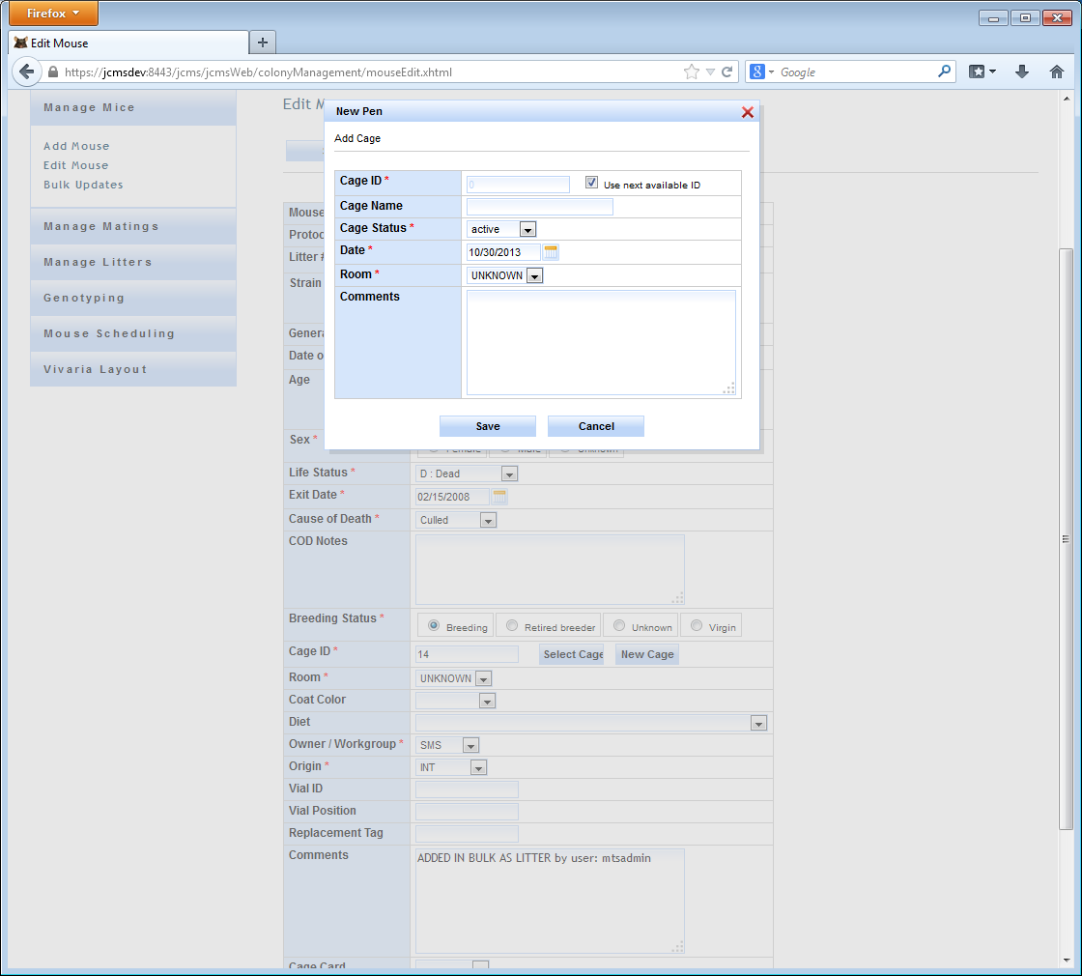

Figure 21: Edit Mouse - New Cage

| **Action** | **System** |
| --- | --- |
| User clicks the ‘New Cage’ button in the parent form  Cage information is added when ‘Save’ button is clicked  Cage information is added when ‘Save and Close’ button is clicked | System displays New Cage form  Data entry fields are displayed  New cage is added to database, lets user add multiple cages  New cage is added to database and pop-up window closes |
| **Exceptions** | **Validation Message** |
| Cage ID is blank | Message “Cage ID is missing. Please enter a Cage ID” is displayed |
| Cage Status is blank | Message “Cage Status is missing. Please enter a Status” is displayed |
| Date is blank | Message “Date is missing. Please enter a Date” is displayed |
| Room is blank | Message “Room is missing. Please enter a Room” is displayed |

### Business Rules or Validation

* Date defaulted to today and cannot be in future.
* Cage ID must be unique otherwise the user will see an error message “Cage ID already exists. Please choose a unique Cage ID.”
* When next available Cage ID is checked, Cage ID text box is disabled and it auto populates the next Cage ID.

## Add Mating

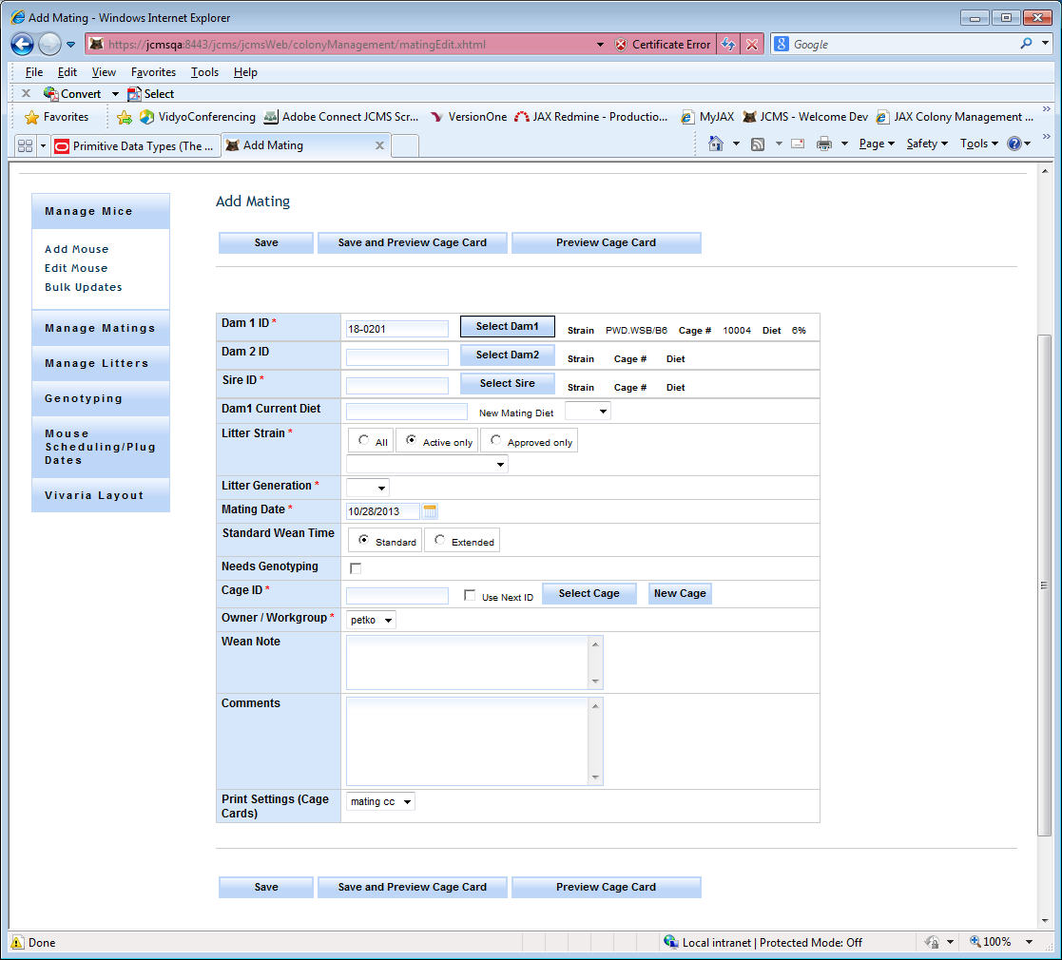

Figure 22: Add Mating

|  |  |
| --- | --- |
| **Action** | **System** |
| User clicks the ‘Add Mating’ link from the ‘Manage Matings’ sidebar  ‘Save’ button is clicked | System displays Add Mating Form  Data entry fields are displayed  New Mating is added to database |
| **Exceptions** | **Validation Message** |
| Dam1 ID is blank | Message “Dam1 ID is missing. Please enter a Dam1 ID” is displayed |
| Sire ID is blank | Message “Sire ID is missing. Please enter a Sire ID” is displayed |
| Litter Strain is blank | Message “Strain is missing. Please enter a Strain” is displayed |
| Litter Generation is blank | Message “Generation is missing. Please enter a Generation” is displayed |
| Mating Date is blank | Message “Mating Date is missing. Please enter Mating Date” is displayed |
| Owner is blank | Message “Owner is missing. Please enter Owner” is displayed |
| Cage ID is blank | Message “Cage is missing. Please enter a Cage ID” is displayed |

### Business Rules or Validation

1. Dam1 is required and you need to select the female mouse from the ‘Select Dam1’ pop-up search window.
2. Dam2 is defaulted to the Dam1 strain in the search criteria in the pop-up search window.
3. Sire ID is required and you need to select the male mouse from the ‘Select Sire’ pop-up search window.
4. Mating Date is defaulted to today and cannot be in the future.
5. Dam 1 Current Diet is displayed when Dam 1 is selected. In case you want to update Dam(s) and Sire with a new diet, New Mating Diet is displayed as a drop down and can be selected.
6. Mating ID is auto-generated once the Save button is clicked and validation is successful.
7. Mating Status is set to Active by default for new matings.
8. Litter Strain rules as follows

Dam1 and Sire ID need to be selected prior to selecting the litter strain.

If the setup variable called JCMS_ENFORCE_APPROVED_MATINGS is true, then the ‘approved only’ radio button is selected by default. The approved strains registry will be checked for the selected Dam(s) and Sire strains in order to populate the Litter strain choices. The user may change this option to show either ‘All’ or ‘Active’ strains as Litter strain choices.

If Dam(s) and Sire are of the same strain, the litter strain will be the same strain too.

### Dam/Sire ID Search and Selection

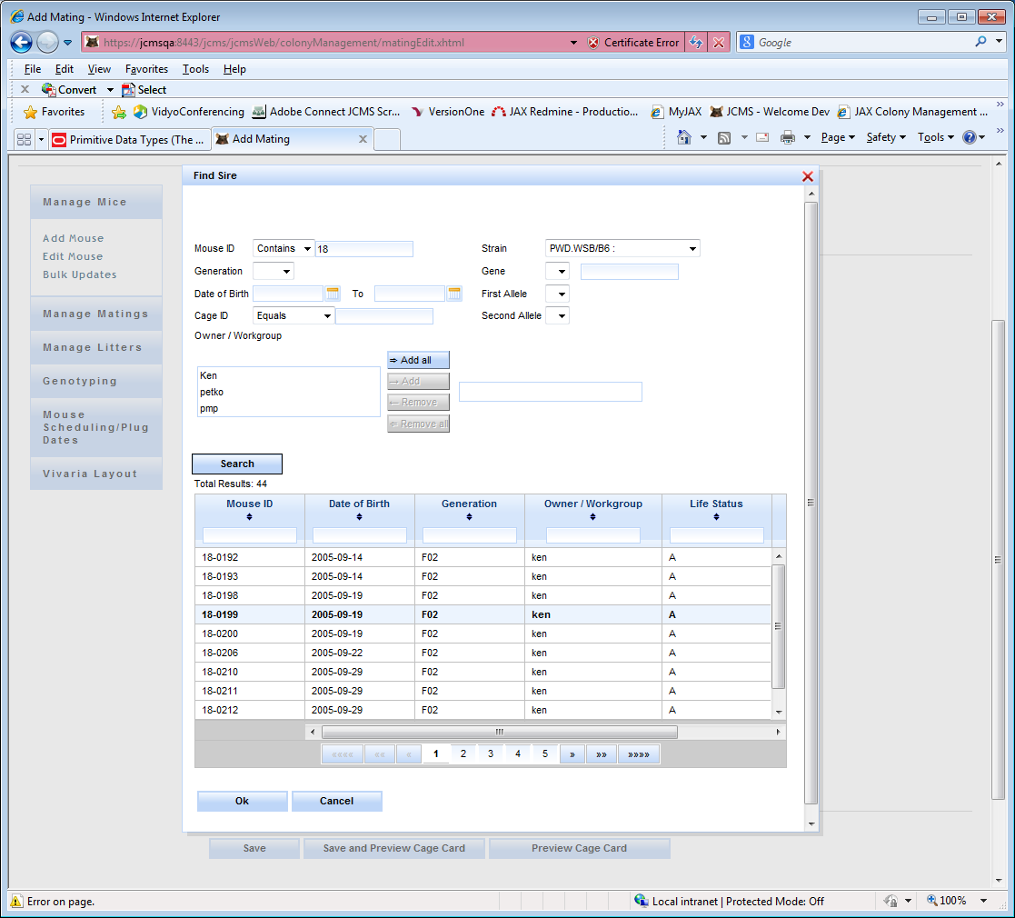

Figure 23: Add Mating – Select Dam/Sire

Dam / Sire ID column is a text box that the user can directly type in or click the button ‘Select Dam1/Dam2/Sire’. When you click ‘Select’ on the Add Mating Form, the pop-up window in the figure above appears.

Search criteria can be selected and you get the search results by clicking the ‘Search’ button. Life Status is defaulted to “Alive”. The desired row can be selected and when you click the ‘Ok’ button, the Mouse ID will be populated in the Dam/Sire ID column.

Some search criteria need to be selected to avoid too many results showing up.

Search Results has the columns: Mouse ID, Date of birth, Generation, Owner/Workgroup, Life Status, Breeding Status, and Diet.

* All the above columns can be sorted in Ascending or Descending order by clicking on the column header.
* To avoid performance problems, only up to 500 rows are fetched from the database at a time.

## Edit Mating

Use this screen to make changes to any mating record you have ownership of. You are first presented with a search screen where you can enter criteria for Owner(s), Mating ID, and Mating Status. Only 500 rows are returned at one time.

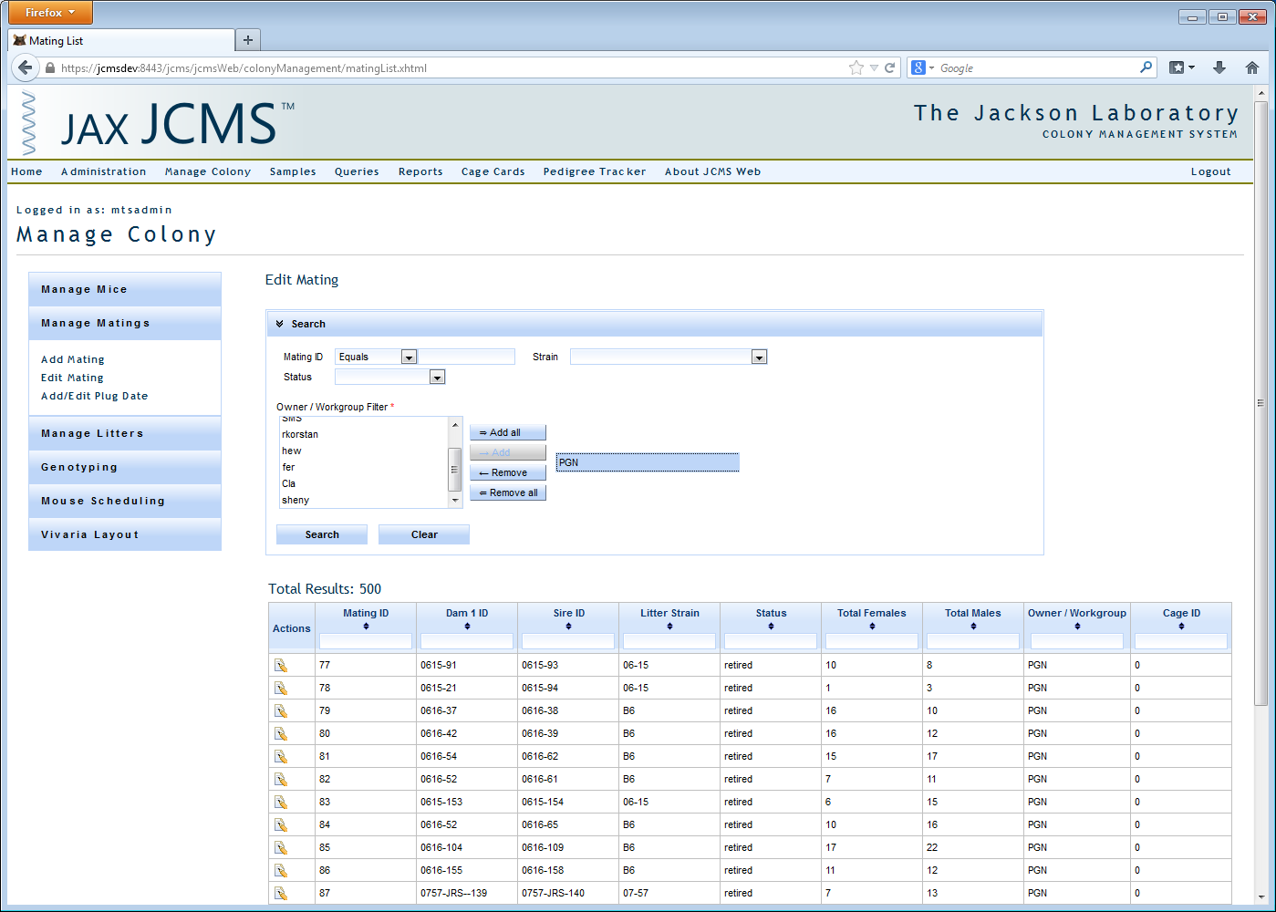

Figure 24: Select Mating for Editing

You must then click the edit icon next to one of those matings and you will be brought to the edit mating page.

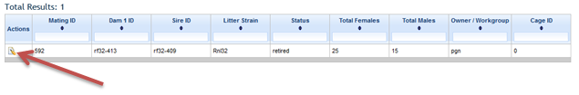

Figure 25: Edit Icon

You’ll notice that the form appears somewhat like the Add Mating form with a few exceptions. At the very top of the form there is a ‘Mating ID’ input field that contains a list of all the matings that you own. To change the mating you are currently editing simply change this field’s value by clicking on ‘Select Another Mating’, typing in or selecting a value, and tabbing out of the field. The remainder of the page will update itself with the information for that particular mating and its mice. If you wish to update the mating with the next mating ID (current mating ID + 1) just click the ‘Next’ button, and if you wish to edit the previous mating click ‘Previous’. In order to not lose any changes, before navigating away from this mating by leaving the page or moving on to another mating be sure to click the ‘Save’ button at the top of the page.

In the Dam 1, Dam 2, and Sire panels you’ll see a Cage ID link and an ‘Edit Diet’ button. Clicking the link will show a pop up that allows you to change the cage where that mouse currently is and specify information for that cage such as its name, status, comments, etc. If you click the ‘Edit Diet’ button a drop down list will be shown containing all the diet options that are available in your database. You can change the mouse’s diet by selecting the desired diet from the drop down and clicking the ‘Save Diet’ button. Another feature of the Dam 1, Dam 2, and Sire panels is that should a user change any of the mice in that mating, a new row will appear containing the information for the mouse that was originally associated with that mating, in case it was mistakenly changed.

There is a Retired Date field that corresponds to the date the mating was retired. At the moment there is no printing cage card functionality on this page.

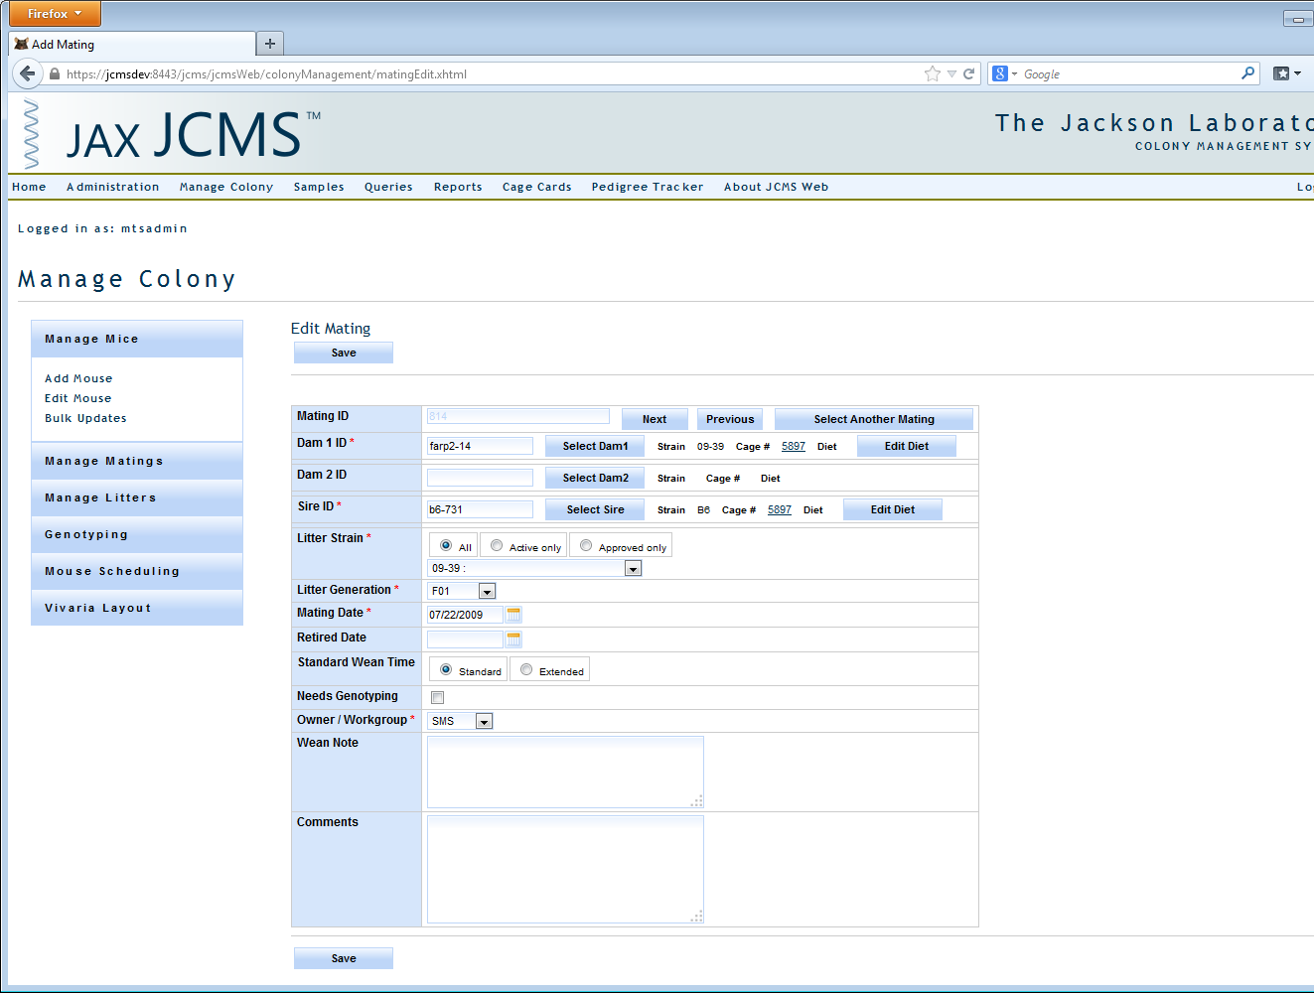

Figure 26: Edit Mating

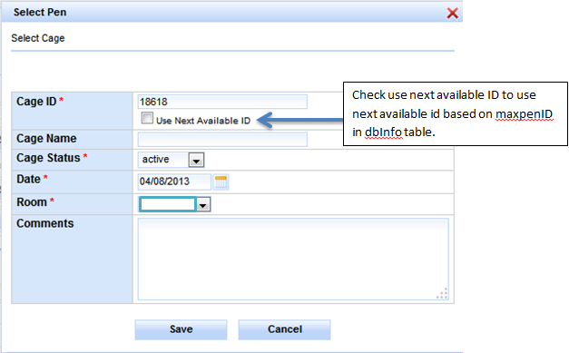

Figure 27: Select Cage

## Add Litter with Pups

Click ‘Manage Litters’ and ‘Add Litter with Pups’ choices.

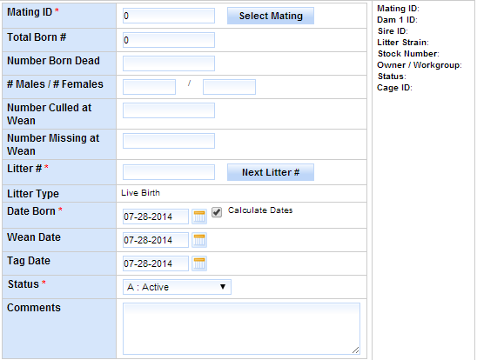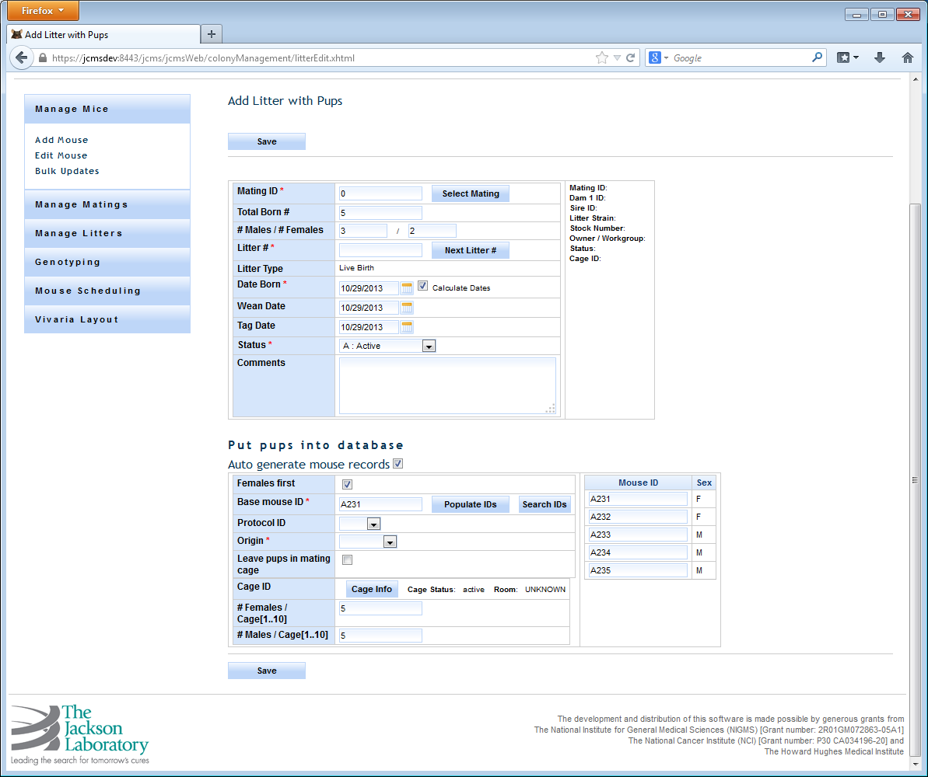

Figure 28: Add Litter with Pups



Figure 29: Add Litter with Pups (lower portion)

|  |  |
| --- | --- |
| **Action** | **System** |
| User clicks the ‘Add Litter with Pups’  Litter information is saved when ‘Save’ button is clicked | System displays Add Litter with Pups Form  Data entry fields are displayed  New Litter is added to database |
| **Exceptions** | **Validation Message** |
| Mating ID is blank | Message “Mating ID is missing. Please enter a valid Mating ID” is displayed |
| Total Born # is blank | Message “"Total Born # is missing, Please enter Total Born #” is displayed |
| # Males / # Females is blank | Message “# Males is missing. # Females is missing.” is displayed |
| Litter # is blank | Message “Litter # is missing, Please enter Litter #” is displayed |
| Date Born is blank | Message “Date Born is missing. Please enter Date Born” is displayed |
| Status is blank | Message “Status is missing. Please select a Status” is displayed |
| Origin is blank | Message “Origin is missing.” is displayed |
| Base mouse ID is blank | Message “Base mouse ID is missing. Please select a Base mouse ID” is displayed |

### Business Rules or Validation

1. Total Born # needs to be a valid number > 0.
2. # Males and # Females cannot be greater than Total Born #.
3. Total Born #, # Males, and # Females are required or need to be a valid number > 0 only if pups are entered, otherwise optional.
4. Limit # Males to <= 10 and # Females to <= 10 otherwise show error message “Number of males and females cannot be greater than 20”.
5. Date born is defaulted to today and cannot be in future.
6. Wean Date is defaulted today’s date. Once mating is selected, if Mating’s wean time is true, then standard wean time (18) days are added to today’s date or when false extended wean time (28) days are added to today’s date.
7. Tag Date is defaulted to today’s date. Once mating is selected, if Mating’s wean time is true, then standard wean time (18) days are added to today’s date or when false extended wean time (28) days are added to today’s date.
8. Auto generate mouse records is defaulted to true. When true generate pups and cages in the database for the litter. When false, do not generate any pups. Pups section will be hidden.
9. Female’s first checkbox defaulted to true. When true process females first and then males or vice versa when false.
10. Leave pups in mating defaulted to false. When false, Create new cagefor

* The set of males and
* The set of females and
* When the max limit per cage is reached.

When true,use the same mating cagebut if the mating cage is retired, gives an error message “The mating cage is retired. Unable to keep pups in a retired cage”. When true, Cage ID, # Females per Cage, and # Males per Cage fields are hidden.

1. # Females or # Males / Cage cannot be greater than the value of the setup variable “MTS_MAX_MICE_PER_PEN”.
2. Cage ID is used if ‘Leave pups in mating pen’ is false. Clicking the button ‘Cage Info’ populates a pop-up form which provides cage information and generates next available Cage ID whenever necessary, otherwise use default cage information.
3. Base Mouse ID provides a valid first Mouse ID for the pups. ‘Search IDs’ is a pop-up search form that provides search criteria for Mouse ID, Life Status, Strain, and Owner. When a Mouse ID is selected from the results, it generates a base mouse ID by incrementing it and if it is valid unique mouse ID, then populate it as the base mouse ID otherwise leave it blank.

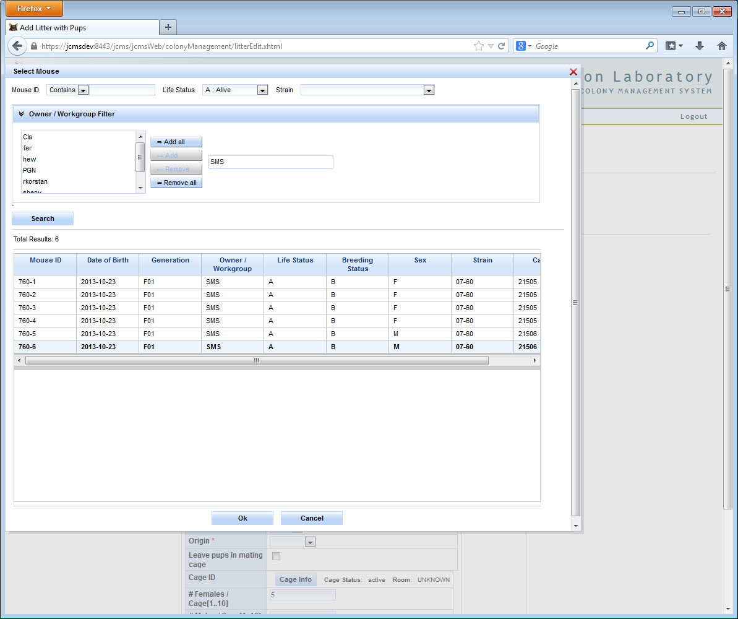

Figure 30: Add Litter - Mouse Search

1. ‘Populate IDs’ will use the base Mouse ID if it exists and show the mouse ID’s that will be used for the pups as follows.

* Clicking ‘Populate IDs’ takes the Base Mouse ID and shows the list of Mouse IDs that will be created.
* If the Base Mouse ID is blank, get the maxAutoMouseID value from the dbInfo table, append it to the value of the setup variable “MTS_MOUSE_ID_PREFIX”, and shows the list of Mouse IDs that will be created.
* The list of Mouse ID’s to use may be manually edited before saving the pups.

## Edit Litter

Edit Litter starts by providing search criteria to search for the litter.

Search criteria need to be selected to avoid too many results showing up. Otherwise the user will see an error message such as “Select some search criteria”.

The following Search columns are provided:

Litter #, Mating ID, Born After specific date, Owner, and Strain

Clicking on the ‘Search’ button brings up the search results. Clicking on the ‘Clear’ button clears the Search criteria and search results.

To avoid performance problems, only up to 500 rows are fetched from the database at a time.

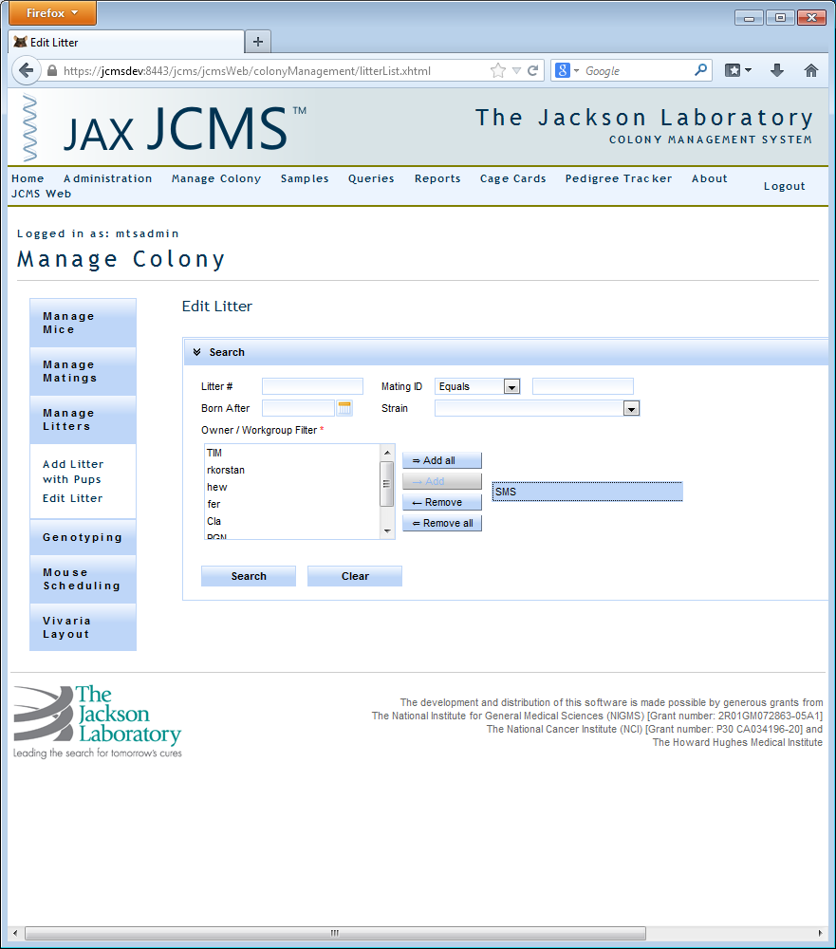

Figure 31: Edit Litter - Litter Search

### Litter Search Results

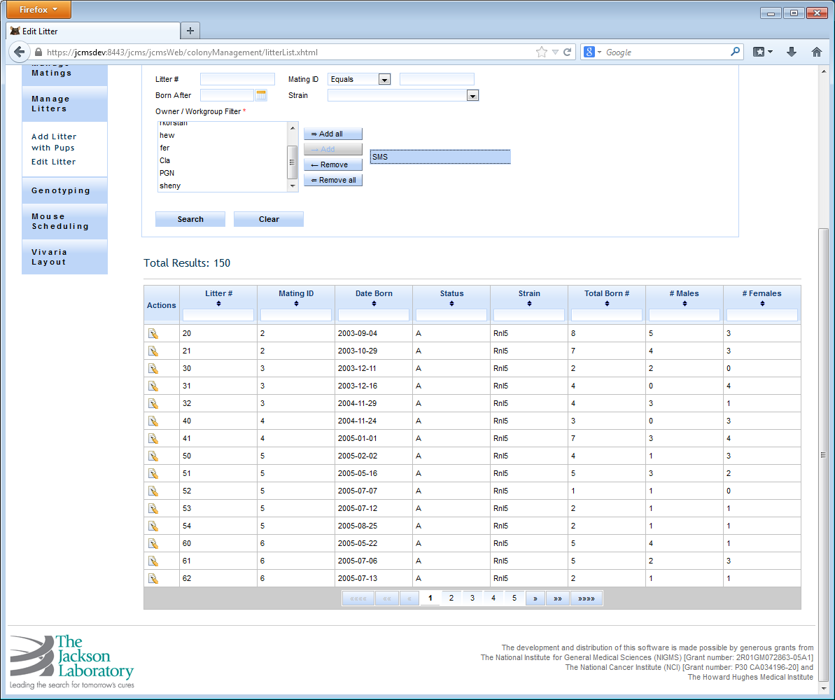

Figure 32: Litter List/Edit Litter - Search Results

Litter Search Results

* All the above columns can be sorted in Ascending or Descending order by clicking on the column header.
* Search results can be filtered by typing in the filter criteria in the columns header text box.
* Pagination of the results is provided. 15 rows are shown per page; click the pager control to get to the next set of results.
* Litter #, Mating ID, Date Born, Litter Status, Strain, Total Born #, # Males, # Females are provided as read only columns in the results.
* Clicking on the Edit icon for a row takes you to the Edit Litter form.

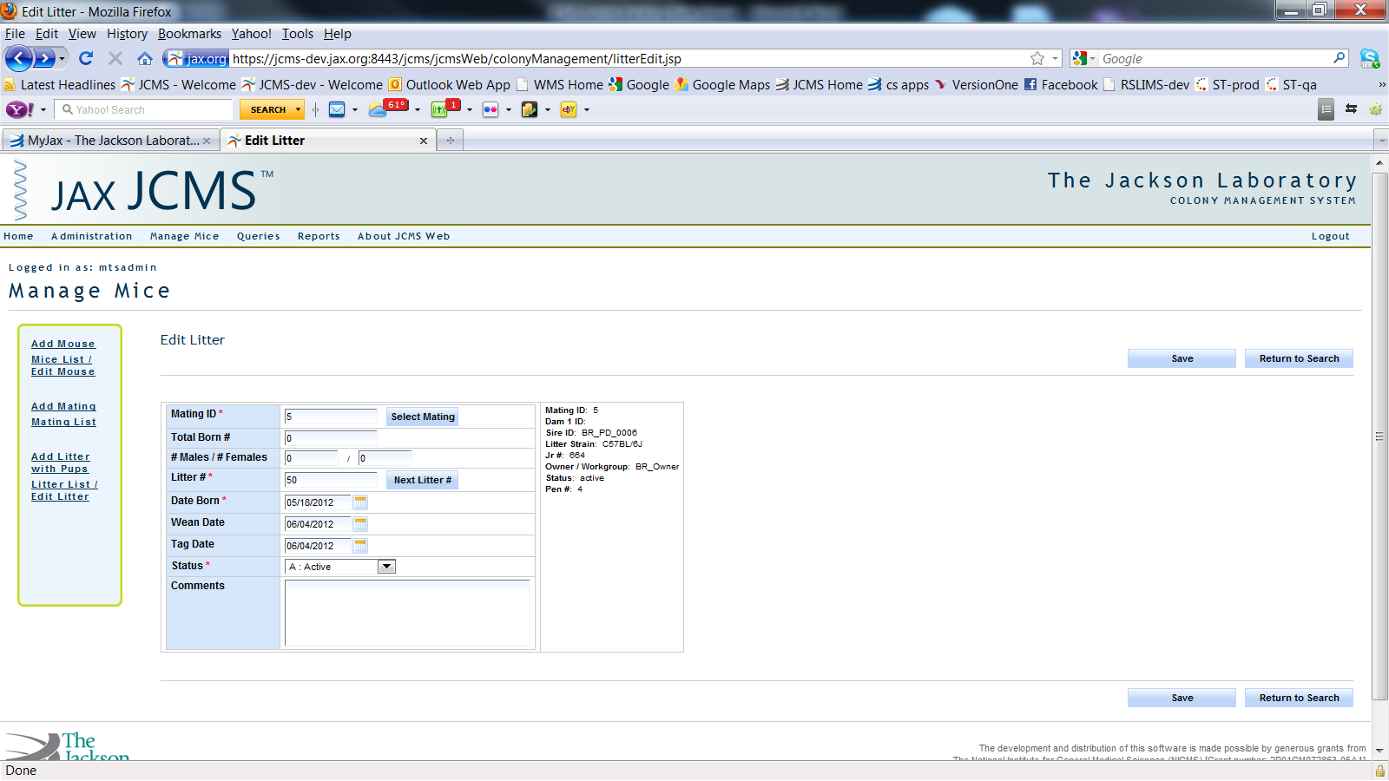

Figure 33: Edit Litter

Edit litter:

* Form lets user edit Litter information and add pups to an existing litter.
* Click the ‘Save button’, the form checks the validations and business rules. If successful, the changes are made to the database and the user sees a message that “Litter has been updated”, otherwise the user will see validation error messages as discussed in the above section.
* Click the ‘Return to Search’ button to go back to the search results where the user came from.

## Add Genotype

This module provides the functionality to add genotypes to mice. A search panel is provided for finding a mouse or list of mice.

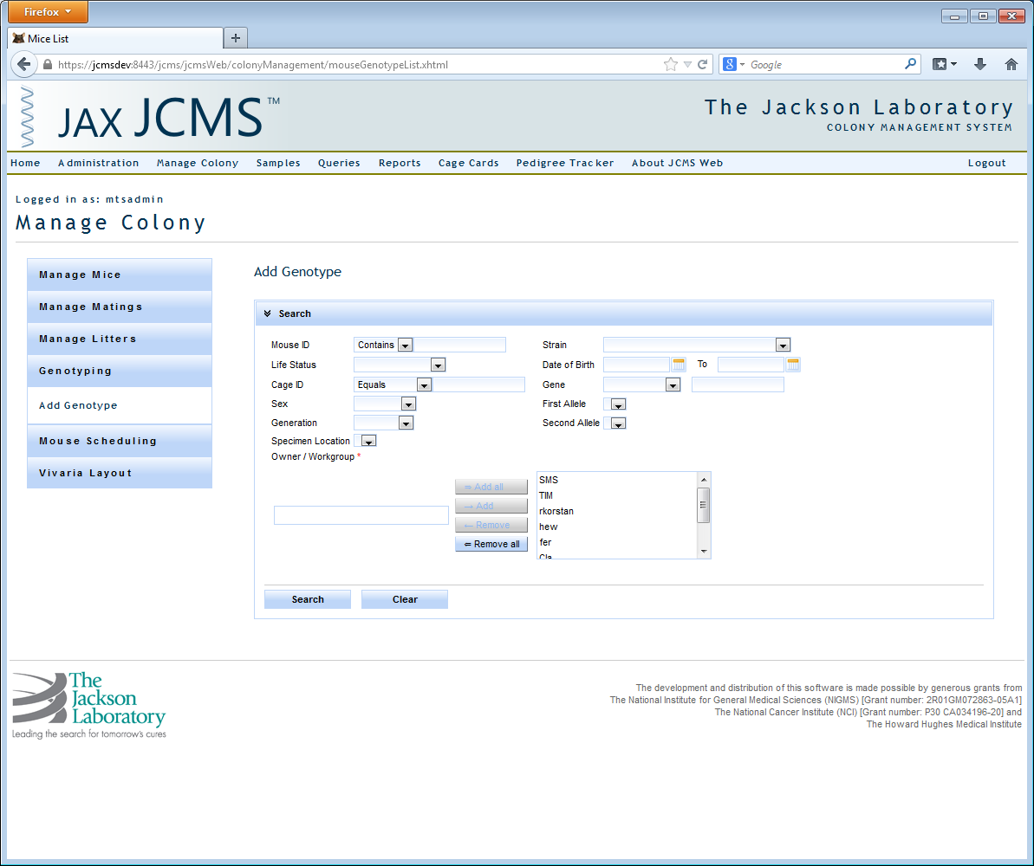

Figure 34: Add Genotype - Search

The format of the gene filter is different from some other filters. The equals filter is a drop down list of genes and you activate the filter by selecting a gene from the list. The “contains” filter is a text field just to the right of the “equals” filter where you can enter the partial text of a gene name. If filters are entered for both the search query will get all genotypes with the selected gene and all the other genotypes containing the entered filter. When specifying a genotype filter using gene, first allele, or second allele only mice with genotypes matching this criteria are returned. If you are looking for mice only, opt out from specifying a genotype filter.

Select search to execute the query. Search results will display below. Click on the search header to collapse the search filter providing more room to view search results.

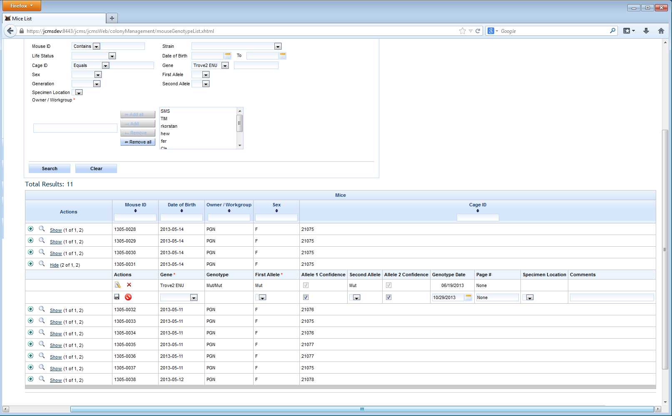

Figure 35: Genotype Search Results

In the actions column, you may have an option to add a genotype, search genotypes, or show/hide genotypes. By clicking the show link, a sub table of genotypes matching the filter criteria for this Mouse ID is displayed. From here a genotype can be edited or deleted for the parent mouse. Add genotype automatically expands the sub table and inserts a new genotype row for you to fill out and save. Search genotype provides a more robust search engine than the general search mechanism located at the top of the Add Genotype screen. In this release, the numbers of genotype results are constrained to 10 genotype records per mouse. In the future, a feature is planned allowing a user to advance through all sets of genotypes returned by the query. When adding a new genotype, gene and first allele are required, and a new genotype must be saved prior to adding another.

In this example below, the text “Show (6 of 6, 6)” needs some explanation. The first number is the total number of genotypes returned matching the genotype filter not to exceed the maximum of 10. The second number, of 6, is the total number of genotypes matching the genotype filters for this mouse. The last number represents the total number of genotypes associated to this mouse.

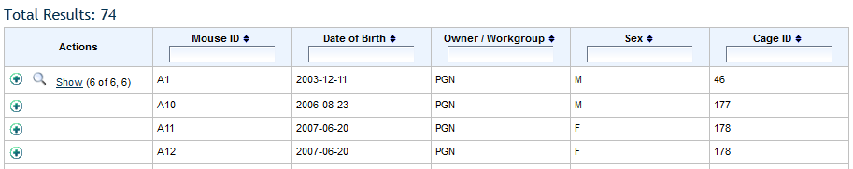

Figure 36: Add Genotype – Show Link

### Edit Genotype

Clicking the edit icon provides a simple pop up of a single genotype where you can change values and save. Changes are reflected on the main list after the edits are saved.

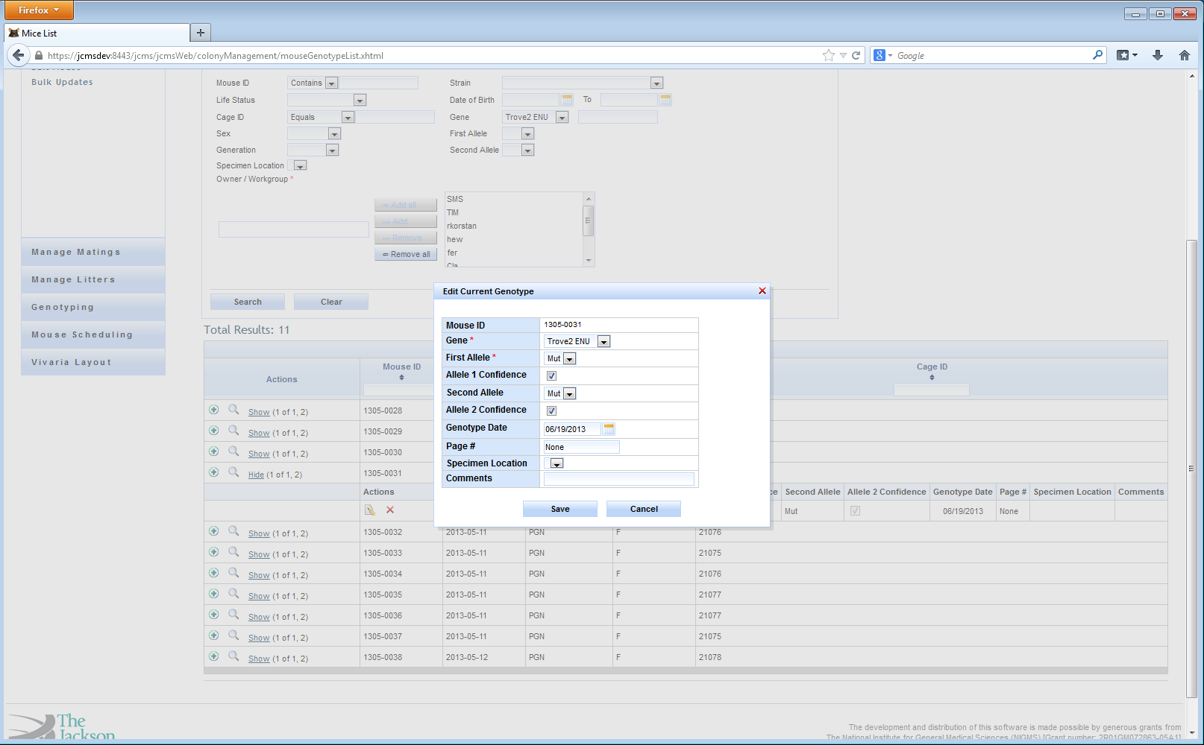

Figure 37: Edit Genotype

## Mouse Scheduling

Mouse Scheduling can be reached through the Manage Mice sidebar by clicking on the ‘Mouse Scheduling’ link.

### Add Mouse Use

This form allows users to schedule, edit, and delete uses for their mice such as necropsy or clinical exams.

A user must first select a mouse which can be done by either typing in a mouse ID in the Mouse ID input field or by searching for and selecting a mouse using the ‘Select Mouse’ button. The only other field that is required to add a mouse use is to select a use from the use drop down directly below the mouse ID input.

The field below use is ‘Use Age Determination’ which can be either Manually Entered or calculated from plug date and DPC (days post conception). If you are manually entering the use age you can simply type in a value in the ‘Use age in’ input and upon tabbing out you will notice that the projected date is automatically calculated by adding the Use Age In to the selected mouse’s birth date. If you instead choose to calculate based on plug date and DPC you will see a new row appear that has a drop down for DPC and a drop down containing the animal’s plug dates that have been inserted into the database. After selecting a plug date and a DPC value the projected date and use age in will be automatically calculated based on the DPC added to the plug date (for the projected date) and projected date minus the mouse’s birth date to calculate the use age.

The observed data columns are for the data associated with the scheduled use and the labels for the observed data will be changed according to what the selected use was.

The final two fields that need to be explained are the ‘On Submit Don’t Clear Data’ checkbox, which can be selected. Then, upon saving, the information in the form is not cleared.

To add the use to the mouse, simply click the save button located at the top and bottom of the form.

When the ‘Auto Increment ID’ checkbox is selected, a user can add the same use to a series of mice by repeatedly clicking ‘Save’.

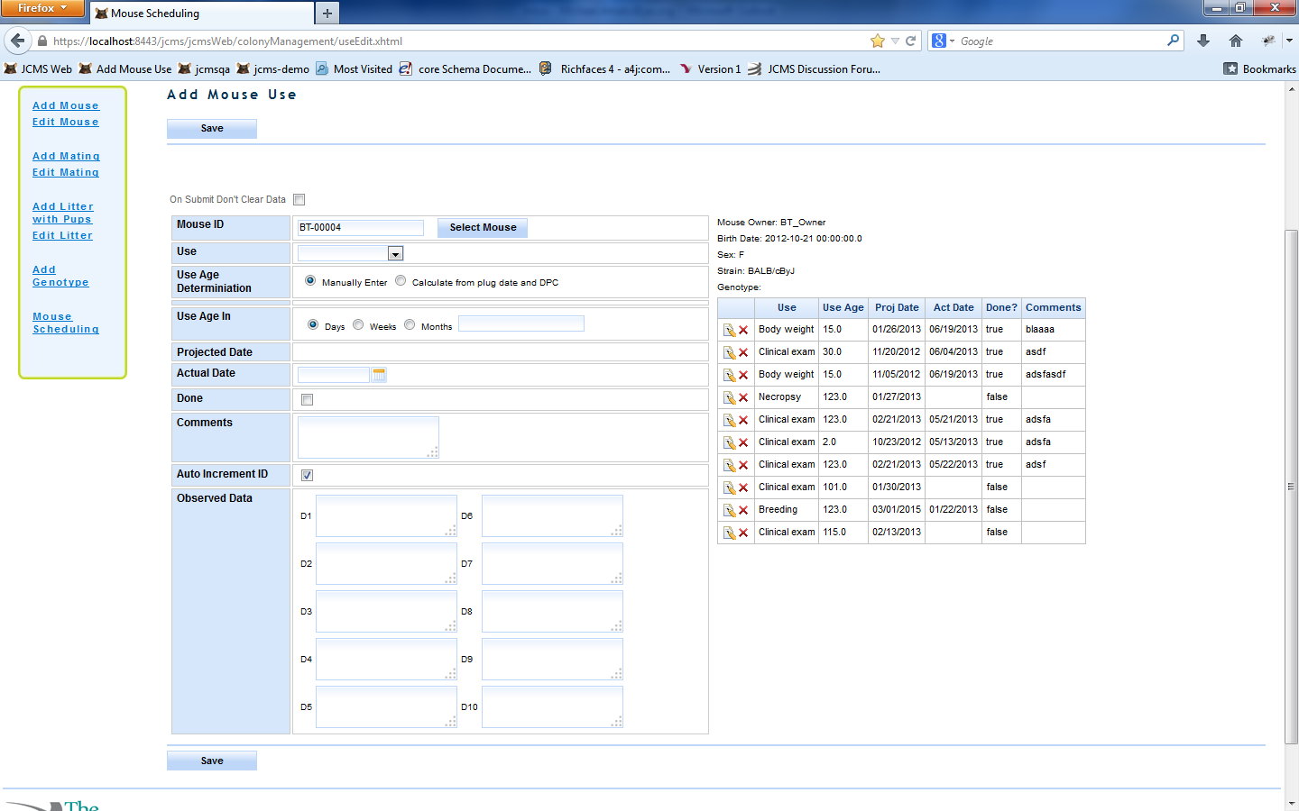

Figure 38: Mouse Scheduling

### Edit Mouse Use

To edit a use click the edit icon next to the use in the table of Mouse Uses to the right of the form, make the desired changes and click the Save button at either the top or bottom of the form. If you do not wish to make any edits simply click the cancel icon next to the use in the use table.

### Delete Use

To delete a use click the delete icon (red ‘X’) in the Mouse Uses table to the right of the form and you will be prompted to confirm the delete. Confirm you wish to delete (or cancel if you do not wish to delete) and the use will be deleted.

## Mouse Scheduling Calendar

This module is a Calendar view of the different mouse uses that are scheduled. It is found in the Reports interface. First criteria must be selected to populate the calendar from Mouse Uses, Owners, Strains, and Use statuses. After the Display Calendar button has been pressed the Calendar will populate and be displayed below the search box.

In the Calendar view a yellow use implies the date is based on projected date, a blue use implies the use is based on the actual date. If a user drags a use to a different day the actual or projected date is changed depending on whether the use is based on actual or projected date. A user can also edit the details of a use by clicking on the use and changing the data in the editable fields in the pop up.

### Add Use

From the calendar view a user can add a use to a day by clicking on that day and selecting a mouse and use. Either a projected date or actual date or both must be given to add a use from this particular view.

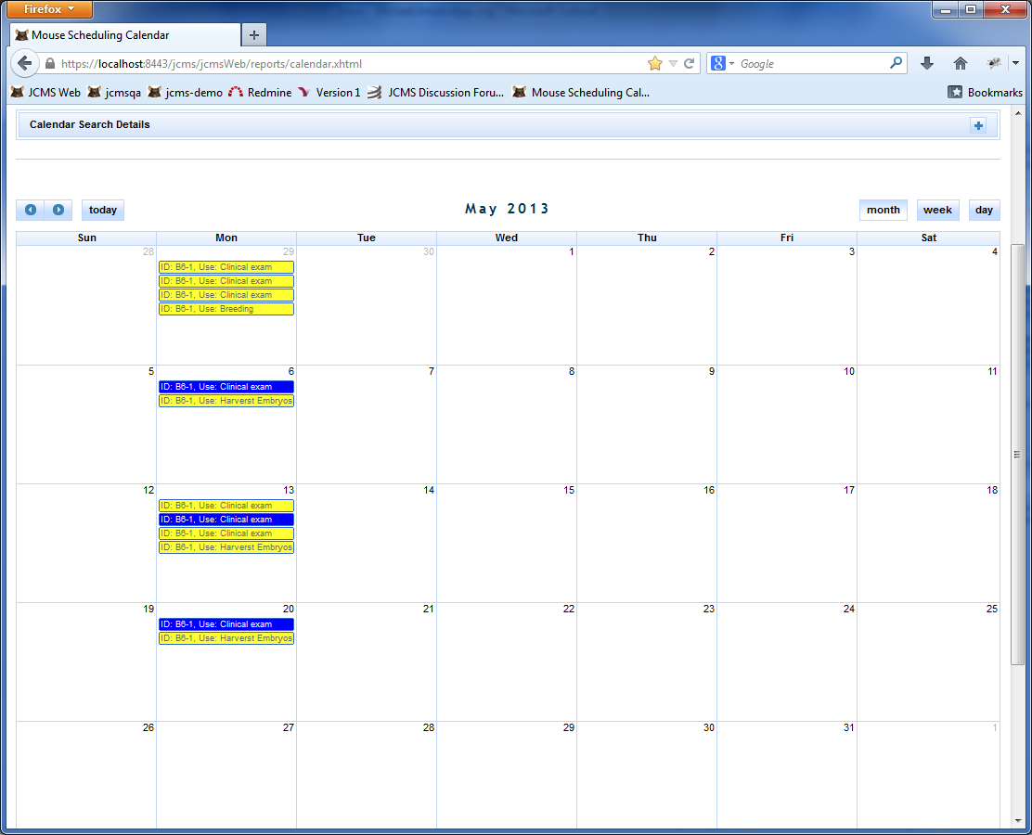

Figure 39: Mouse Use Calendar

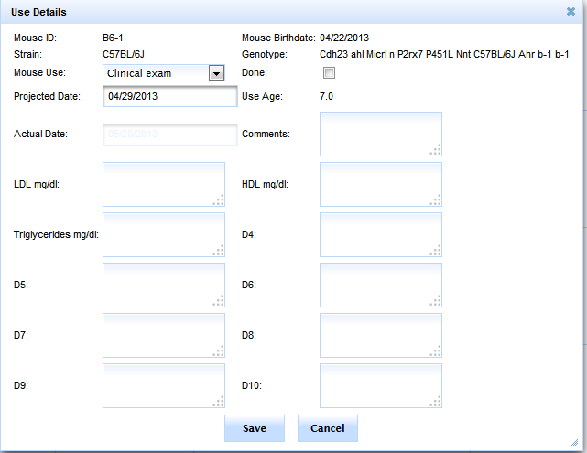

Figure 40: Edit Mouse Use on Calendar

### Projected Wean Dates

To view projected wean dates check the ‘Display Projected Wean Date’ check box and then select a time period starting from the first selected date to the second selected date.

After clicking ‘Display Calendar’ a calendar will appear with the number of wean dates and uses printed above the calendar. On the calendar all the pink boxes represent projected wean dates. A projected wean date can be caused by one of three things:

1. There exists an active mating that has not produced a litter in the wean time (either standard or extended depending on what’s recorded in the database for the mating) plus the gestation period.
2. There exists an active litter that does not have a wean date recorded for it. The wean date will be projected to be the birthdate plus the wean time (extended or standard depending on the mating that created it).
3. There exists an active litter that does have a wean date but does not have any pups associated with it in the database.

When you click on one of the pink wean dates on the schedule you will see a panel pop up like the one below:

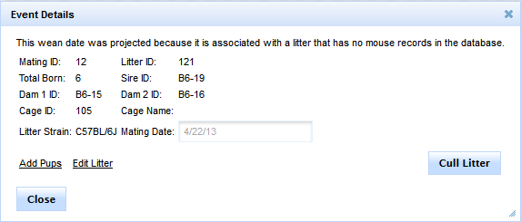

Figure 41: Projected Wean Date Pop Up

The links and buttons will change according to what caused the projected wean date. If the wean date was related to a mating that hasn’t produced a litter the Cull Litter button will read ‘Retire Mating’. Clicking cull litter will automatically change the litter status to ‘Harvested’ and remove it from the calendar view. Clicking ‘Retire Mating’ will set the litter status to retired, set the retired date to today’s date, and remove the projected wean date from the calendar.

## Plug Dates

The plug date module can be accessed by navigating to ’Manage Colony’, then ‘Manage Matings’, and clicking on the ‘Add/Edit Plug Date’ link in the sidebar.

### Add Plug Date

To add a plug date, type a mating ID in the mating ID field and tab out. This will load the mating information and you will see a screen that appears as shown below.

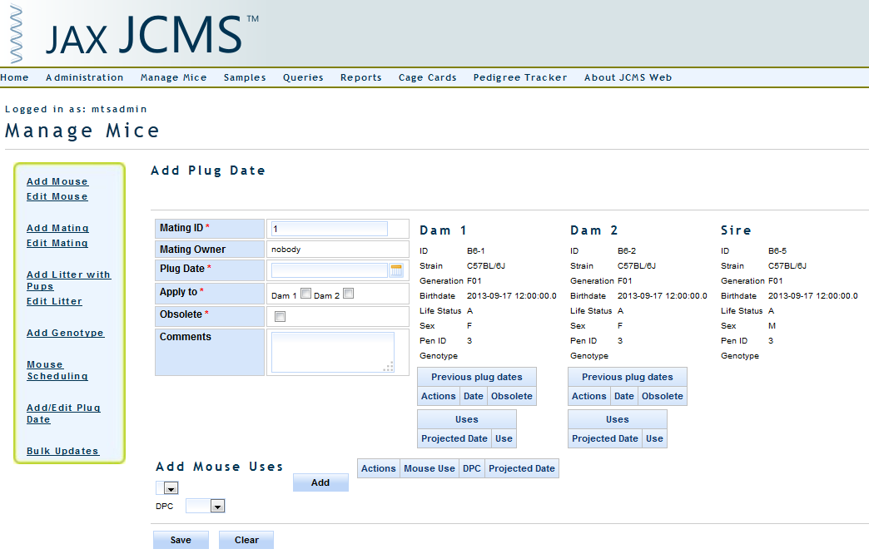

Figure 42: Add Plug Date

Select the plug date, which Dams to apply it to and whether it is obsolete, hit save, and you will have added the plug date(s). You can add mouse uses directly from this page that will be associated with the plug date you add, by selecting the mouse use you would like to add, a number of days post conception (DPC) and clicking the add button. Upon saving the plug date it will save all the uses you’ve added as well.

### Edit Plug Date

To edit a plug date type in the mating ID that the plug date is associated with and tab out. Then click the edit icon next to the plug date you wish to edit, your screen will appear as below.

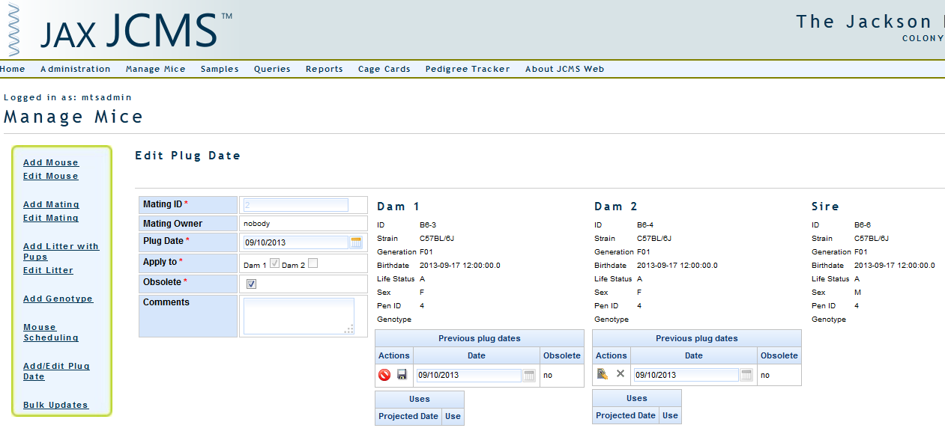

Figure 43: Edit Plug Date

You can then change the date, comments, and whether it is obsolete by changing those values and clicking the ‘Save’ icon.

## Bulk Updates

The ‘Bulk Updates’ screen is used for changing the status of groups of mice all at once without having to use the ‘Edit Mouse’ screen. This form may also be used to add a phenotype to a group of mice. This interface is located in the Manage Colony section under Manage Mice.

First the user must select what they are editing (Life Status, Diet, Protocol, or Owner) or adding (Phenotype) and what unit they would like to edit by (either Mouse ID, Cage ID, or Litter ID). Then a user must select what Strain the Mice/Litters/Cages are, if editing by cage any cage that contains any mice of that strain is included (so if one C57BL/6J mouse and two DBA/J mice are in a cage and the selected strain is C57BL/6J the former cage will be included in the list of cages you can select from).

The mice in the units you select will be shown in a table to the right of the pick list. After saving the mice in that table will be updated with the value indicted in the new life status/diet/phenotype drop down (or whatever value you are bulk updating).

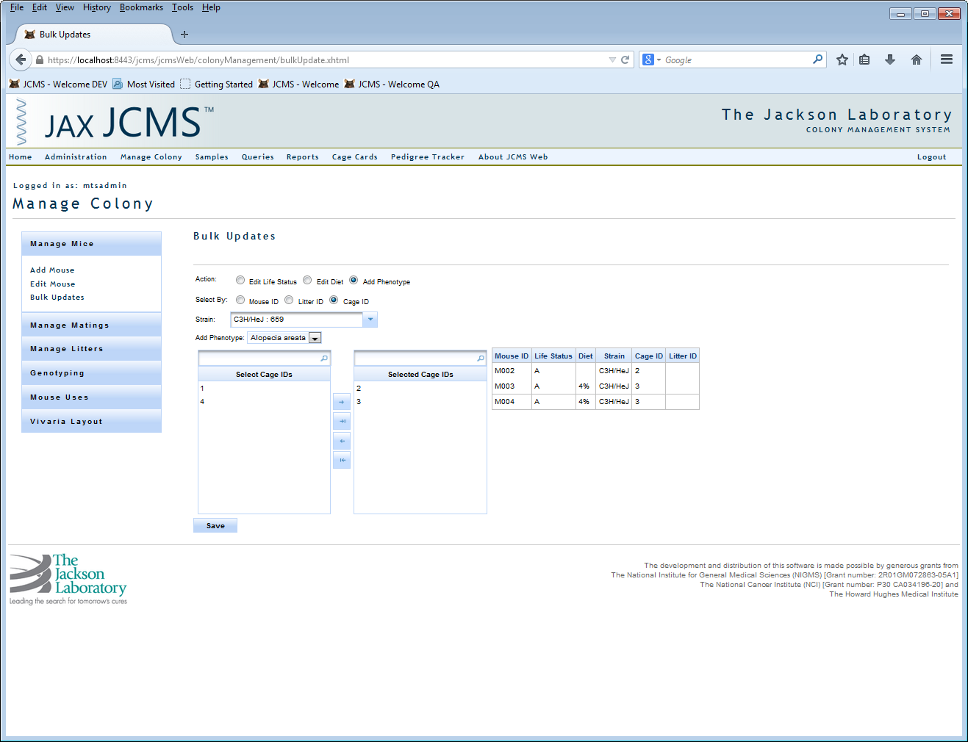

Figure 44: Bulk Update

## Vivaria Layout

The ‘Vivaria Layout View’ provides a visual method of displaying and moving the cages within a room. Mice may be moved between cages on the same rack. It also allows for retiring cages and exiting the mice. Please note that the Vivaria Layout view does not work properly in the Internet Explorer browser and we recommend using Firefox or Chrome.

First use the’ Vivaria Layout Manager’ to subdivide your rooms into sections, racks, etc. This is described in the Administration section under Vivaria Layout Manager.

To open this interface, select ‘Manage Colony’ from the menu, ‘Vivaria Layout’ from the sidebar, and then ‘Vivaria Layout View’.

### Moving Cages

Select the ‘Move Cage to Rack’ radio button. Select the rack to fill. Select a strain from the strain drop down. A list of cage IDs containing one or more mice of that strain will be populated in the strain list box below the strain drop down. Drag any Cage ID from the strain list into an empty space on the rack. The cage is now moved. Move a cage within the rack by dragging it into an empty space. Switch two cages within a rack by dragging one cage and dropping it over the cage it should be switched with. To move a cage to a different rack, you must move it using the strain list.

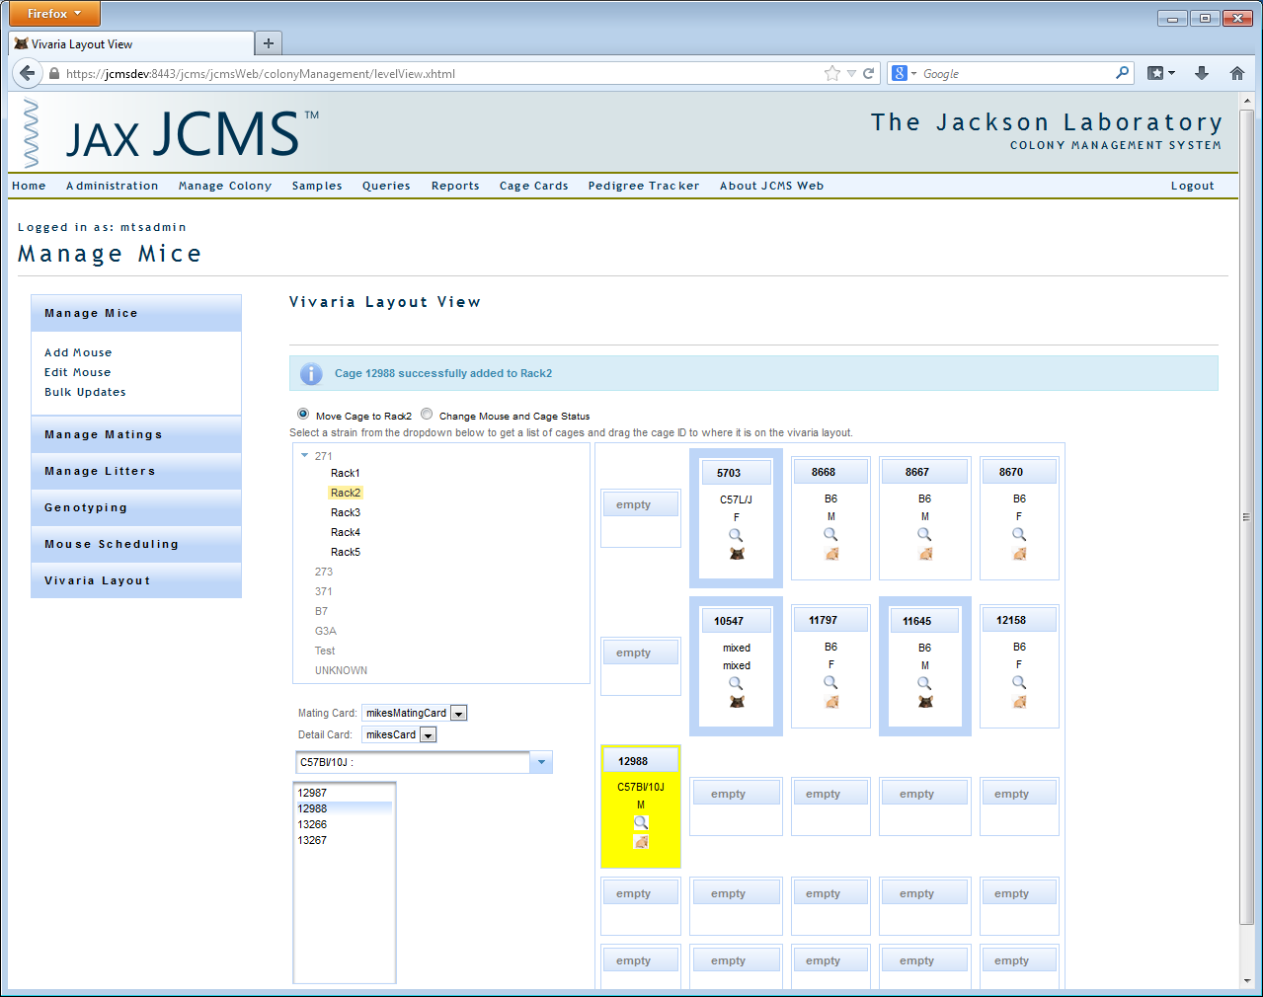

Figure 45: Vivaria Layout View

### Vivaria Layout Color Coding and Icons

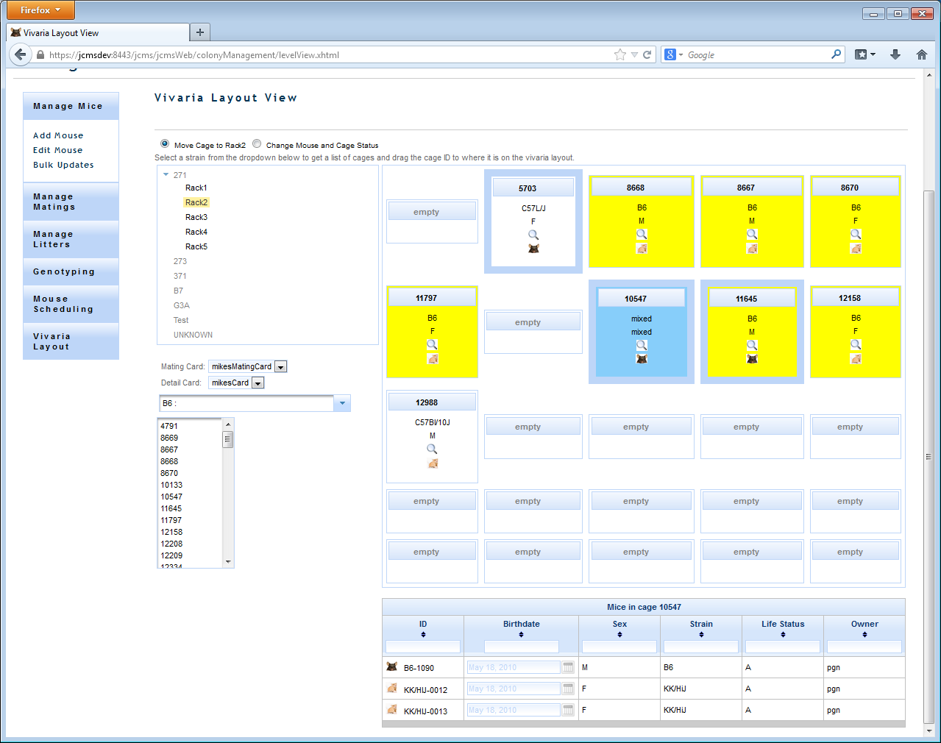

Figure 46: Layout Color Coding and Icons

Each cage is represented by a box.

* The top row contains the cage ID number or “empty” if there is no cage in that space.
* The second row contains the strain. It says “mixed” if the mice have different strains.
* The third row gives the sex as “M”, “F”, or “mixed”.
* The fourth row contains a magnifying glass ‘Search’ icon. Click the magnifying glass and a list of the live (non-exited) mice in the cage will be displayed below the rack display and the background of the box changes to a solid blue.
* The fifth row contains a mouse icon. Click the mouse icon to print a cage card for this cage. The cage card format is selected in the ‘Mating Card’ and ‘Detail Card’ drop downs.
* A cage with a yellow background contains at least one mouse with the strain that was selected.
* A cage with a thick blue border contains a mating. A cage is defined as a mating cage if one of the females is a dam 1 in a mating (even if the dam 1 is no longer alive). Note that sires may be moved into a different cage from the dam(s) in the mating.
* A cage with a red background has been selected to have the mouse life status and cage status changed.
* When dragging, the background of a list or the box representing a cage will change to a light blue when the item may be dropped there.

### Adding Cages

Figure : Cage Details Panel

To add a cage click one of the green ‘+’ icons in an empty cage slot when one of the Add Mating options is not selected and a cage details panel will render on the left hand side of the screen and the slot you selected to add a cage was will be colored orange. Fill in the cage details panel with the desired details and click the save icon or to cancel click the cancel icon.

### Change Mouse and Cage Status

Select the ‘Change Mouse and Cage Status’ radio button. This feature is designed to be used to retire cages and exit mice. All mice in the cage will have their life status changed. Select a ‘New Life Status’ and ‘New Container Status’. Both fields are required. Drag the cages from the rack into the ‘Status Change List’. Note the color of the cage on the rack now changes to red. Use the red ‘X’ delete button to remove any cages accidentally added to the status change list. Click ‘Submit’ to finalize the changes. Be careful with this as the cages will no longer be shown on the rack or in the strain list once they are retired, so a mistake will be difficult to fix.

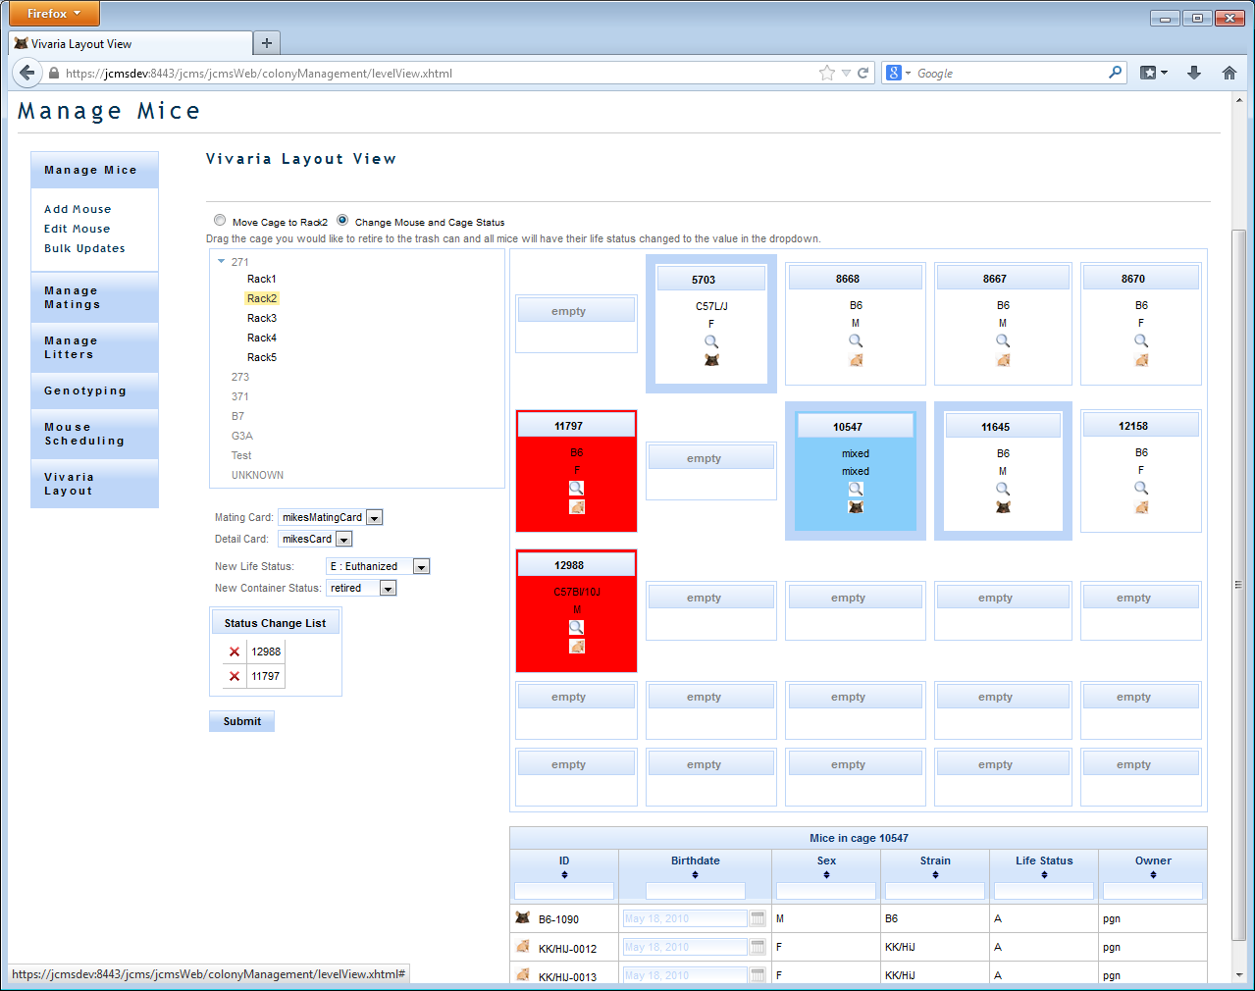

Figure 48: Change Life Status and Cage Status

### Move Mice

Click on the ‘Mouse Icon’ next to the mouse ‘ID’ and drag it into a different cage.

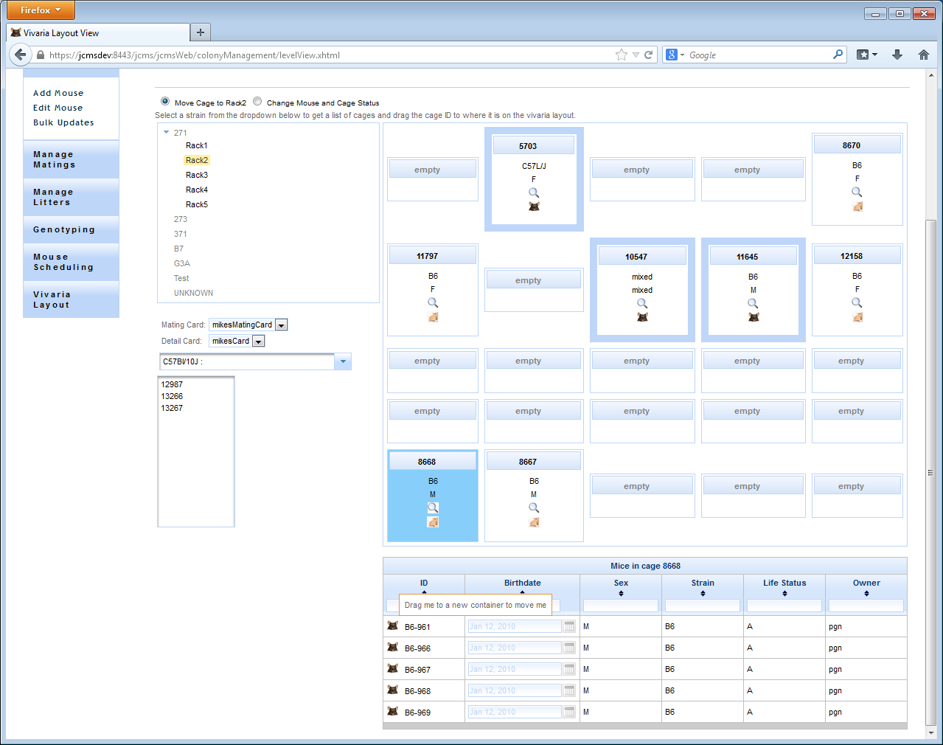

Figure 49: Move Mice to a New Cage

### Create Mating

To create a mating select either the ‘Add Mating’ or ‘Add Trio Mating’ option from function choice list at the top of the page. The only difference between the two is that if you drag a cage onto the box in which you are trying to create a mating if Trio is select and the cage is a female cage two dams will be added where as if Add Mating is selected only one dam will be added.

After selecting ‘Add Mating’ or ‘Add Trio Mating’ the empty slots in the view will all have a green plus icon in the middle of them. To create a mating you have to click the green plus in one of those cages (only one can be selected at a time). This cage will become highlighted in pink and save and cancel icons will be rendered on the cage as well as labels for the dam1, 2, and sire.

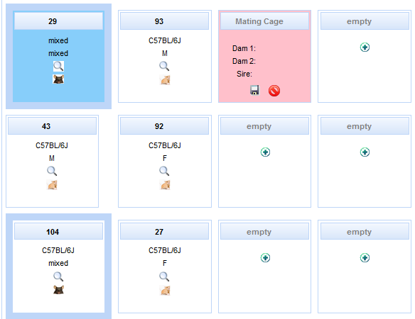

Figure 50: Add mating with Vivaria Layout

After selecting one of the add mating functions a mating details window will render to the left of the vivaria layout. The details of the mating will fill out according to sire and dams added to the matings. The mating owner will default to the owner of dam1, the litter strain will automatically be filled in depending on whether there is an approved mating strain relationship for the dam(s) and sire, if the sire and dam are of the same strain, or if the previous mating had the same dam and sire strains as the one currently being created in which case the litter strain will default to the same strain as the previous mating. The mating diet will default to Dam 1’s diet unless it is changed by the user, in which case it will remain the value provided by the user. The remainder of the mating info will have to be filled in manually.

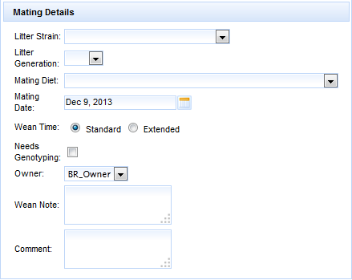

Figure 51: Mating Details

There are two ways to add a dam or sire to the mating. One can either drag a cage into the mating cage which will add the first dam that is not in an active mating to the mating or in the case that it is a male cage, the first male in the cage (regardless of whether it is in an active mating). The other means is to click on the magnifying glass in the cage that contains the desired member of the mating and a list of the mice in that cage will be shown on the page below the vivaria layout. The mouse icon next to each one of the mice can be dragged into the cage which will add that particular mouse to the mating.

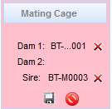

Figure 52: Mating Cage

From here the mating can either be saved or canceled. If saved the mice you added to the mating will be moved to the new cage and a mating will be added to the database. If cancelled the mating cage will turn back into a normal cage, but if you which to add a mating to another cage the dams and sires will remain the same until removed with the red x icon.

### Add Litter with Pups

To create a litter with pups select ‘Add Litter’ from the selection menu at the top of the page. After this selection a panel will render on the left hand side of the screen with all the litter and pup information. Also every breeding cage will have a new green ‘+’ icon rendered on it. Clicking on that icon will select the mating in that cage as the mating for that litter. It will also change the color of that cage to purple and render a save icon as well as a cancel icon on that cage. In the litter details panel the Mating ID and litter strain will be filled out based on that particular mating and the Base Mouse ID will be set to Dam 1’s ID.

To add a pup to the litter simple drag the female mouse icon (agouti) or the male mouse icon (black) to the desired location (can be either an empty slot, or a cage already on the rack). Any cage you add a pup to will have its background color changed to pink, and after dropping the mouse in the cage/empty slot you will see it added to the pup details table on the LHS of the screen at the bottom of the Litter Details panel. The mouse ID will be determined based on the Base Mouse ID field in the Add Pups portion of the panel. In the example in figure 48 above upon dropping a mouse the application will look in the database for the highest ID containing the ‘B6-‘ id pattern and increment that so instead of B6-16 being next the next will be B6-106 (as my last B6- mouse was B6-105).

Figure : Litter Details Panel

If you hover your mouse over (or on a tablet hold your finger on) either the cage or any mouse in the pup details table all the mice in that cage will be highlighted green as well as the cage those mice will be in. If you would like to add a Cage Name to a new cage you are adding pups to you can change it in the cage name field in the Pup Details table.

To save the litter click the save icon in the breeding cage that is associated with the litter.

## Use Schedules

Use schedules provide users a means of grouping Mouse Uses and scheduling mice for multiple uses with a single click, with those uses scheduled according to a date of importance such as a plug date, or a mouse birthdate.

A mouse can be added to a use schedule either through the Add Mouse screen, the Add Litter with Pups screen, or the Add Plug Date screen. Once a mouse has been added to a use schedule the uses associated with that schedule will automatically be added according to the days after event of the use schedule, and the start event (plug date or birthdate) date.

### Use Schedule Manager

The use schedule manager can be reached through Use Schedule Manager link in the Manage Colony accordion.

There is a filter panel that can be used to return only the use schedules of interest with both mouse based and use schedule based filters. After selecting some search criteria and clicking ‘Search’ a list of Use Schedules will be displayed below. This interface provides a convenient means of entering mouse use data for the uses associated with a mouse’s use schedule. From here the use schedule itself can also be marked as ‘done’ indicating that the use schedule is no longer active for that mouse.

Figure : Use Schedule Manager link

### Kaplan Meier Plots

With the use schedule model comes the ability to create Kaplan Meier plots. Kaplan Meier plots can be used to illustrate the survivability of mice in a use schedule by showing the volume of mice that were alive after a number of days.

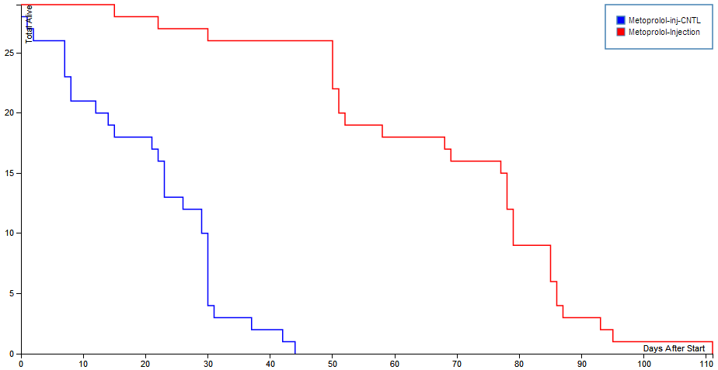

Figure 55: Kaplan Meier Plots

# Queries

This module provides ad hoc query functionality. A user can define and save a mouse or mating query. The mouse and mating forms let a user select the fields to display, specify the filter criteria, preview the result set, and save the query form to load and run at a future date. Run the query to test out the filter. Once satisfied with the definition, select the save button to be able to run it another time. Select clear to reset output field selections and filters.

Select run to execute the query and view search results. Search results view provides a link to download the list of results as a comma separated text file (csv or txt).

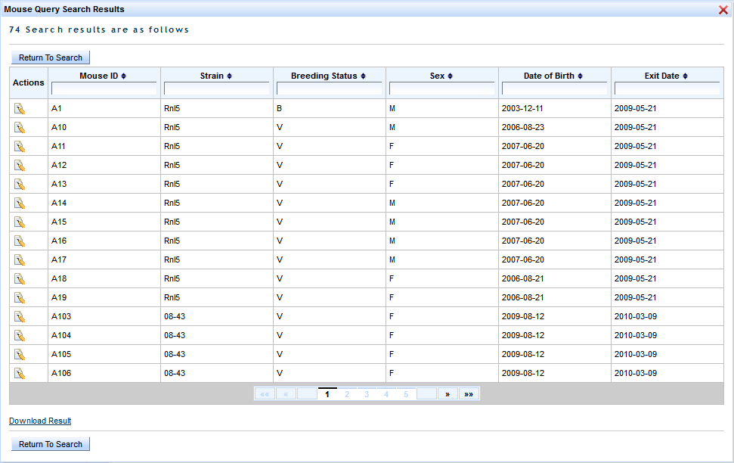

Figure 56: Mouse Query Search Results

The load query interface lists all saved queries by name. Queries are listed by mouse or mating. Select the query name to load. The query is loaded and displays in a new browser tab providing easy navigation back to select another query. The action column provides a delete icon used to remove queries that are no longer useful.

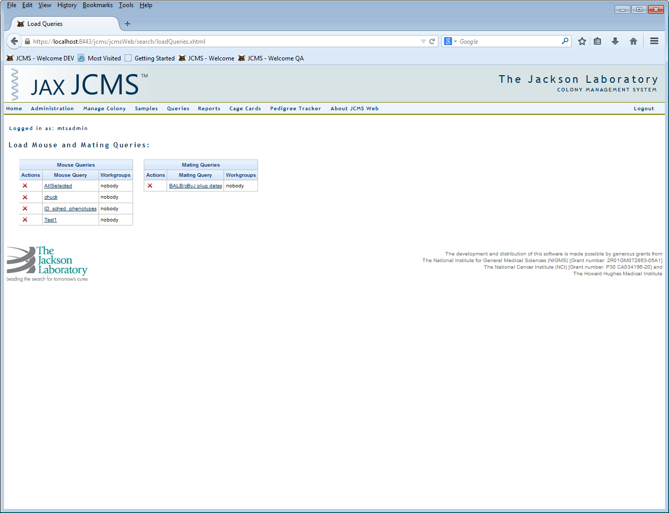

Figure 57: Load Queries

# Reports

## Colony Summary Report

The colony summary report gathers all statistics for the owners/workgroups by:

* The number of live mice and active strains listing owner/workgroup, strain, and number of live mice
* The number of active cages listing owner/workgroup, room, number of cages, and cage status
* The number of active matings listing total number of active matings per owner/workgroup
* The number of active plans and tests listing owner/workgroup, plan, test ID, test, projected number of mice, and test status
* The number of mice scheduled for testing listing owner/workgroup, plan, test ID, test, and number of mice scheduled

## Cage Summary Report

The cage summary report can generate a billing report by room, status, date, and owner/workgroup. Statistics can be grouped by no grouping, room, or status. Cage billing can be defined as any day, full day, partial first day, or partial last day. This report lists the date, number of cages, and room name. Select the ‘Download Result’ link to store results as a CSV text file.

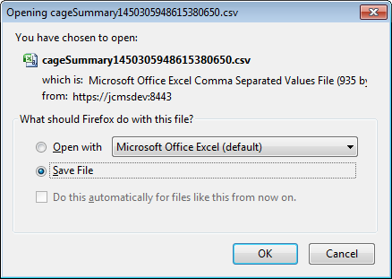

Figure 58: Download Cage Summary Report

## Wean Report

The wean report lists matings that should be checked for a litter to wean. This report may be exported to Excel in the same fashion as the cage summary report (see above). A mating is listed if on the selected date:

* It is an active mating that has not had a litter recorded and its mating date is older than the expected wean time (standard or extended) plus gestation period.
* It is an active mating that has a litter with a birth date but no wean date, and it is past the expected wean time. If the mating has two litters with no wean date, both will be listed.

The following setup variables are used in determining the projected wean date: JCMS_GESTATION_PERIOD, JCMS_STANDARD_WEAN_TIME, and JCMS_EXT_WEAN_TIME.

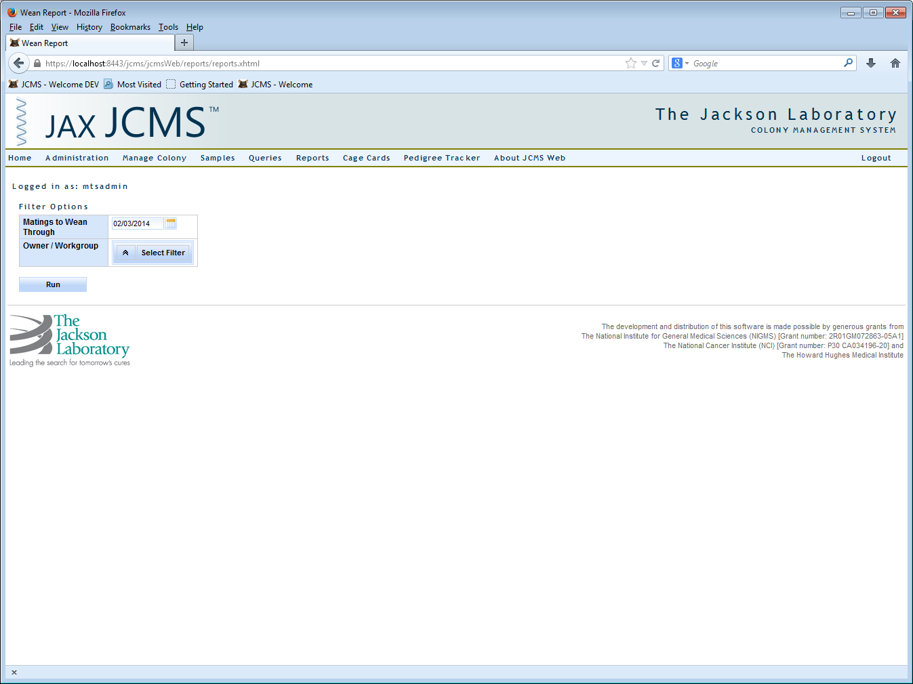

Figure 59: Wean Report Options

Enter an end date for the report. Matings that have a projected wean date within a window of 60 days prior to that date will be listed. This will help to catch older matings that have not produced. To produce a report of work for a particular week, enter Friday of that week as the date.

The report may be filtered by owner/workgroup if run by an administrator. Owners will only be returned a list of their own mice.

## Mouse Scheduling Calendar

This report is described in the Mouse Colony section: Mouse Scheduling Calendar.

# Cage Cards

When a user first navigates to the Cage Card page by clicking ‘Cage Cards’ on the main bar a user has the option to print cards for one or multiple cages, two drop down menus (one for the card type, the other for the particular card), and an input text box (for the Cage ID). The three buttons ‘Submit’, ‘Preview’, and ‘Print Blank Cards’ are for printing cards for the user provided cages (the fields Card Name and Cage ID are required), preview shows the user the cage card that is selected in the Card Name field in a new window, and print Blank Cards opens a modal panel for the user to select cards to print for cages from dbInfo.maxPenID to dbInfo.maxPenID+Number of cards.

The idea is that a person would print off cage cards for cages maxPenID through maxPenID + Number of Cards, proceed to go into a mouse room, on those cards record the information for the printed cages (how many mice would go in there, what strain they are, what gender they are, etc.), return to a computer with that information, and add it to the database using the Add Mouse form.

The first time a user navigates to this page there will be no cage cards in the drop down for any of the card types, to create a card you need to follow the link below the buttons to ‘Make Custom Card’.

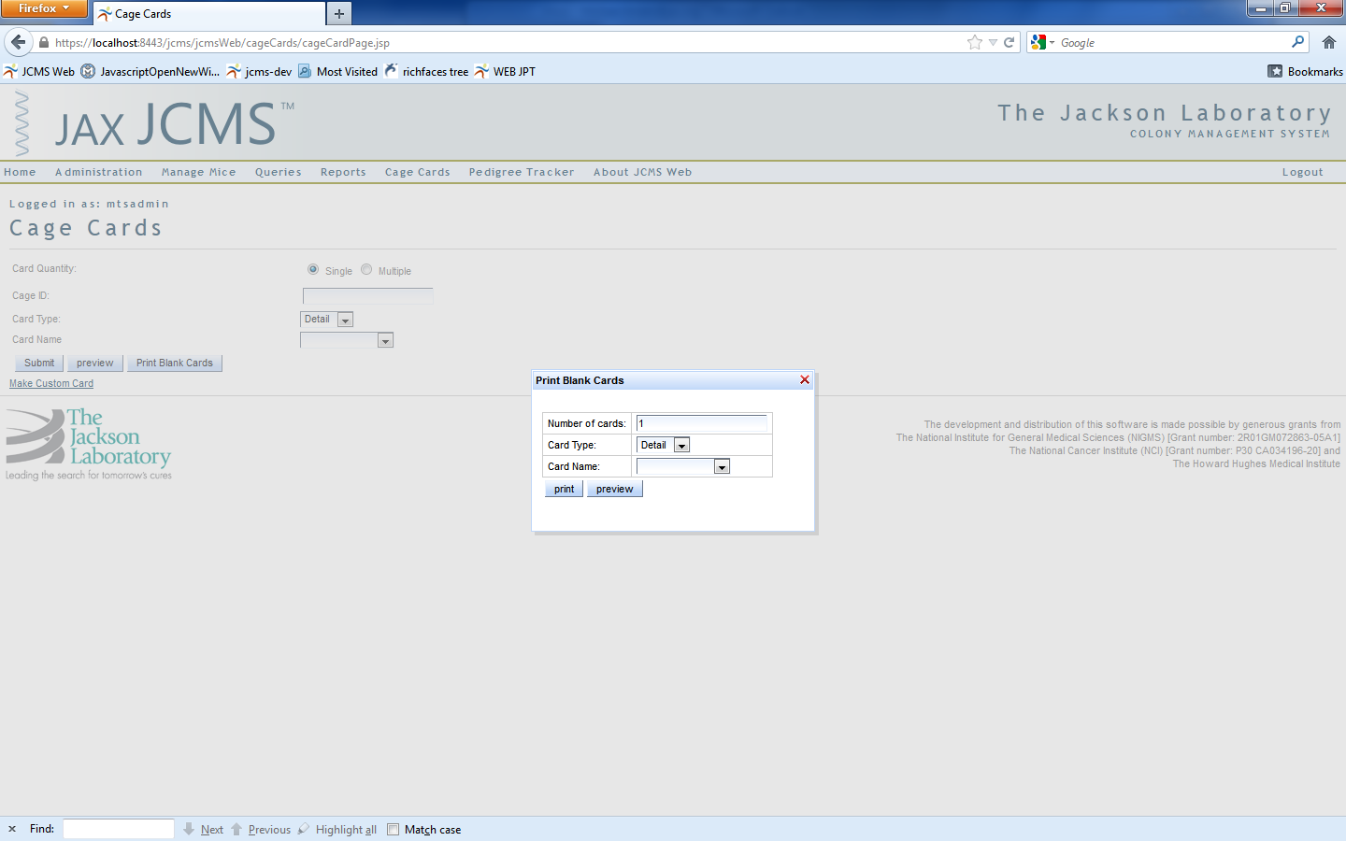

Figure 60: Print Blank Cards

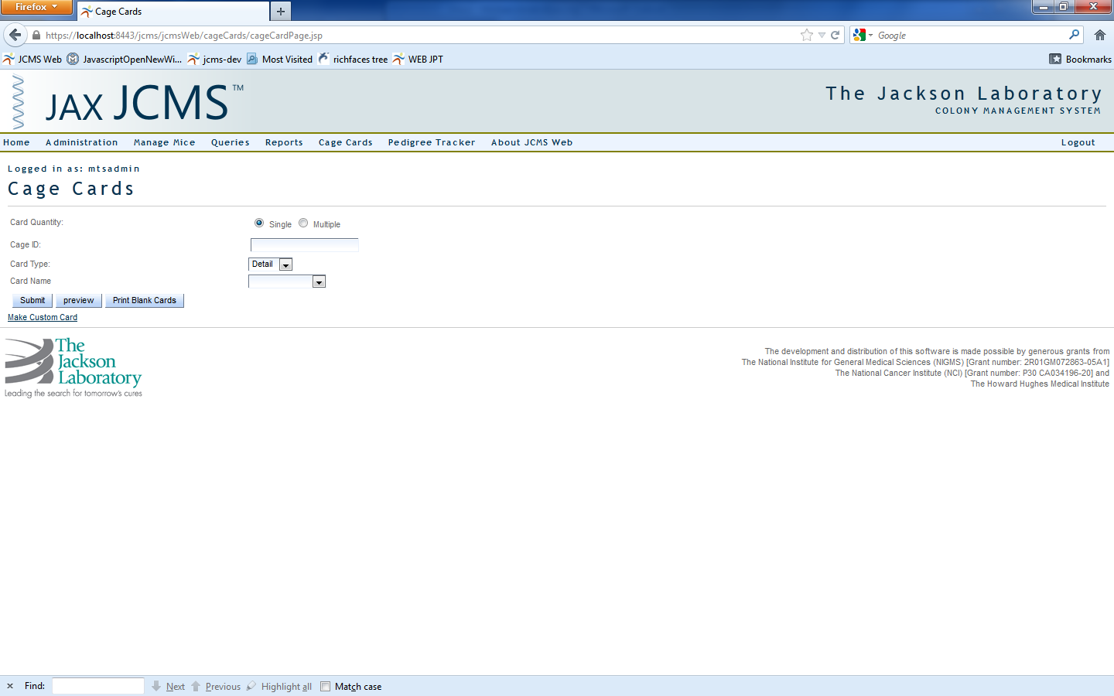

Figure 61: Cage Cards

## Make a Custom Cage Card

The Card Name field is the name of the card as it is saved in the database as well as the name that is seen in the drop down menu from the interfaces where you can print a cage card (cage card, add/edit mouse, and add/edit mating interfaces).

The Card Type button corresponds to the type of card you are making, it is saved in the database (and determines the path that is taken in the code) and affects the fields you are allowed to select in the field menu in the grid below. If you change the card type while you have fields already present in the card, if that field is not available in the new card it will be highlighted in red. To see this effect select Card Type: Detail, add a Detail Card Note, and then switch to another card type.

The Orientation field lets you select whether you are printing a landscape (5x3) or portrait (3x5) style card. What you have selected as the Orientation will change your choices for the Row Portion (a field that will be defined later).

Finally the print settings should be selected according to what your printer is. If you have a printer that has a 3x5 option you can use 3x5, if your printer has a left, center, or right envelope feed, you can use the corresponding 3x5 on 8.5x11 setting.

The Workgroups list to the right of the card settings choices is a multi-select list containing the owners to which this cage card will belong. All the owners selected will be able to use and edit this cage card.

The four buttons below the print settings drop down are to add a field to the cage card having the properties corresponding to the rows in the custom card field grid, preview the card as it is currently built according to the fields you have added, clear the card’s contents (all the fields in the data table below the field grid), and save card which saves the card with the settings as they are set out on the page.

The Load Card link brings you to the Load Card page, more on that later.

In the custom card field grid you have the ‘field’ drop down that indicates what the item from the database is going to be that belongs in the cell to create and add to the card.

The ‘row portion’ is the percentage of the row that will be taken up by cell that you create. Note that if you do not leave enough room for that field to fit in its entirety in the cell then information will be truncated. For example if you only allocate 25% of the row to the strain name of a mouse, then it is very possible that the strain name will not be displayed fully. However, since some of the fields like generation are generally shorter (N2, F1, etc) it can be safe to have certain fields being only 1/6th of a row.

The ‘number of rows’ field indicates how many rows the field will span. For example, if you are adding genotypes to a card, a mouse could have several genotypes (anywhere from one to thousands) and you may want anywhere between 1 through 5 genotypes displayed on your card for a mouse, so you could dedicate two entire rows to it. However, if you wish to have a field span several rows it must take up all of as many rows as you want to expand. So if you have a row portion of anything other than 100%, then you cannot have the field spanning multiple rows.

The ‘bar coded’, ‘labels’, and ‘borders’ check boxes are true/false boxes meant to indicate whether the cell you are creating is to have a border, whether it’s to be labeled, and whether it is to contain a bar code. A note on the bar code, you should have at least 50 percent of the cell dedicated to any field that you desire to be a bar code, otherwise the bar code scales too small and cannot be read by most bar code scanners.

Finally the ‘label’ input field allows the user to customize the label that appears on the created cage card assuming the ‘Labels’ check box is checked. The idea is that if a user wishes a specific label for something like generation because generation takes up too much room they could change it to something like ‘gen’ and convey the same information.

Next, when the user hits ‘add field’ a new row will appear in the data table containing the outline of the cage card. You will see three action icons appear in an ‘Options’ column on the left hand side of the table. The first is a red ‘X’ to delete the field, the second icon is an edit icon, when you click on it a panel will pop up and give you the options to edit the row, and the green ‘+’ icon gives you the option to insert a new row above the field containing the green ‘+’ you clicked on.

Finally, when you’re building your card there is a limit on the number of rows you can insert, for portrait style cards the limit is 30 rows, and for landscape cards the limit is 17 rows. This field will change each time you add a field (using the add field button), insert a field (using the green ‘+’ icon), and edit a field (using the ‘edit’ icon). This field should never fall below 0 and should not allow you to add a field after the counter reaches 0.

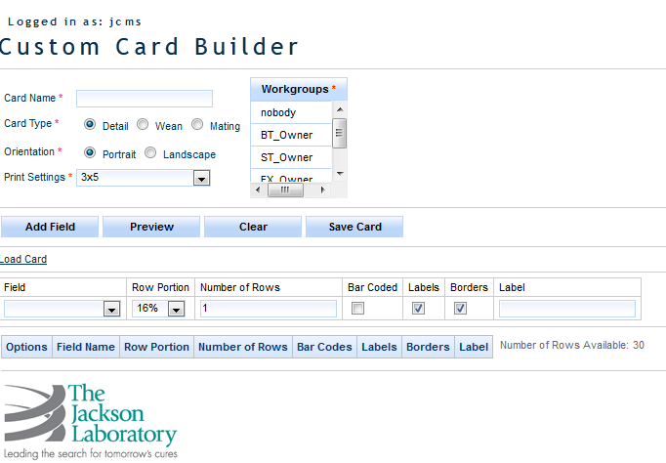

Figure 62: Custom Cage Card Builder

## Load Card

The load card screen is relatively simple; there are two things you can do.

1. Delete a card
   1. Deleting a card will remove it from the database permanently. To delete a card simply click on the red ‘X’ and confirm that your wish is to remove that card.
2. Load a card
   1. To load a card simply click on the link associated with the card and a new tab will open the make custom card page with the exact fields in the field data table and all the card info filled out such as card name, card type, orientation, etc.

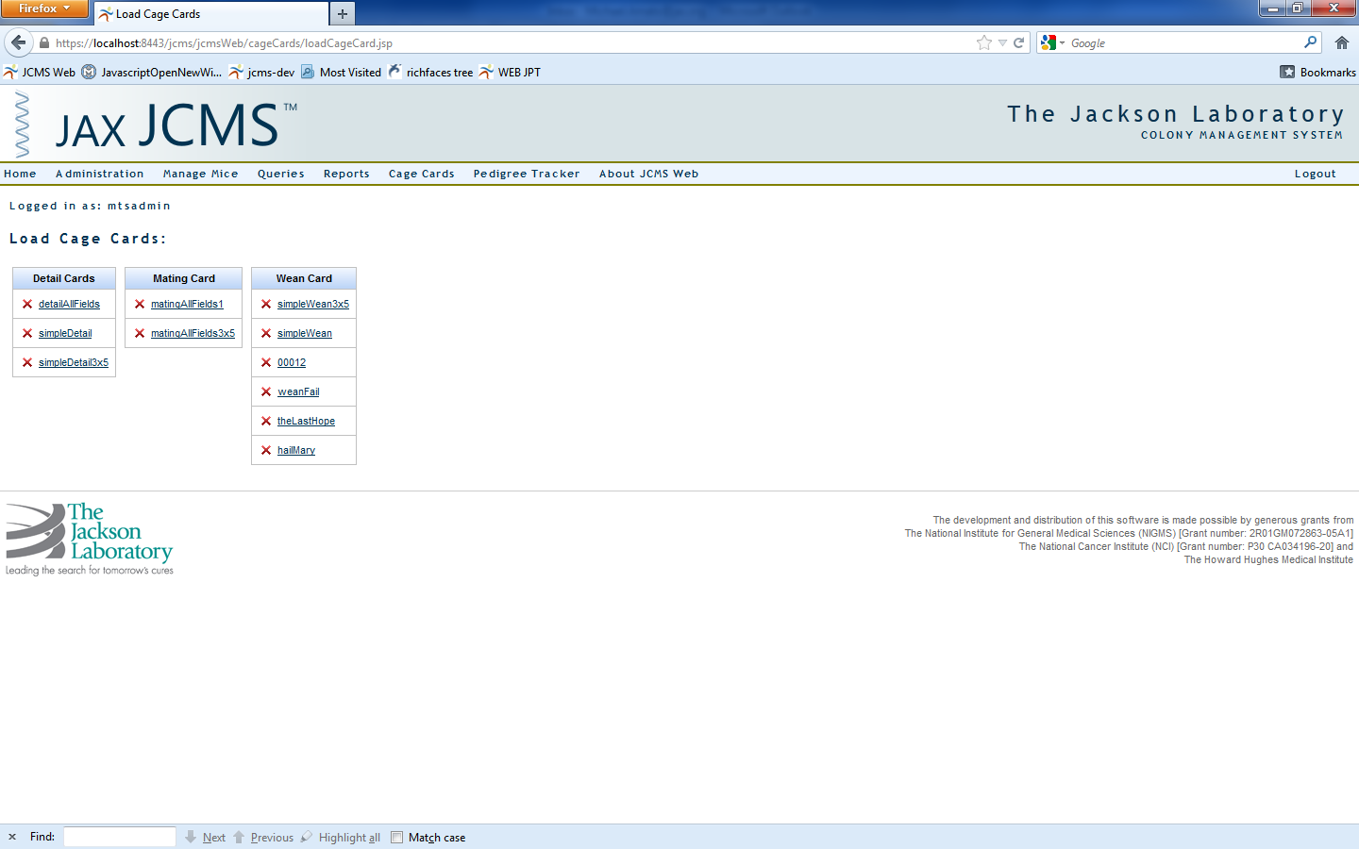

Figure 63: Load Cage Cards

## Business Rules

The wean and mating cards can only be printed if the mice in the cage meet a certain set of criteria. For a mating card the cage must contain either 1 or 2 female mice (dam1 and 2) and 0 or 1 male mice (0 because after a mating has taken place the sire may be moved to another cage).

A wean card must contain mice of the same strain. There is no other qualifier such as litter or gender as it is our desire to allow the user to be as flexible as possible with the application.

There are no qualifiers on detail cards.

Each cage card is associated with a workgroup and to access that cage card you must be a member of the workgroup to which the cage card belongs.

# Pedigree Tracker

A pedigree tracker tracks the ancestry or progeny history of a mouse using a mouse ID. You can either type in the mouse ID in the Mouse ID field or you can click the Find Mouse button and select a mouse from a set found using the search criteria the user defines. The user also must choose a tree depth which represents the number of generation the progeny search goes through with a minimum of one and a maximum of three. The display options grid determines what text is displayed for the mouse results in the pedigree tree.

When the tree criteria meet your specifications click the show tree button, if your tree depth is particularly deep (five or six) a Progeny search could take a while. When the tree is displayed you can click on a mouse to see more of that mouse’s information such as owner, diet, cause of death etc. in both a tool tip, and a panel to the right of the top of the tree.

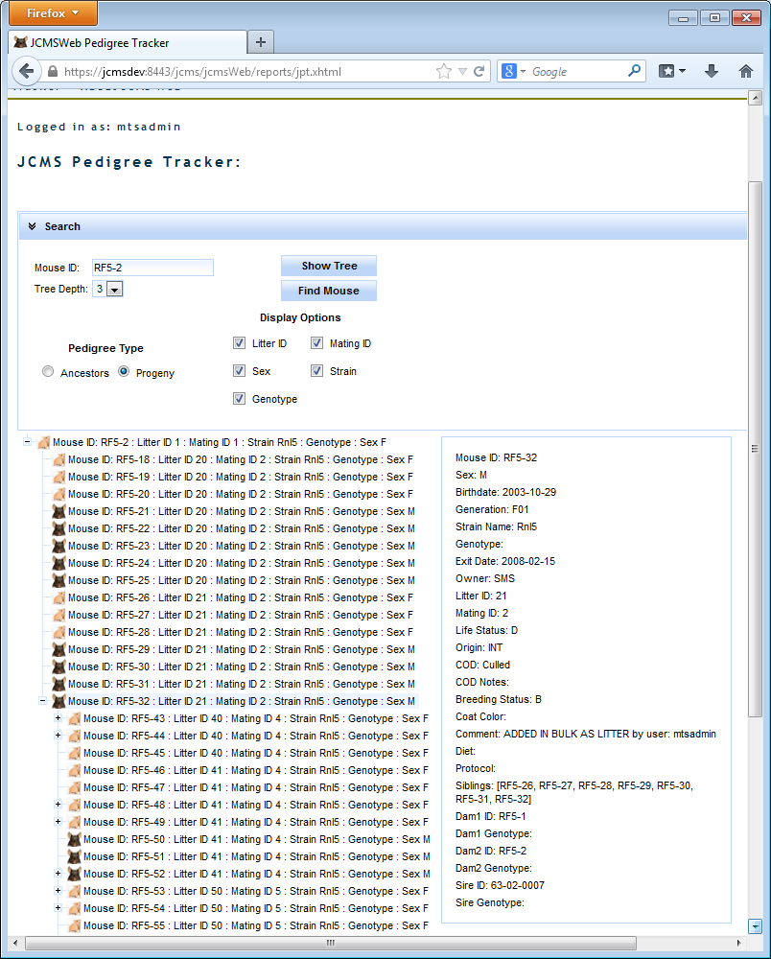

Figure 64: Mouse Pedigree

As part of the JCMS VizBoard a new Pedigree Tracker was created that helps illustrate genotype distribution in your pedigree trees was released.

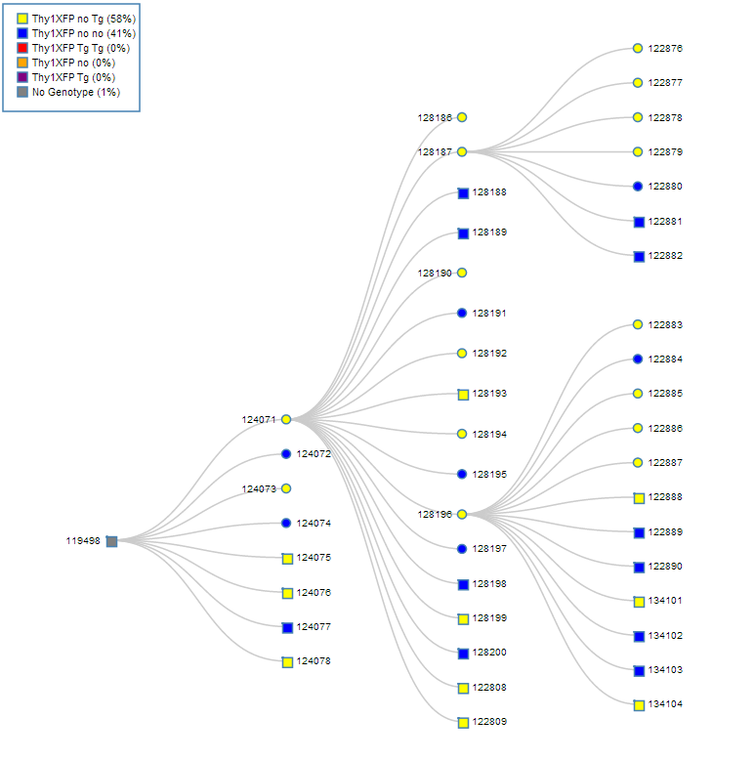

Figure 65: Genotype based Pedigree Tree Visualization

# Strain Viability Report

The strain viability report is available via the JCMS Dashboard on the JCMS Web homepage. After clicking the icon you will be brought to a page with two filters, strain and owner, which can be used to specify what data you would like returned from your database.

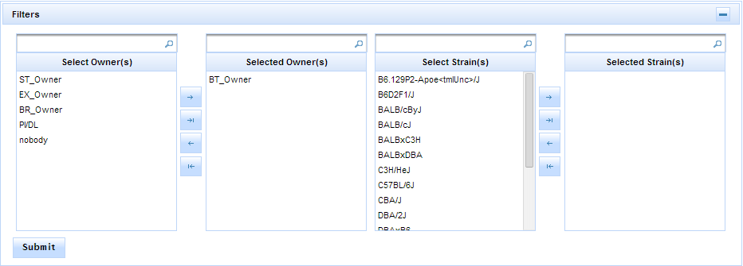

Figure 66: Strain Viability Filter Panel

After selecting some filter criteria hit the ‘Submit’ button to return your results. The results will return a bubble chart where each bubble represents a strain with the size corresponding to the number of mice in your database of that strain and the color representing the viability of the strain. The viability of the strain is calculated based on eight user provided values in the strain table: yellow min # males, yellow min # females, yellow max age males, yellow max age females, red min # males, red min # females, red max age males, and red max age females.

The yellow max age is the age for each gender at which the mouse is considered an ideal breeder – if the mouse were any older it would no longer be ideal for breeding purposes. The red max age is the max age at which a mouse is still considered a plausible breeder, so if the mouse were any older it is no longer a viable breeder (red status mouse). So given the case where a strain has a male red max age of 365 days, and a male yellow max age of 240 days the mouse status would be calculated as follows:

green status 240 days old yellow status 365 days old red status

Once the mouse statuses have been calculated for all the living mice of that strain the strain status is calculated using the following algorithm:

If the number of green status mice of that strain you have is greater than or equal to the Yellow Min # found in the strain table for both sexes for that strain the strain is Green Status.

If the strain is NOT green status and the number of yellow and green combined mice is greater than or equal to the Red Min # for both males and females the strain is considered Yellow Status.

If the total number of green and yellow male or female mice of that strain is less than that sex’s respective Red Min # then that strain is considered red status.

For example let’s say there is an imaginary strain called Strain A with the following values for its line viability numbers:

Red Min # Males: 3

Red Min # Females: 6

Red Max Age Males: 365

Red Max Age Females: 365

Yellow Min # Males: 6

Yellow Min # Females: 12

Yellow Max Age Males: 240

Yellow Max Age Females 240

In this example any mouse less than or equal to 240 days old is a green status mouse, between 241 and 365 days old inclusive is yellow status and any mouse older than 365 days old is a red status mouse (regardless of gender because the red and yellow max age numbers are the same for both sexes).

If a user has 8 green status males and any number of red and yellow status males and 13 green status females (and any number of red and yellow status females) that strain status is green because:

13 (green status females) >= Yellow Min # females for this strain (12 as outlined in the made up data above)

AND

8 (green status males) >= Yellow Min # Males (6 as laid out above).

If a user has 5 green status males and any number of yellow and red status males and 20 green status females the strain status is YELLOW because the number of green status males is NOT greater than the yellow min # males so it’s not green but the number of Yellow and Green status males IS greater than or equal to the Red Min # males for that strain.

If the user instead had 1 green status male and 10 yellow status males and the same number of females the strain would still be YELLOW because to be yellow the total Green and Yellow status mice must be greater than or equal to the Red Min # for that gender.

If a user has 5 Green status females and no yellow status females and any number of red, green , and yellow status males that strain status is red because the Red Min # of females is greater than the total Green and yellow mice in this instance.

The application is shipped to use default values of the following values for a strain that does not have its own line viability values:

Red Min # Males: 3

Red Min # Females: 6

Red Max Age Males: 365

Red Max Age Females: 365

Yellow Min # Males: 6

Yellow Min # Females: 12

Yellow Max Age Males: 240

Yellow Max Age Females 240

# Colony Status Histograms

The JCMS Dashboard Colony Status Histograms are meant to show the status of your colony over the last 30 days by showing total number of living mice and active cages grouped by both owner and strain.

To increase speed of calculation a special table was created that contains calculated data to populate these histograms which needs to be refreshed nightly to be kept current. As part of the upgrade process a MySQL event is created that will automatically refresh the data nightly at 3:00 AM. This event can only occur if the computer is on and active and the MySQL service is running, so in the case where the computer is asleep or shutoff nightly there is a data refresh button that only the mtsadmin user can click.

# Kaplan Meier Charts

The Kaplan Meier chart tool in JCMS Web is meant to offer users a means of plotting survivability of mice either in a protocol or of a certain strain.

JCMS Web queries the database retrieving all the mice that do not have the ‘alive’ life status and plots the percentage of mice that are alive after however many days. The plot comes with seven different colors allowing a user to plot as many as seven unique lines on the chart at a time with each line representing either a strain or a use schedule. To select a strain or a use schedule to plot simply select it from the list pick lists at the top and click the ‘Submit’ button.

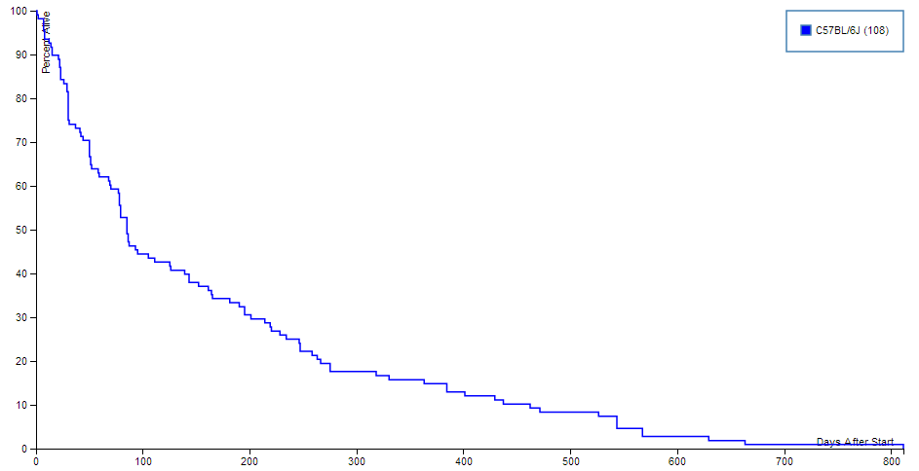

Figure 67: Kaplan Meier Chart Tool

# Samples

## Add Sample

To add a sample in JCMS it must be associated with a source. That source can be another sample, a mouse, a litter, a mating, or other. If other you only have to select a strain for that sample. A sample can have multiple sources, but they have to be of the same source type so one cannot have a sample which has a mouse source and a mating source and so on. A sample can only have multiple strains in its sources if ‘Relax Single Strain Constraint’ is selected.

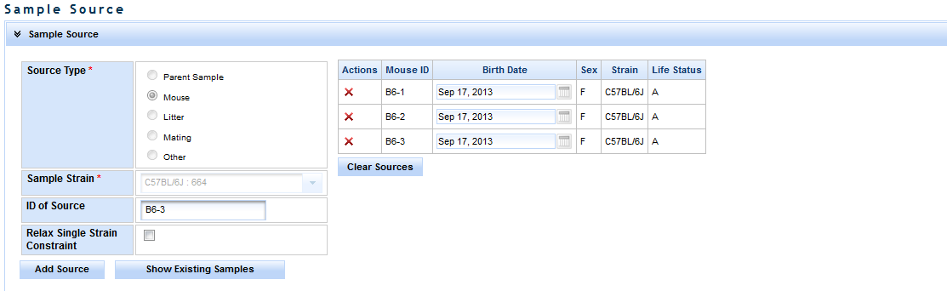

Figure 68: Add Sample – Choosing a Source

Once the sources have been selected the source box can be collapsed to provide more room for the samples information. Each sample has a unique identifier (the ID), and owner, and different information defining the type of sample etc. When a user first navigates to the samples page drop down, sample type and the preservation fields will be disabled. They will remain that way until you select a field that has sample type, preservation type/method/detail associated with it. For example sample types and preservation types are associated with a sample class. So once a sample class is selected if that sample class has sample types or preservation types associated with it those drop downs will enable and be populated with the values associated with that sample class. Preservation methods are associated with preservation types, and preservation details are associated with preservation methods.

The Age of the sample can be calculated assuming that all the sample have the same birth date/sample date. If they do not a sample date has to be entered manually.

Each sample must be associated with a location. To select a location simply expand the location tree until the desired location is visible and click on it. If all samples are in the same location you can collapse the location panel to save room on the screen.

Once all the information is filled out as desired click the ‘Add’ button. You will see the sample appear in a table to the right of the sample information table. It is important to note that these samples are not saved until the Save button is clicked, after the samples have been saved their color changes from white to blue background.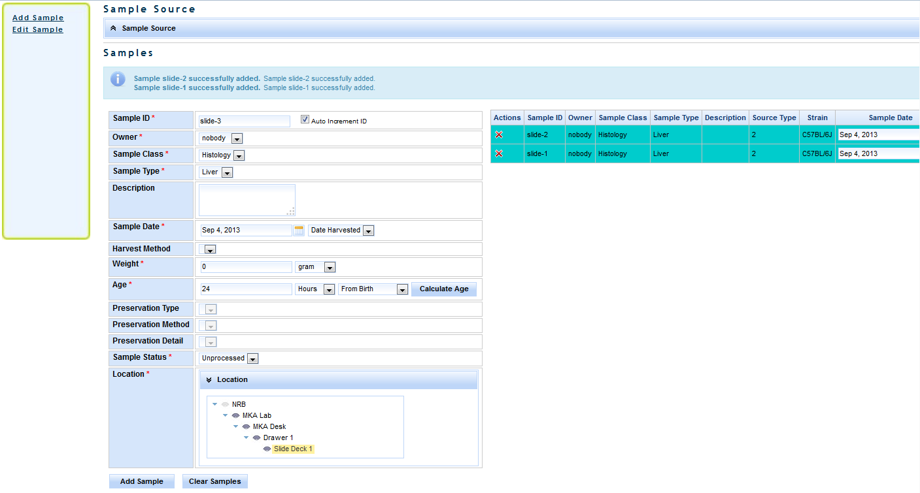

Figure 69: Add Sample

## Edit Sample

To edit a sample click the ‘Edit Sample’ link in the samples sidebar on the left hand side of the screen. You will see a panel with some search criteria as shown below: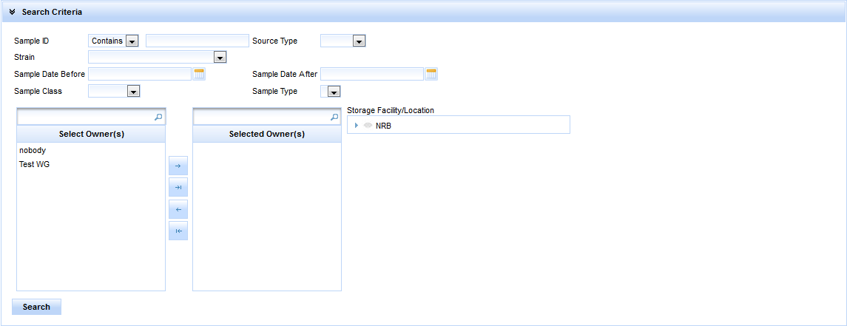

Figure 70: Edit Sample

After selecting a search criteria and clicking ‘Search’ a list of matching samples will be displayed in a table below the collapsible table. A sample can be edited by clicking the edit icon in the left most column in the row.

After clicking the icon you will be taken to a screen similar to the ‘Add Sample’ screen with the fields all filled out with the values that are associated with that sample. Any of these values can be changed by simply selecting a new value and clicking the ‘Save’ button. To change the ID of the sample click the ‘Change ID’ button, a panel will pop up where you will type in the new ID, and click ‘Save’. You can also edit a different sample by clicking ‘Edit Different Sample’, typing in a new sample ID, and tabbing out. You can return to the search view by clicking the ‘Return to Search’ button.

# Experiment Data

Multiple data records may be associated with a mouse. Normally this data is from an experiment, but the content of the records is designed by the user, so it could be anything you desire. The definition of the data is called a “test type”.

This section is accessed from the “Experiments” choice on the menu bar.

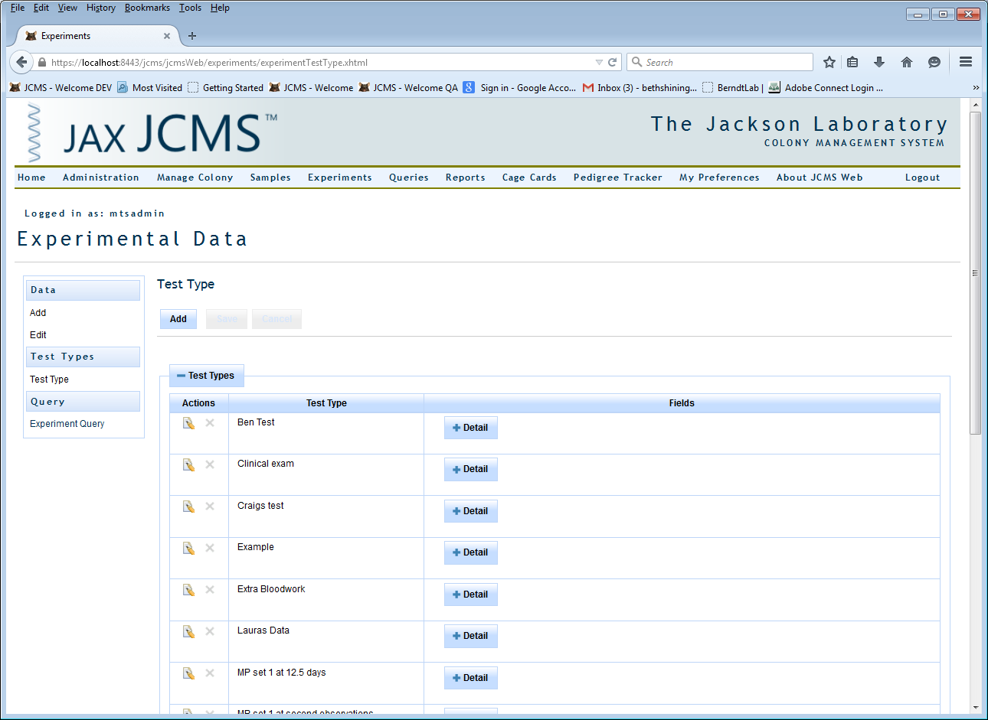

Figure : Experiments

## Add Test Type

The test type defines the data results fields to be collected. It must be created before data can be added. Only an administrator or colony manager may create a test type. Select “Experiments” from the menu bar and then “Test Type” from the side bar. An alphabetical list of existing test types is displayed.

Click on “+ Detail” to see the fields used by the test type.

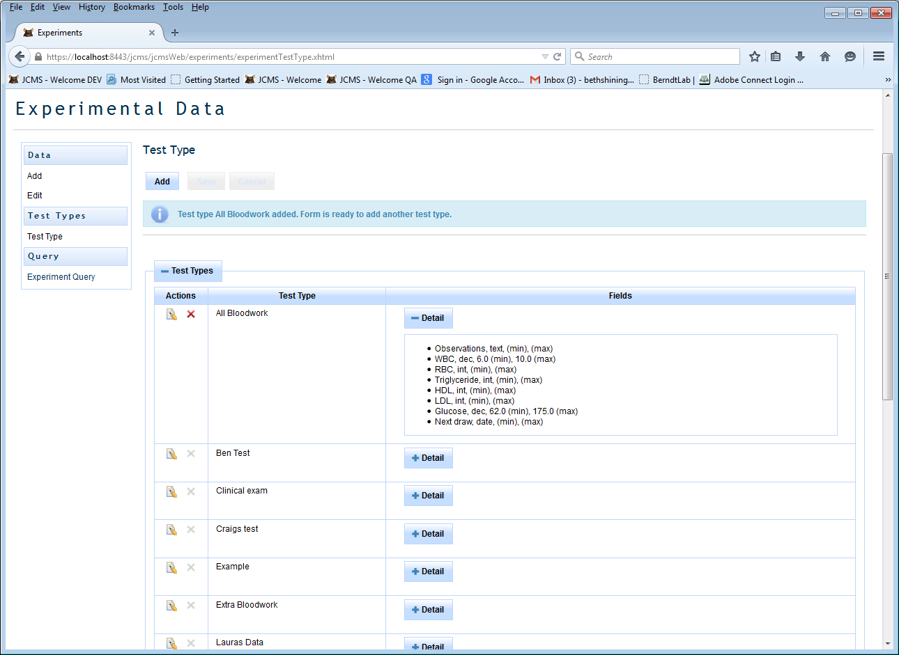

Figure : The test type detail list shows all the data result fields, format, and any min/max values

Click on the “Add” button to create a new test type, or click on the edit icon next to an existing test type to use it as a template for creating a new, similar, test type. Once a test type has data associated with it, it may not be edited or deleted. Instead create a new one containing the necessary changes to be used going forward.

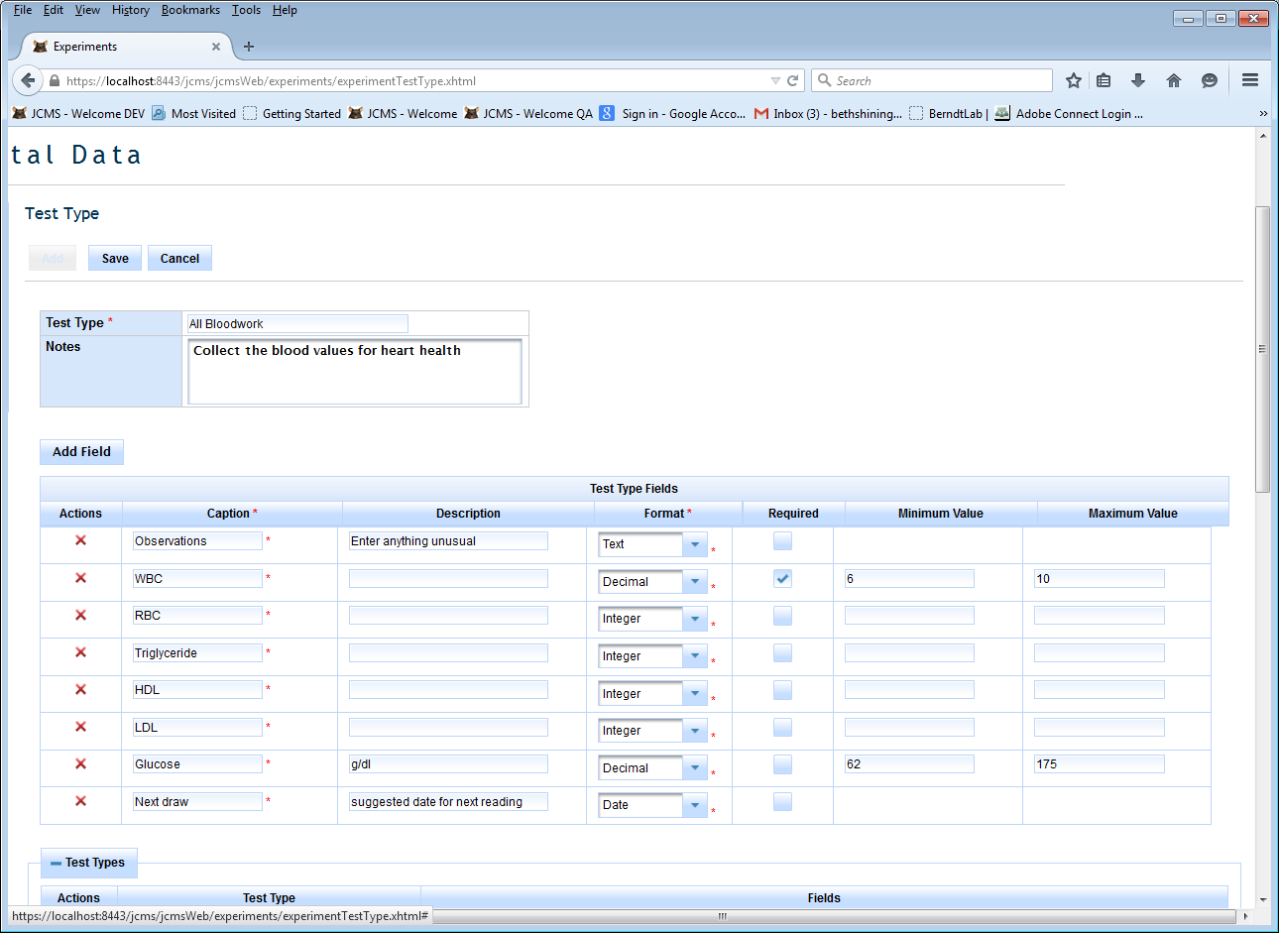

Figure : Add a test type

Use a brief but meaningful name for the test type, up to 32 characters long. This name must be unique (not used by any other test type). Use the notes field to enter a description of the test, protocols, etc. Up to 30 fields may be added, each field describes a single data result to be recorded.

* Caption: The “name” of the data to enter. Use a short but meaningful caption, up to 32 characters long.
* Field description: An optional short description of the result field. The description might indicate the units such as cm, gm, etc. or the expected text entries such as yes/no or mutant/control. It may be up to 32 characters long.
* Format: Select text, date, integer, or decimal value. The format will be used during data entry to check for errors. For example, when the data results are entered, if a numeric format (integer or decimal) is chosen no text or special characters will be allowed except for the normal ones associated with numbers (- +. ,).
* Required: Indicates if the field is required or not during data entry. By default, fields are not required.
* Min value: Optional field. When data is entered, numeric data may not be less than this minimum value.
* Max value: Optional field. When data is entered, numeric data may not be greater than this maximum value.

Click “Save” to create the test type.

## Add Experiment Data

Select “Experiments” from the menu bar and then “Add” under “Data” on the side bar.

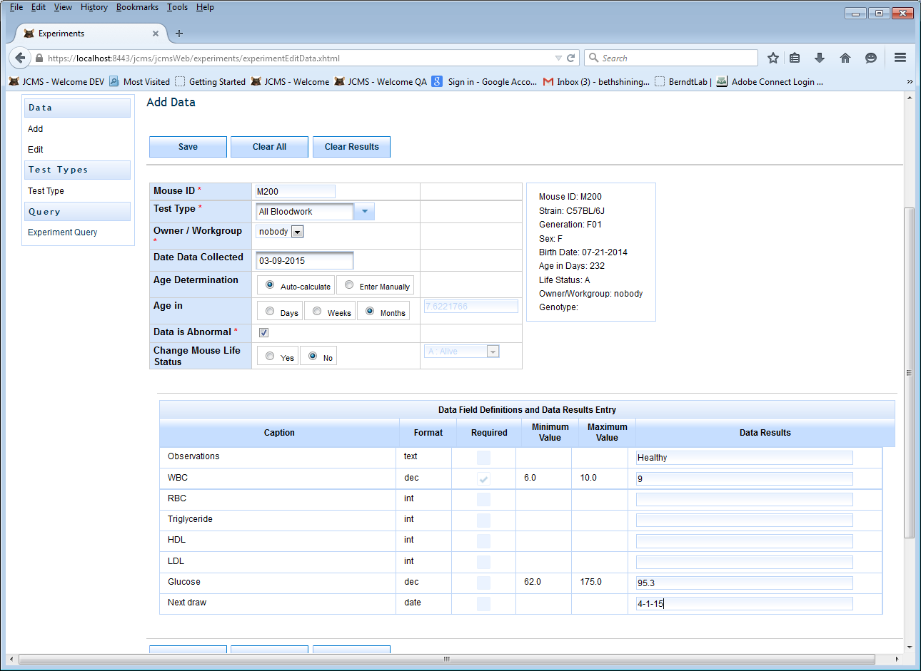

Figure : Adding data for an experiment

Begin by typing the mouse ID. The mouse’s information will then display in the box on the right side of the screen. Choose a test type. The captions for the data fields will then appear on the form. Any minimum or maximum values will be displayed and the required box will be checked if the field must have data entered. The owner of the data may be set to any workgroup. A warning will be displayed if the owner is different from the mouse’s owner. The data collection date is optional.

Age determination: The optional age field indicates the age of the mouse at the time of data collection. JCMS will calculate this from the data collection date and birth date of the mouse if the auto-calculate button is selected. JCMS will store the age field value as number of days old. Age may be entered in weeks or months by selecting the appropriate radio button.

If one or more data result values for this mouse are abnormal, then check the data is abnormal box. Later, this value may be used to easily locate all experimental data records with unusual results.

If the “change mouse life status” box is checked, then the mouse record will be updated at the same time as the experimental data record is saved. The mouse will not be updated unless the save is successful for the experimental data record. The mouse’s life status will be changed to the value selected. If that value is an exit life status, the mouse’s exit date will be changed to the data collection date. If there is no data collection date, the mouse may not have its life status changed to an exit life status.

The Data ID for this experimental data record is assigned by JCMS and will be displayed on the form. Record this number, it will prove useful to find the record for editing.

## Edit Experiment Data

Select “Experiments” from the menu bar and then “Edit” under “Data” on the side bar.

This form looks and works the same as the add version, except it adds the data ID field used to select the data record to edit.

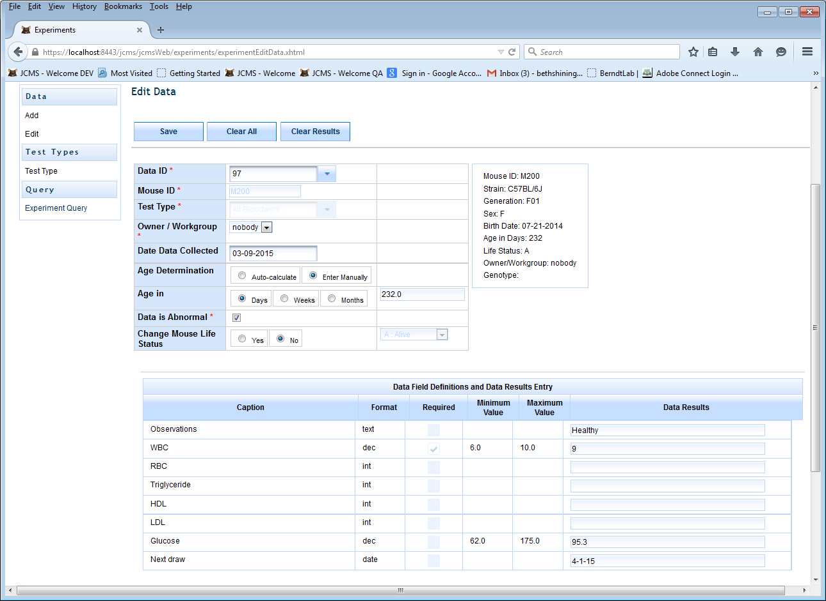

Figure : Edit experiment data

## Query Experiment Data

Select “Queries” from the menu bar or “Experiments” from the menu bar and then “Experiment Query” on the side bar.

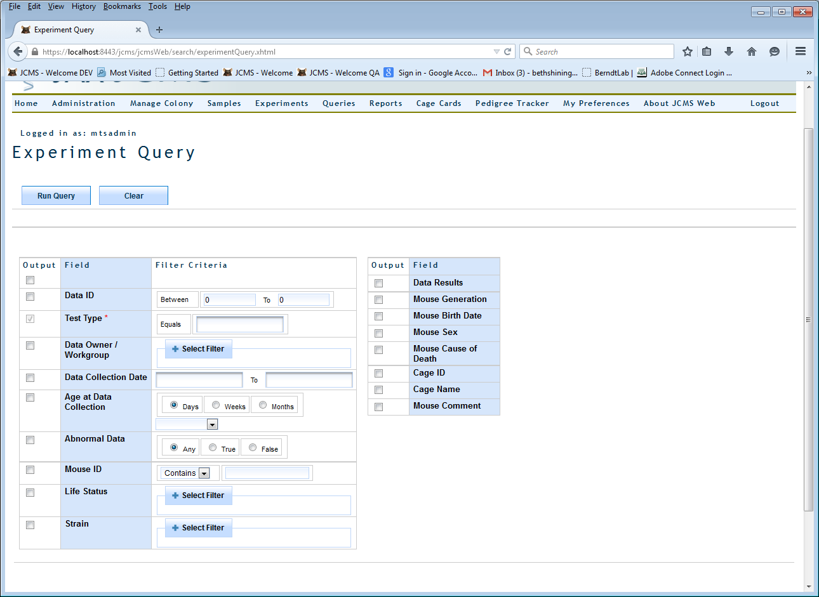

Figure : Experiment query

The test type is required and this query will only return data records for one selected test type. If you are also using the JCMS Access interface, all data records for the test type can be returned but the results will not include the experimental plan or test information.

# My Preferences

The preferences feature allows each user to specify their own settings. Over time, more preference settings will be added. This section is accessed from the menu bar.

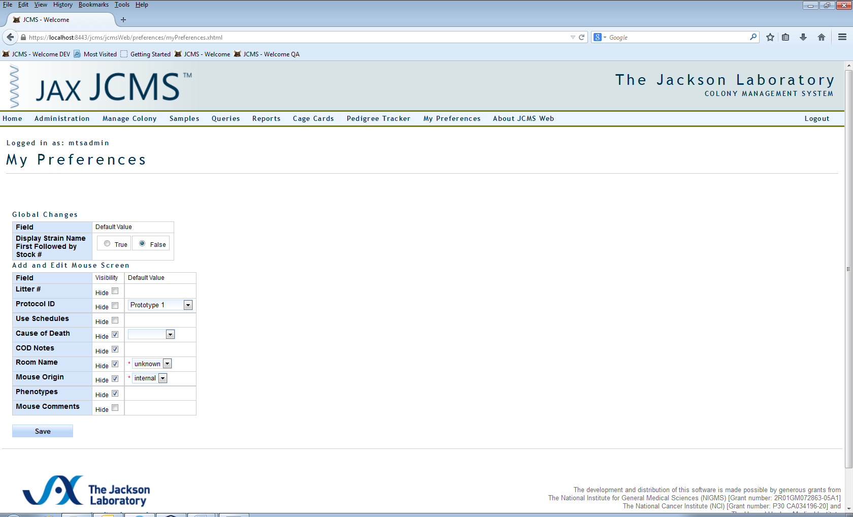

Figure : My Preferences on the Menu Bar

Any changed preferences will take effect the next time an affected screen is re-opened. At any time, if a user wants to see a hidden field, simply change the My Preferences visibility setting. The default values can be changed back and forth too, so for example, if work is being done in one room, and later in another, simply change the default value for room name.

A hide icon (eye with a slash through it) is displayed next to a field that may optionally be hidden. Clicking the icon will open the My Preferences page.

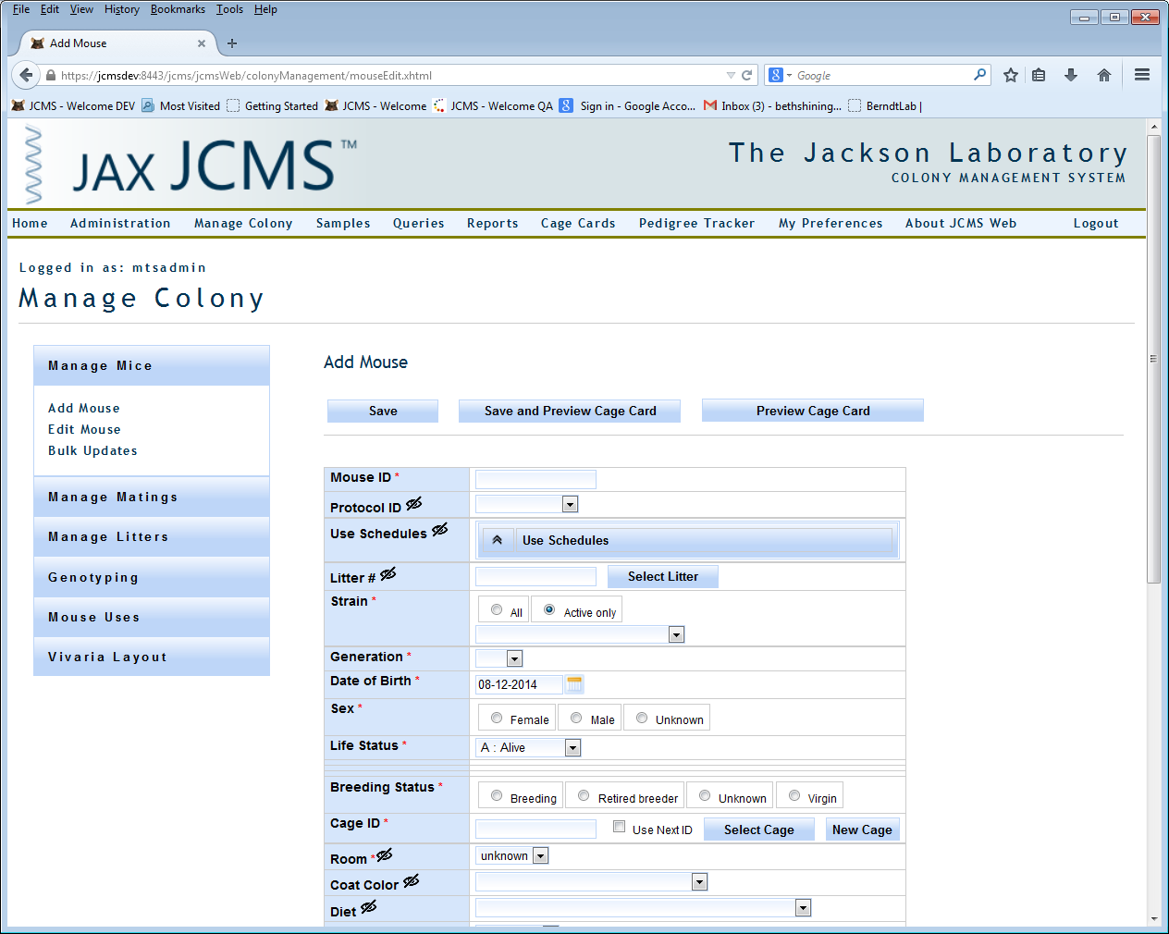

Figure : Hide Icon

## Global Changes

### Strain Name First

Some users prefer to use the Stock # instead of the strain name. By setting “Display strain name first followed by Stock #” to false, most selection lists will switch the display of strains to be by Stock #.

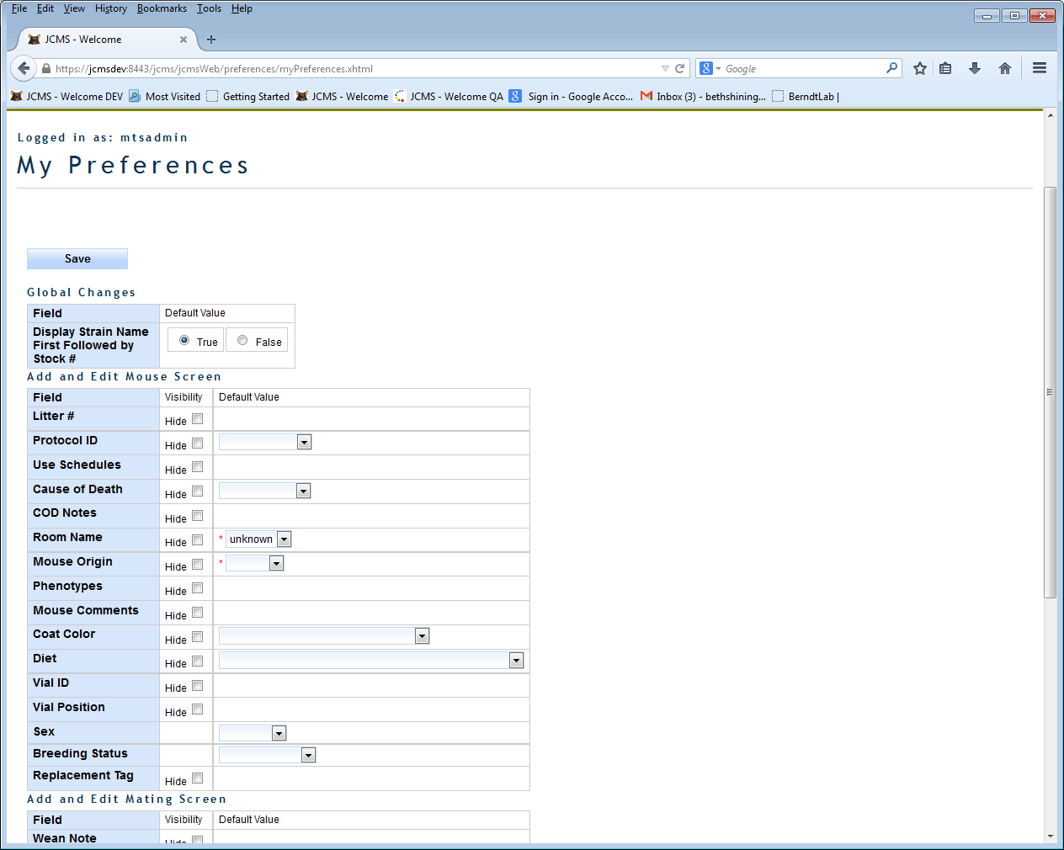

Figure : My Preferences Choices

## Add and Edit Mouse Screen

Changing the settings for the fields listed in this section will only affect the screen used when adding a new mouse or editing a mouse. Enable the visibility setting for ‘Hide’ to remove the field from view. A default value specified here will be shown on the Add Mouse screen when it is opened. The default value will be saved even when the field is hidden. Note some fields are required and must have a default value specified if they are hidden.

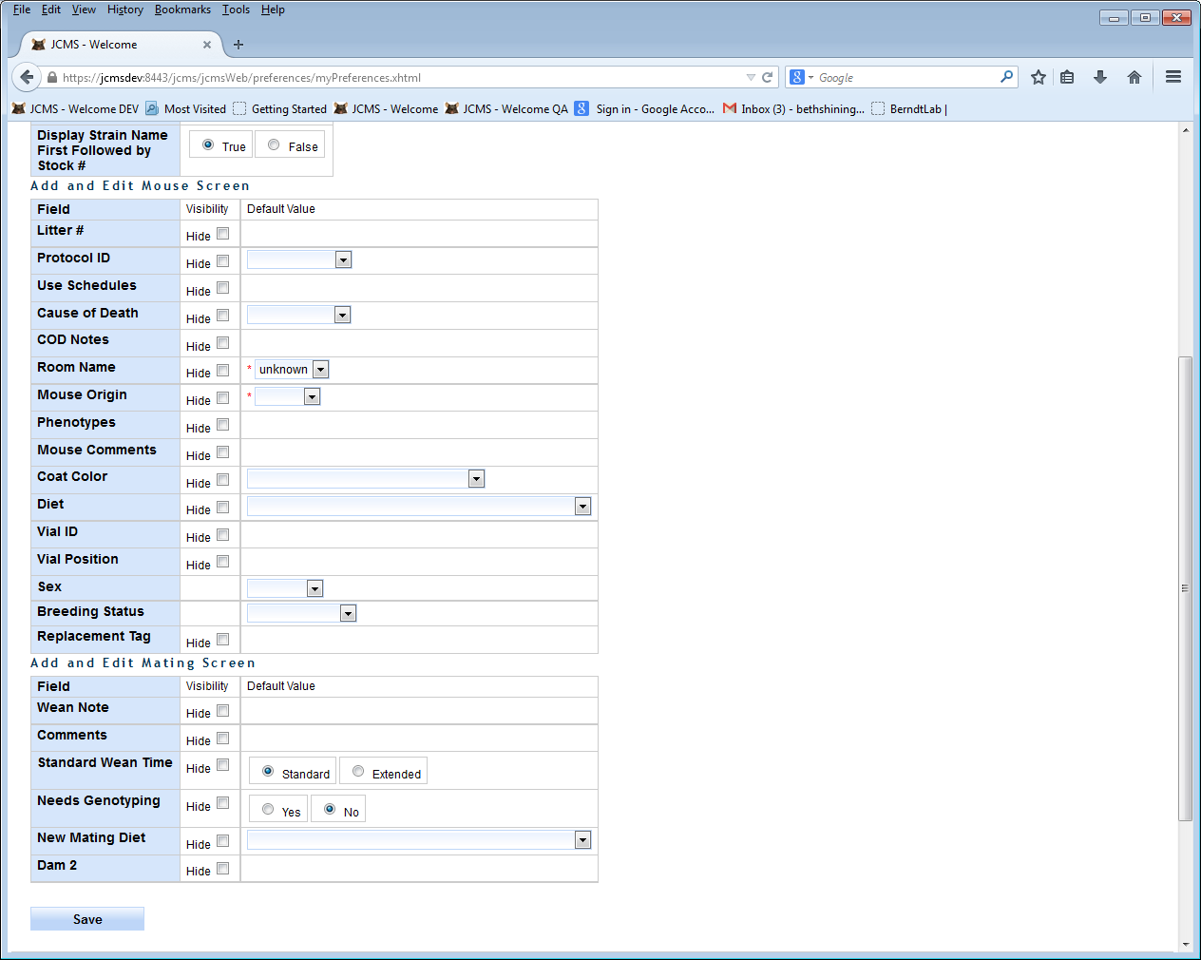

Figure : Preference Choices for the Add and Edit Mouse Screen

The Edit Mouse screen will hide the same fields as the Add Mouse screen. Anything previously entered in these fields will not be changed, except when a life status is changed, which has to work a little differently. If an exited mouse’s life status is changed to a non-exit status the exit date, cause of death, and COD notes are all removed. If a mouse that is alive has its life status changed to an exit status, the cause of death field will become visible so a value can be entered, even if it is supposed to be hidden.

## Add and Edit Mating Screen

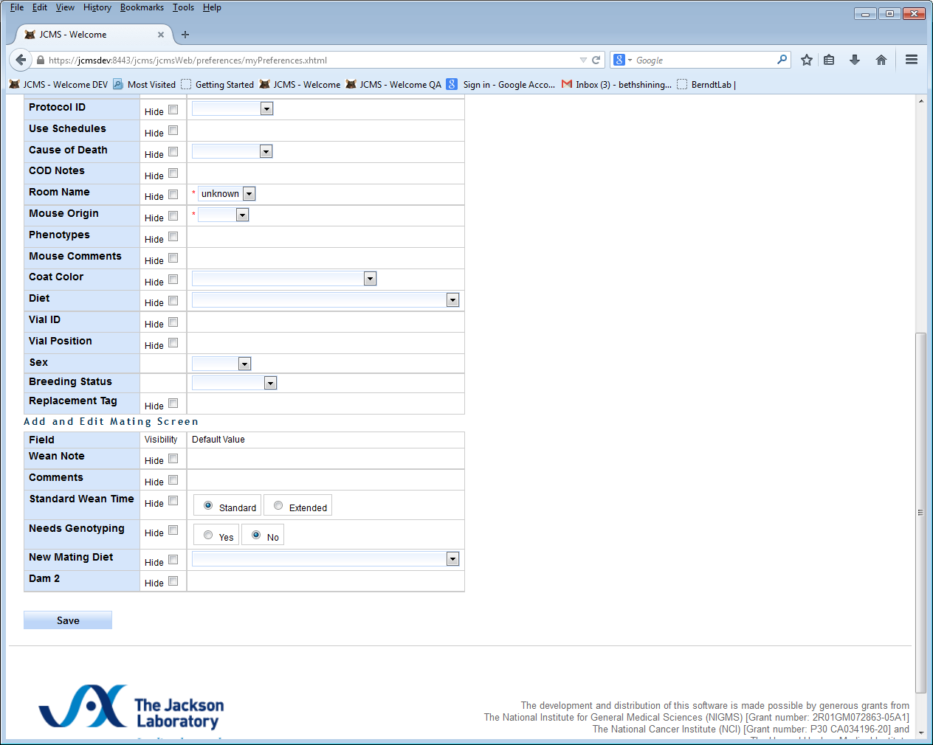

Figure : Preference Choices for the Add and Edit Mating Screen

Note that Dam 2 may be hidden even if there are matings with a Dam 2.

Note that hiding the new mating diet will also hide the display of the Dam 1/2 and Sire diets and the edit diet buttons.

## Add and Edit Litter Screen

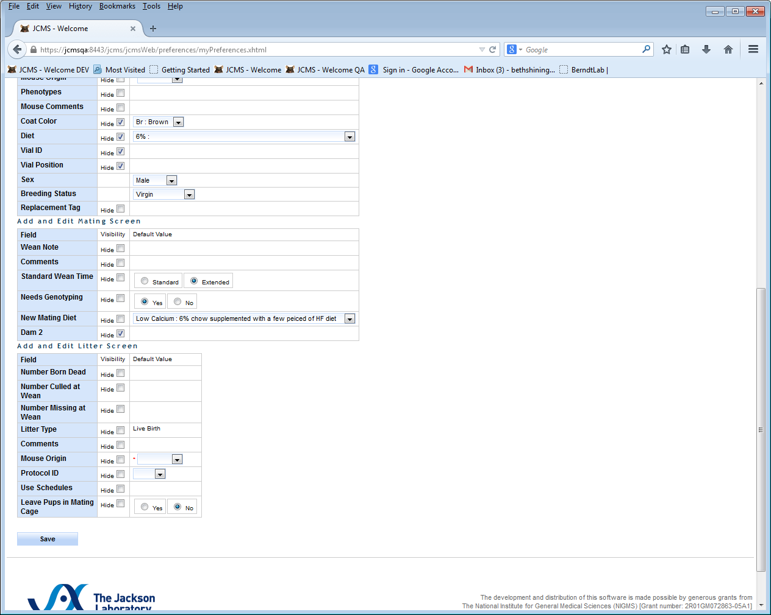

Figure : Preference Choices for the Add and Edit Litter Screen

# Known Issues

## HTTP Status 403 – Access to the requested resource has been denied

This occurs when a general user without privileges to access a certain module attempts to access that module.

## Browser is unable to display the web page

The web server may not be running. If your server is on your local machine, then jcmsweb.cmd must be started, give it two minutes to complete, and then leave it running (minimized). Now open the web page.